Blindata Release Note 8.5.8 

4 August 2017

Bug Fixes and Enhancements

The following bugs were recorded in www.support.blindata.co.uk and have been resolved.

3335. EDI Not Working
3357. Changes made to our invoice template Bespoke 52

New Work and Customer Requests
5408. Blinds.com XML

There is a new button for importing XML orders from Blinds.com. This is controlled by a new flag in Administration > Users > Advanced Permission > Blinds.com EDI Import

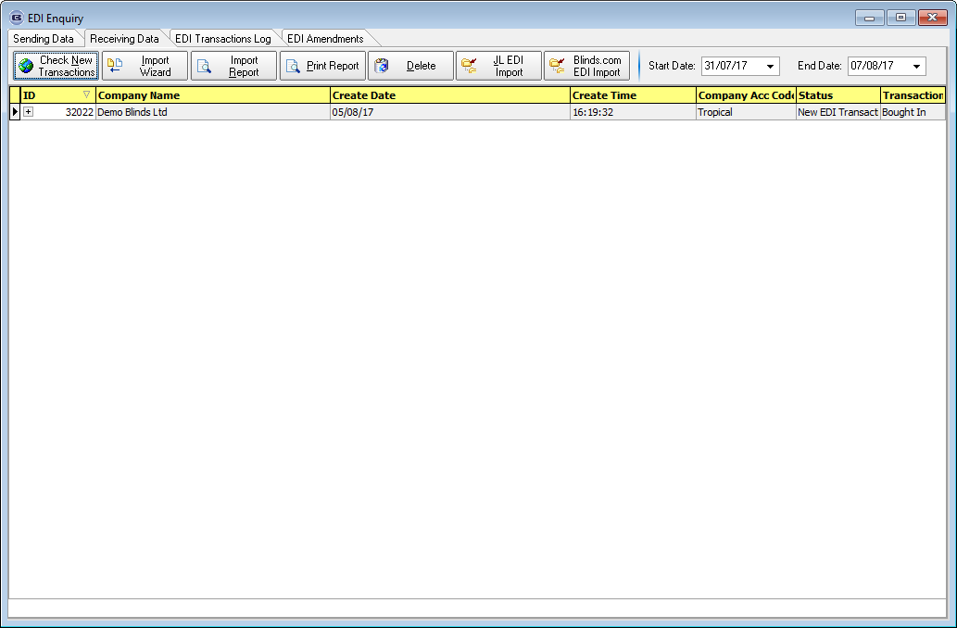

5474. Landed Cost

There is a new field in the stock record called ‘Landed Cost’.

There is a new parameter in Parameters > Quotations called ‘Use Landed Cost In Quotations’, which defaults to false.

When a quotation is entered and a BOM calculated, there are new columns in the BOM record for ‘Landed Cost’ and Landed Cost Total’. There is a sum of this total at the bottom of the form.

If ‘Use Landed Cost In Quotations’ = true, then this is used as the cost (instead of the unit cost price(base) and the profit, margin and mark up are calculated on the total for the landed cost.

5475. Import From Excel > Sales Tax Codes

There is now an import routine for sales tax codes (VAT Rates). There are fields for ‘Tax code’ and ‘Tax Percentage’.

5476. System Tables > Dimension Codes

Fullness Ratio, Roll Width and Number Of widths are no longer greyed out.

5477. Works Order – Bespoke 73

Exact fullness now appears on the works order (in brackets beside the fullness), but it has to be set up as a cutting size called ‘Exact Fullness).

The blind id barcode now prints.

5480. Order Processing > Orders > Tube Deflection

If ‘Check Tube Deflection’ = true, when an order detail line is entered, it now display what the tube deflection is in the BOM form. If the tube deflection is too high, the warning message now displays the formula and the calculation being applied in the tube deflection calculation.

