Blindata Release Note 8.5.2 

23 June 2017

Bug Fixes and Enhancements

The following bugs were recorded in www.support.blindata.co.uk and have been resolved.

2858. Deliveries against PO not being updated to stock
2929. Option discounts when using "Replace Base Price" Option price table
2948. Stock Item- Stock transaction tab
2992. Payment Due Date missing
3001. Vertical Fabric Qty Calculator
3011. Fabric stock in hand
3023. Lost ability to put someone on Credit Hold from the Order Amend Enquiry screen
3024. Pro Forma Invoice
3038. Label Printing
3041. shutters export csv file
3072. Pricing > Option Price Enquiry > Formula
3073. Order Processing > Orders > Curtain Formula Pricing
3074. Order Processing > Orders

New Work and Customer Requests
5417. System Tables > Carriage By Area and Total

There is a new column for Customer, so a carriage rule can be set up for a specific customer, and the area is left blank. The record is validated so either the area or customer field has to be filled.

When carriage is calculated (either at order entry or EDI Import or at ‘Create Invoices’) the above change is taken into account.

5419. Dashboard – Bar Graph

There is now an option to display this by area instead of by rep. Previously there were two choices for Dashboard in Parameters – ‘Standard’ and ‘Bar Graph’. ‘Bar Graph’ has changed to ‘Bar Graph Rep’ and there is a new choice called ‘Bar Graph Area’.

There is a new field in System Tables > Area called ‘Daily Sales Target’ which will have to be filled in for ‘Bar Graph Area’ to work properly.

5429. Google Maps New Zealand

Two new fields have been added to the Employee record called ‘Start Waypoint Address’ and ‘End Waypoint Address’.

If these new fields are not filled then the existing logic will be applied without any changes.

If these new fields are filled but post(zip)code is not filled then the new ‘Start Waypoint Address’ and ‘End Waypoint Address’ will be used in Google Maps without ZIP code.

When these fields are filled and postcode(zip) is also filled then new ‘Start Waypoint Address’ and ‘End Waypoint Address’ will be used in Google Maps with postcode or ZIP code.

Therefore New Zealand users will need to fill the new ‘Start Waypoint Address’ and ‘End Waypoint Address’ fields and leave postcode empty.

5430. Order Processing > Orders > Valance

There is now a ‘Valance Ovirridden’ flag if the valance is changed. This means it will not get changed if options or sizes are then changed.

5432. Purchase Order Enquiry > Update

When a purchase invoice is created for a PO, the user is asked if they want to enter a carriage amount.

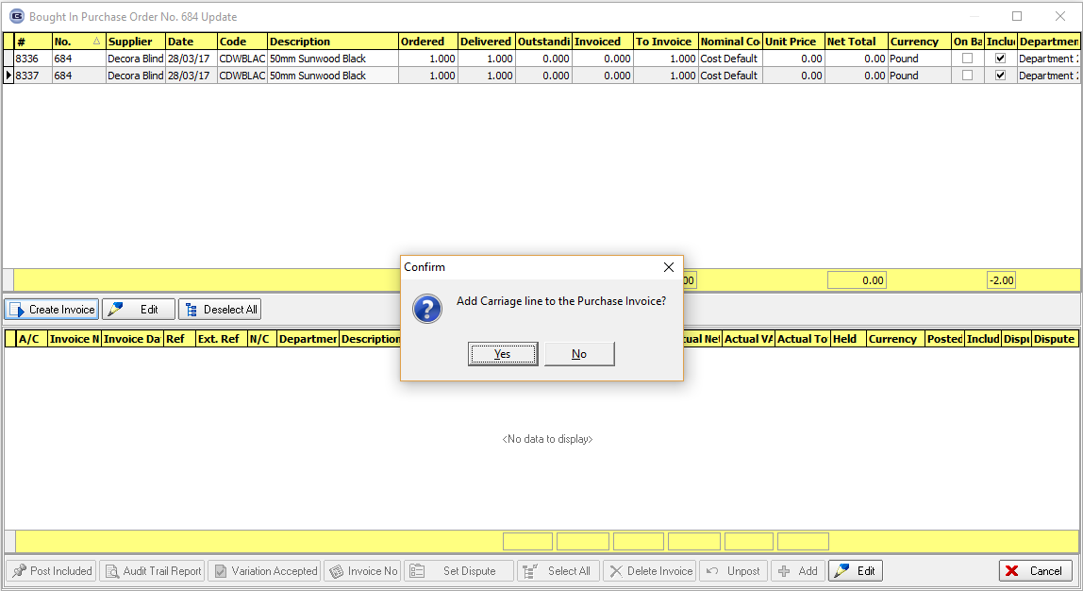

If yes is answered to this, a carriage amount is then taken from the PO or can be entered.

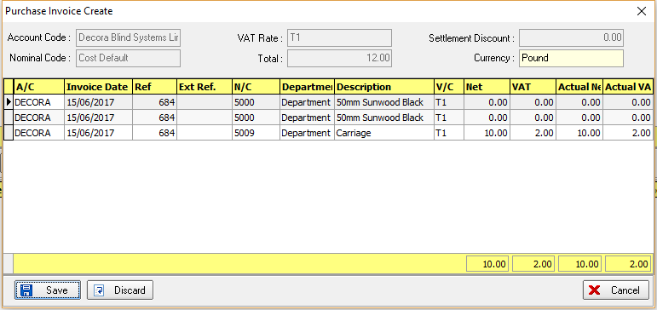

When ‘Save’ is selected here, it is now possible to assign this carriage amount to the sales order or orders that relate to this PO. Therefore another window now appears that says ‘Assign Carriage Cost to Sales Order(s), with choices of ‘Yes’ and ‘No’, default ‘Yes’.

If ‘Yes’ is answered, then the carriage cost is apportioned against the sales orders, with a record or records created in the ‘ExtraCosts’ table for the value entered for Carriage in the PO. This record will then be viewable in the sales order in the ‘Extra Costs’ tab.

There is a new field in System Tables > Cost Price Description called 'Carriage'.
When cost price is added for PO carriage, the system will try to find the record with 'Carriage' = true. This record will then be used in the added Sales Order>Extra costs record.

5433. Purchase Order Enquiry > Update

When a regular PO is created, the detail lines in the PO can be related to sales order records.
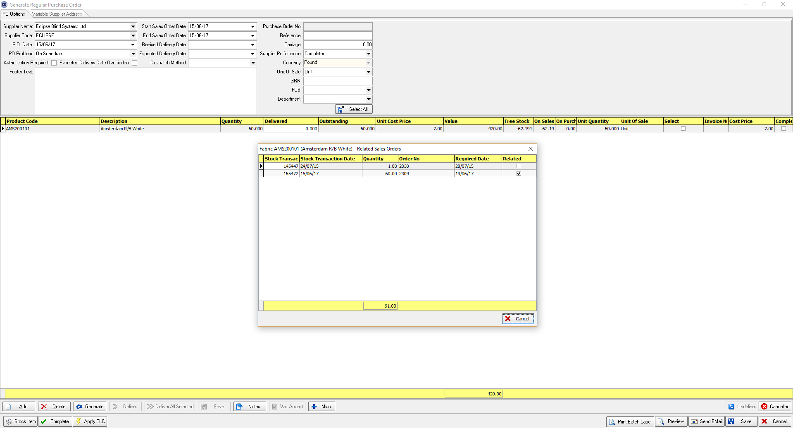

When the purchase invoice is being created from the PO, if the cost price for an item is changed, the user is asked if they want to change the cost price in the stock record.

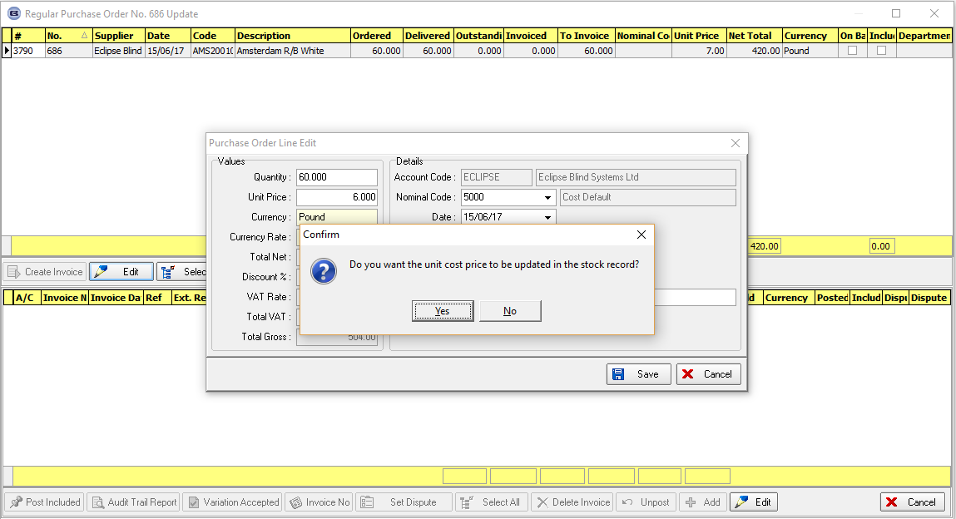

There is now an extra question here: ‘Do you want to update the cost price in the BOM for sales orders related to this PO?’, with choices of ‘Yes’ or ‘No’. If ‘Yes’ is selected, then the cost price in the BOM records is updated and the cost price of the blind recalculated and saved in the order detail line. A flag is also set to true in the BOM record to indicate the cost price has been changed.

5434. Label Print – Bespoke 68

These label prints use the logic in Blind Types > Blind Type Setup > Label Control. We have a situation where a customer may want to print 2 production labels for a blind type. Therefore we will set up 2 ‘Production Label’ records in ‘Label Control’.

There may be cases where they only want to print one label – for example, if there is an option for ‘Valance’ and one of the choices is ‘No Valance’. In this case, only one production label should print.

To resolve this, there is a new flag in the stock record called ‘No Production Label’ which defaults to false. If true, then if any of the options in the production label have this flag set to true, it does not print.

5436. Purchases > Suppliers

There is a new field in the supplier record called ‘Wholesale EDI Account Code’ which defaults to blank.

If a wholesale EDI record is being transmitted, it now checks to see if this field is filled and, if so, uses it, otherwise uses the account code field in Administration > Company Details. See Redmine 2933.

5438. Administration > Parameters

We made a change in dev 5384 (8.4.7.1) so additional items in additional items would be added to the BOM. There is a new parameter called ‘Add Additional > Additional to BOM’ which defaults to false. If set to false it now does what it did before 5384, if true then the functionality in 5384 applies.

5439. Order Processing > Orders > Curtain Detail Line Entry

The fabric selling price (taken from the stock record) is now displayed on this form and is editable, so it can then affect the price (if a formula is used in ‘Square Metre/Linear Width Pricng’). This means this field is now stored in the OrderDetail table.

5440. Blind Details > Blind Types

If blind identifier = Curtain, there is now a default field for ‘Lining Hem Allowance’, displayed beneath ‘Hem Allowance’.

5441. Label Print – Bespoke 64

There is a new label report called ‘Label Print – Bespoke 64’, which is based on ‘Label Print – Bespoke 68’. We then removed order number, order date, due date, and tube cut size.

The fields for customer, location, sidemark and order no are now larger.

