Blindata Release Note 8.5.0 

9 June 2017

Bug Fixes and Enhancements

The following bugs were recorded in www.support.blindata.co.uk and have been resolved.

2885. Invoices not posting to QB when using automated invoice tasks & Sales tax not posting correctly
2886. Automated invoice printing
2897. Invoice
2913. Bug Report: Setting invoice from Posted to invoice printed
2915. Random Window Blind Amend appearing after saving order
2926. Option Price Spreadsheet

New Work and Customer Requests
5358. Order Processing > Orders > Multi Band

We have refined the way that the multi blind order entry works.

If a ‘multi band’ blind type is selected, the number of choices now ranges from ‘2 on 1’ up to ‘8 on 1’.

Once a choice is made, the band width will be calculated by dividing the overall width by the number of bands, . The user then has to select the options as normal. However there will be one option that will only have the choices of IDL, C1, C2.. or DRV. (This option will be identified with a code in System Tables > Option Names eg Band Identifier).

This means we can identify the control side by selecting either IDL or DRV for the first blind.

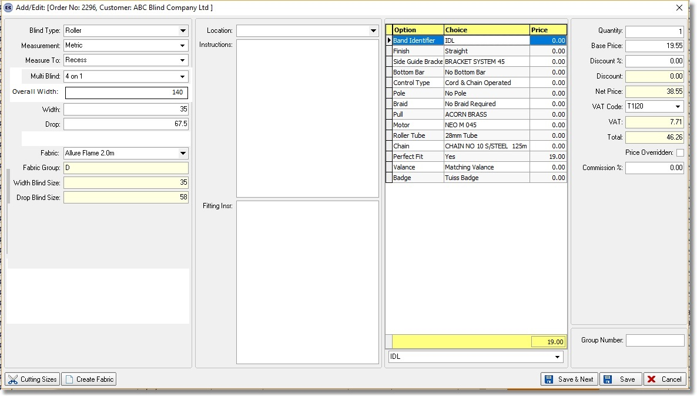

If the user has selected a ‘4 on 1’ blind, and the band identifier option is IDL in the first line, then the second line will have that option set as C1, third as C2 and fourth as DRV. If the lines are generated automatically, these will be filled like this. If the first line has the option as DRV, then the last will be IDL.

This means we can use the link options to select other options (possibly dummy stock items) determined by the band identifier option. Therefore the cutting sizes for each band can be identified using the cutting option ‘Calc From BOM’.

The rules for roll up diameter and tube deflection feasibility will be applied to the individual band detail lines. The torque will be calculated for the entire shade, because now we have a defined BOM for all the bands and the torque calculation will be just an addition of all plus the % or static coefficient for the number of intermediate brackets. This torque value will be checked against the DRV clutch/motor/drive.

If the first line is edited, then all detail lines will be recalculated.

The following needs to be implemented to get this to work properly.

Add a new System Tables>Option Name record with a Code called 'Band Identifier'

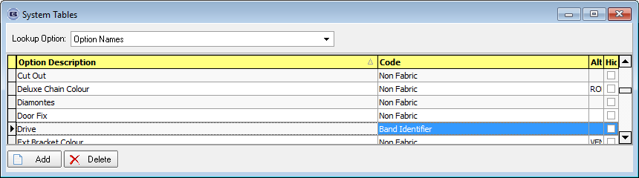

A new integer field has been added to Stock Item>Defaults called 'Band Index', default null.

Three new choices have been added to Stock Item > Special called 'IDL', 'DRV', 'Main'

Operator need to add a new stock item with 'Band Identifier' link option and Special = Main
Operator need to add a new stock item with 'Band Identifier' link option and Special = DRV
Operator need to add a new stock item with 'Band Identifier' link option and Special = IDL
Operator need to add a X new stock items with 'Band Identifier' link option where 'Band Index' should be incremented for each next stock item.
Operator need to add 'Band Identifier' option to Blind Type>Option Setup (for multi blind)

When new multi blind detail will be entered (4 on 1 for example) then 5 new detail lines will be created (1 main detail line and 2-4 multi blind detail lines).
In the first (main) detail line the 'Band Identifier' choice will be selected as point 4 stock item. (Special = Main)
In the 1 multi blind detail line the 'Band Identifier' choice will be selected as point 5 stock item(DRV) or point 6 stock item(IDL) depends on from Blind Type>Option Setup>Option Selection>Default flag

In the 2-3 multi blind detail line the 'Band Identifier' choice will be selected as stock item with Multi Blind Index = detail multi blind index.
In the 4 multi blind detail line the 'Band Identifier' choice will be selected as point 5 stock item(DRV) or point 6 stock item (IDL).

5406. EDI Enquiry > Import

When a client places an online order for blinds and the roller blind requires a join, a message appears saying that a join is required.

When the order is imported it is being placed automatically on customer hold.

There is a new parameter called ‘Fabric Join Exclude From Customer Hold’, and when an order is imported, it will not be placed on customer hold if a join in the fabric is required.

5413. Statement – 8.5 x 11 Standard

A new statement layout has been created which is based on ‘Statement – A4 Standard’. It is page size 8.5” wide x 11” deep.

5415. Invoice – Bespoke 34

The date to the right of ‘Payment Terms’ has been removed from the footer of this invoice.

5418. Order Processing > Orders > Order History

If a user goes into an order but does not change anything and then selects the ‘Save’ button, an order history record is no longer created.

5420. Works Order – Bespoke 34a

If the blind identifier = Vertical, the number of brackets now print on the works order. The number of brackets is set up in Blind Types > Brackets tab.

5421. System Reports > Customer Discount Report

There is now an option to filter out any products with a fabric class on this report. A new criteria flag has been created called ‘Show Fabric Class Records’, which default to true.

5427. Label Print – A4 88m x 14mm

If ‘Show Cord Spacing’ = true in the blind type record, the cord spacing now prints on this label.

