Blindata Release Note 8.5.1 

16 June 2017

Bug Fixes and Enhancements

The following bugs were recorded in www.support.blindata.co.uk and have been resolved.

2966. Feature 1934 - OOS email
2943. Outstanding order report
2956. Delivery Address Override
2964. POST CODES
3007. Torque calculation

New Work and Customer Requests
5409. Sales Files > Customers > Sub Accounts

There is now an option to show prices online for each sub-account. There is a new flag called ‘Hide Online Prices’ which defaults to false. The online site then looks at this flag when determining whether to display prices or not.

5416. Order Processing > Orders > Global

There is now an option to change the ‘Measure To’ field globally.

5422. Invoice – Bespoke 66

The layout has been changed as per the customer specification.

5423. Works Order – Bespoke 34a

If the blind identifier = Venetian, the cord spacing now prints on the label.

5424. Order Processing > Orders > Curtains

If the blind identifier = Curtain, there are now fields in the order detail line entry for:

Left Return
Right Return
Overlap
Hem Allowance
Lining Hem Allowance

Also taken into account are borders on curtains. A border is another piece of fabric (or multiple pieces) that is used in making a curtain so this fabric will be selected from an option choice (The option will have link option = Fabric). It will be possible to select from 1 up to 4 borders.

If the Border Flag is ticked, we then need to record which borders are required and the size of them. The following information is required.

 | Width/Drop
Top Border | 0
Left Border | 0
Right Border | 0
Bottom Border | 200

The screen will then display the roll width and pattern repeat for that fabric (the one chosen in the option section).

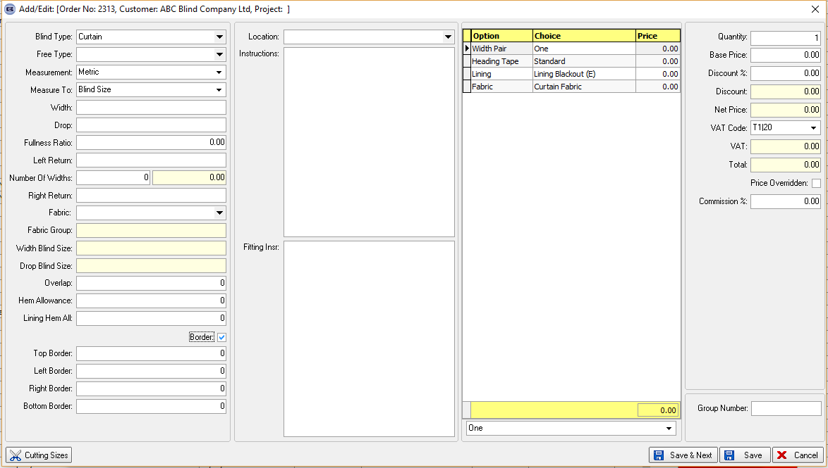

All these new fields have been added as choices in ‘Formula’ in Pricing > Option Price Enquiry > Formula and in Pricing > Square Metre / Linear width Pricing, and in Dimension Calculations > Formula.

5428. Financial Reports > Project Profitability Report

If a cost is entered against an appointment in Orders, this cost now appears in the ‘Project Profitability Report’. This added cost will reduce the overall profit.

5431. Label Print – Bespoke 33B

The order id barcode has been moved up slightly and the gaps in the labels adjusted.

