Blindata Release Note 8.4.6 

12 May 2017

Bug Fixes and Enhancements

The following bugs were recorded in www.support.blindata.co.uk and have been resolved.

2600. Total Fabric Length calculation - re Feature 2051
2708. Re: Missing Number Of Brackets On Tickets
2746. Bottom Weights Link Option Not Exporting to Vertical Opt Export File
2750. Pricing > Option Price Enquiry > Export To Excel
2758. Date format

New Work and Customer Requests
3668. Curtains

‘Roll Width’ and ‘Pattern Repeat are now field choices in order entry if the blind identifier = ‘Curtain’. This defaults to the roll width and pattern repeat of the fabric selected but can be changed in the detail line.

5371. Square Metre / Linear Width Pricing

There is now a field for ‘Formula’ in the square metre / linear pricing screen. This is to enable the following formula to be used for curtain pricing.

(Window width * fullness ratio / roll width) rounded up to next integer * (((Drop + hem allowance)/Pattern repeat) rounded up to next integer)*Pattern repeat.

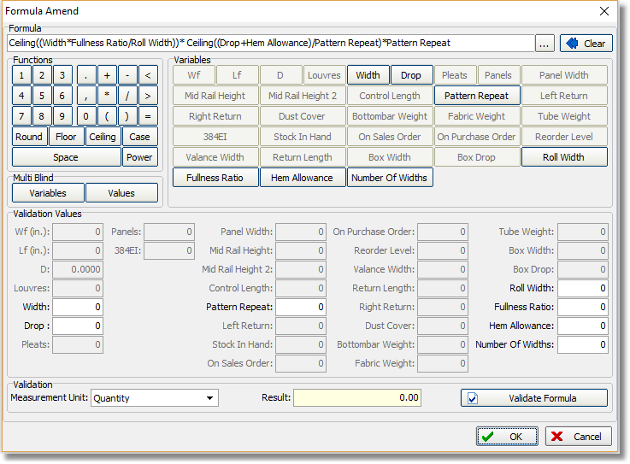

5373. Order Enquiry > Blind Process Scan

There is now an option to scan either one process or another.

We have a customer that has two different fabric cutting machines. They have set these up as processes ie ‘Machine 1’ and ‘Machine 2’. When a blind process scan is done for a blind, it will be done for one or other of the machines, but not both.

To achieve this, there is a new system table called ‘Process Group’. A record can be entered here, and then a new field in Blind Types > Man Process Types called ‘Process Group’ can be updated. If the same process group is applied to two different processes, then only one of them has to be scanned.
0516345
5374. Mertex Credit Control Checking

1. Credit Check for a new order
Once a new order has been saved, Blindata now credit checks the order against the excel Stop List, using the existing logic, with the following amendments:
The Customer Account is not put on Credit Hold if the order fails the check.
If an account code is not found on the Stop List, or the Stop List cannot be found (e.g. deleted), the order being credit-checked is put on credit hold.

2. Credit Check for an existing order
For an existing order, if it is opened, changed and saved, Blindata only credit checks the order if:
There has been an increase to the “Net Total” of the order
The increase in the Net Total exceeds a pre-specified threshold.
It is possible to set and change the pre-specified threshold in the Blindata Parameters.

3. Error message re Web Service URL
Blindata is giving us an error message each time an order is credit checked, relating to the Web Service live credit check into Mertex. If the “Accounting System” selected is Mertex:

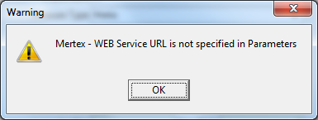

Disabled this warning if “Credit Control Spreadsheet Location” has been specified.
Enabled this warning if “Credit Control Spreadsheet Location” has not been specified.

5375. Order Processing > Orders On Credit Hold

The ‘Products’ field is now a column choice on this form.

5376. Administration > Parameters > Online

There is a new parameter called ‘Forgot Password Text’ in Administration > Parameters > Online. It is possible to hold a hyperlink in here so an email can be sent.

We also added a ‘Forgot Password Text’ area to the Online tab. If user presses the Pen icon at the left top corner you will see a HTML editor. If you press the Chain icon then you will see a Create Hyperlink window. For example above user should enter the following data to fields:
- Text:
Forgot your password? Contact our Customer Service Department on 028 9049 3999 or email sales@ball-software.com
- URL:
mailto:sales@ball-software.com?subject=Forgot Webtex Password&body=Test%0D%0AEMail%0D%0ABody
- Target: _self.
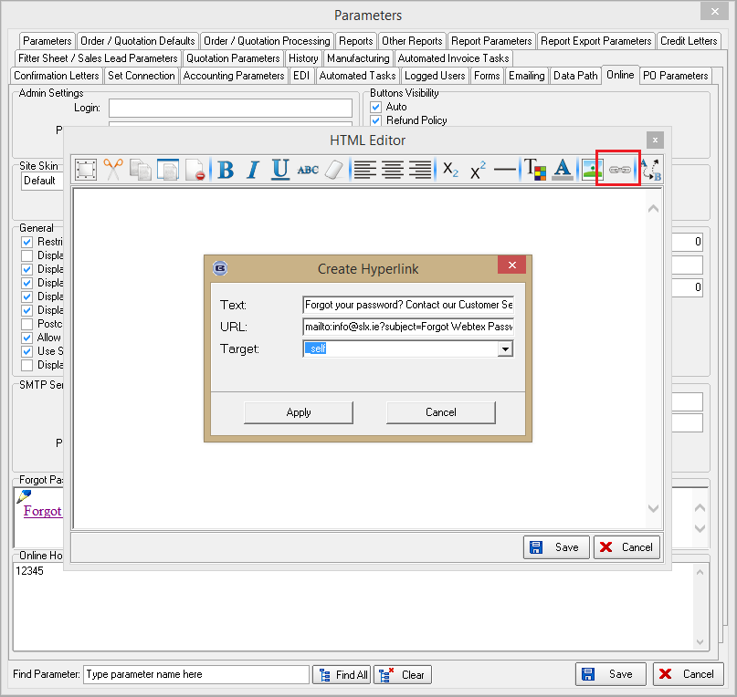

The customer is then requested to to fill the email body and subject by default. If you look at URL above you will see the following attributes:
- mailto: - this is email address where Email will be sent.
- ?subject= - this is email subject. All text after this attribute will be used as Email subject
- &body= - this is email body. Any text could be entered here. For line breaks ‘%0D%0A’ sequence should be used.

5377. Administration > Parameters > Online

There is a new flag for ‘On Customer Hold’ in the ‘Order Columns Visibility’ section.

5378. Works Order – Bespoke 42

For blind identifier = Roller and Austrian/Roman and Curtain, the ‘Total Fabric Required’ now print. The existing logic applies to all other blind identifiers.

5379. Order Processing > EDI Import

The EDI import now calculates the number of brackets on the tickets from the field table In Blind Type > Vertical Blinds > Brackets. This currently works if the order is entered manually. This dev item relates to Redmine 2708.

5380. Financials > Invoice Batch Print

There is a new field in the Department > Email Texts tab record called ‘Email Invoice Text’. Also the subject line in the email says the invoice comes from the department name and not the company name from Administration > Company Details. Please note that ‘Get Company Details from Department’ in Report Parameters must be switched on.

5389. Label Print – Bespoke 33B

The types of blinds (1 S25,1R,1DUO) are now printed in the line to the right of ‘Required Date’ and the customer order number is displayed in the line above the delivery information.

5393. Label Print – Bespoke 70

Some minor modifications have been made to this label.

5394. Acknowledgement – Bespoke 70

Some minor changes have been made to this report.

