Blindata Release Note 8.4.2 

18 April 2017

Bug Fixes and Enhancements

The following bugs were recorded in www.support.blindata.co.uk and have been resolved.

2029. Fitters Sheet Address Field Amendment
2118. Venetian Opt Export File - additional field
2392. Xero CSV File Date Adjustment
2567. Global change 'issue'
2568. Multiple Vendor in PO
2571. Pricing
2576. PO Label print
2586. Tube Deflection - Admissible Deflection
2600 - Total Fabric Length calculation - re Feature 2051

New Work and Customer Requests
5321. Reports > System Reports Employee Efficiency Report

There is a new report called ‘Employee Efficiency Report’. This shows the % efficiency, according to the total of the process * minutes worked compared against the hours worked. There is criteria for start and end date, by employee.

The ‘Hours Worked’ are taken from Employees > Working Hours, and the number of Processes Completed and Process Minutes taken from the ProcessTransactions table.

5333. Financials > VAT > VAT Reports

The VAT report now takes into account EC Vat sales.

There are two new flags set up against the VAT code, called ‘EC Sales’ and ‘EC Purchases’.

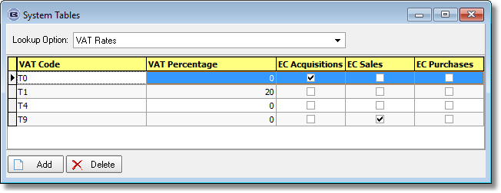

The VAT return form (in Company > Financials > VAT) has been changed.

- The ‘Total value of sales, excluding VAT’ and ‘Total value of purchases, excluding VAT’ now include the sales for VAT codes where ‘EC Sales’ and ‘EC Purchases’ are flagged respectively).
- There are two new rows, which only show the value of EC Sales and EC Purchases.

The VAT Return has been changed so it has the above fields in it.

5343. Stock Control > Reports > Box Blinds WIP Not Validated

There is a new report that shows all stock items (box blinds only) that have a status of WIP but have not yet been validated (in Order Enquiry > Pick List Validation). This has columns for stock code, stock description and quantity.

5345. Acknowledgement / Quotation / Invoice – Bespoke 31

The logo and header now only appear on the first page of these documents.

5346. Stock Control > Stock Transaction Entry

The ‘Reorder Level’ for the stock record now appears in this form, beneath ‘On Purchase Order’.

5347. Administration > Users > Printers

There is new a default choice to print Purchase Order Labels (option in purchase order enquiry).

5348. Purchases > Purchase Order Enquiry

There is now a Ctrl/U shortcut to get to the ‘Purchase Order Enquiry’ form.

5350. Order Processing > Orders > Global

There is a situation for some customers in the USA where they may have a tax code (VAT code) set up against a customer eg for 8%, but that in certain situations there will be no tax on a quotation/order/invoice. But they still need to record the sales tax code as being the 8% code.

The following solution has been agreed on.

There will now be two sales tax codes set up for specific tax codes e.g. NY NYC at 8% and NY NYC0 at 0%. The default can then be set up against the customer.

If ‘Post Sales Tax Code to Quickbooks’ is switched on, there is a new field in System Tables > Sales Tax Codes called ‘Quickbooks Tax Code’, which allows duplicates. When a sales invoice is posted to Quickbooks and this flag is switched on, it posts the ‘Quickbooks Tax Code’ instead of the existing tax code.

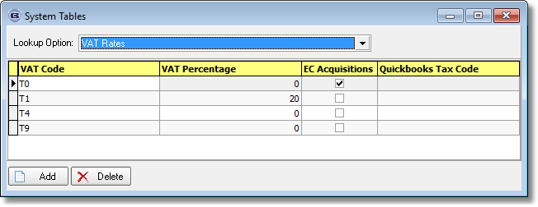

Secondly, we need to be able to change the Sales tax/VAT code in a quotation or order. At the moment it can only be done at detail line level. Therefore there is now functionality so this is done in the ‘Global’ function. If a tax code is changed, all the detail lines are recalculated. When entering an order, the tax code will default to the one set up against the customer. However if ‘Use Blind Type Sales Tax’ is switched on in Parameters, this field is not displayed.

5351. Administration > Company Details > Email Texts

[Department] has been added as a choice of field to select.

5352. Import From Excel > Stock Code Cutting Sizes

The field ‘Measure to’ has been added to the ‘Cutting sizes by BOM’ import routine.

5353. Administration > Export Data

There is now an option to export the cutting options held against all stock codes. This file is in the same format as Import From Excel > Stock Code Cutting Sizes.

5354. Acknowledgement / Quotation / Invoice Bespoke 70

When "Hide Disc % on documents" is checked: only the net price column of prices now prints. The columns: Disc % , List Price are hidden. The options prices, Options total, and Unit price are hidden.
When "Hide Disc % on documents" is checked Net Prices for components now print.

5355. Delivery Docket – Bespoke 67

For miscellaneous orders, the detail section has been changed.

5356. Label Print – Bespoke 67

- Special instructions now print on this label.
- The font for the fabric description is slightly smaller.

5357. Works Order – Bespoke 67

- More room has been made available for the fabric description.

5365. Works Order Label 210mm x 200mm

The barcode has been moved left by 10mm because it was partly printing on the label at the moment.

The actual label text has been moved left by 5mm.

