Blindata Release Note 8.4.0 

31 March 2017

Bug Fixes and Enhancements

The following bugs were recorded in www.support.blindata.co.uk and have been resolved.

1992. Works Order Label A5
2051. Works Order Label 210mm x 200mm
2220. Bespoke 33B
2460. order printing
2464. order Acknowledgement Email Subject
2485. New release

New Work and Customer Requests
5312. Order Processing > Global Search

There is now functionality to find an order in ‘Global Search’ by looking for the blind id or the serial id.

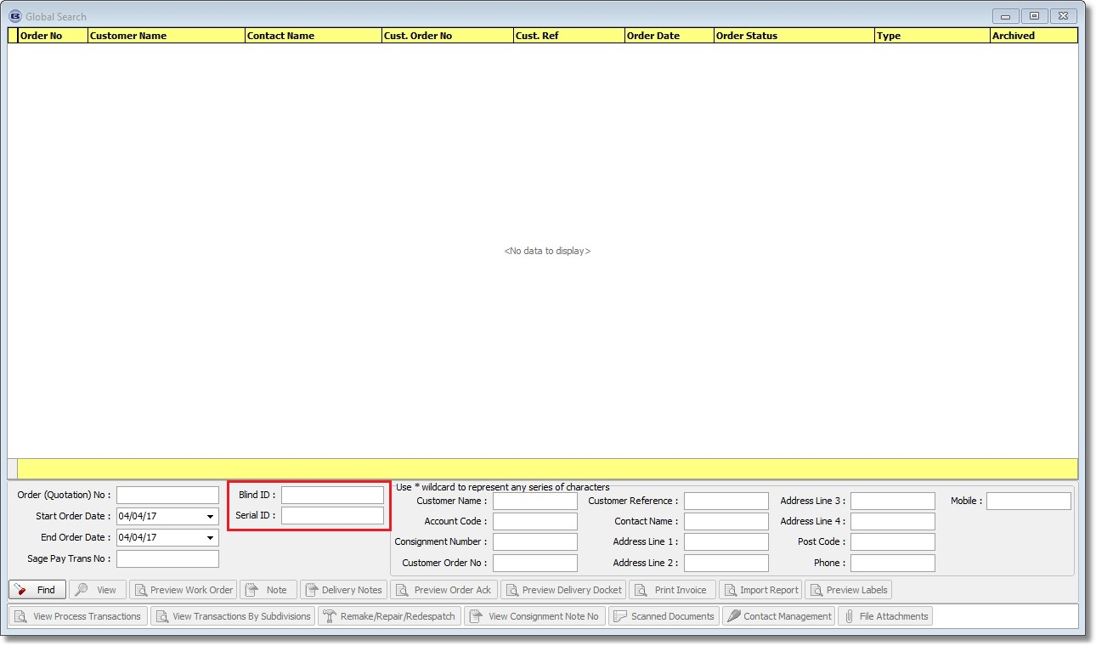

5313. Pricing > Vanes Price Table

At the moment we can hold prices for blind types with identifier = Vanes Only or identifier = Curtain. The problem with curtains is that the width price may be different depending on the number of widths. Therefore if the blind type selected has identifier = Curtain, there is now another column in the table for ‘Number Of Widths’.

Then when the price lookup is done from the order detail line entry, the number of widths forms part of the lookup.

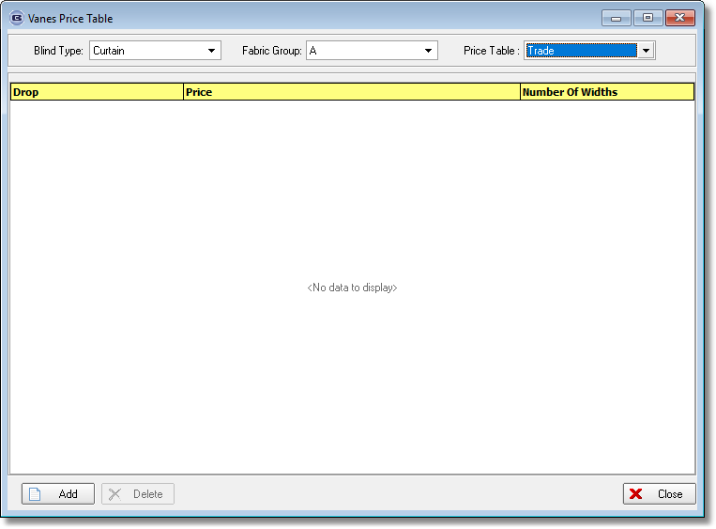

5314. Pricing > Number Of Vanes Pricing

The same principal as 5313 has been done for the option pricing by widths.

5315. Delivery Docket – Bespoke 52

The detail section has been replaced with the detail section from ‘Acknowledgement – Bespoke 52A’.

5316. Label Print – Bespoke 33B

The cord spacing field has been moved so it prints before the cutting sizes.

5318. Order Enquiry > Blind Process Scan

There is now a button to the right of the Employee lookup called ‘Today’. This will then show the processes that have been completed by the employee selected for the current day, along with a total. This button has an advanced permission flag.

5328. Sales Lead Estimate Sheet

The mobile number now prints underneath the tel number on the left hand side of the header section. Although this takes the mobile number from the sales lead, it says ‘Tel 2:’ in front of it.

5329. Fitter Worksheet

If blind identifier = Velux, the Velux code now prints on this report, in the detail line.

5336. Works Order Label 210mm x 200mm

For all blind types, the chain length is now in mm (if ‘Use Measurement in Work Order Label = Metric).

See other changes in Redmine 2051.

5339. Quotation / Acknowledgement / Invoice – Bespoke 70

The following changes have been made to all of these reports:

When Hide disc % on documents is checked, component prices are now printing and the Net prices column does not print for blinds.

When ‘Hide Disc. percent’ is checked:
Only prices in the net column print, option prices & Unit Price do not print. The unit price column header (which has been changed to ‘List Price’) is also hidden.

Increased the space for the ‘Net’ Price column to allow 7 characters to print.
Changed ‘Measurement’ to ‘Measure’.
Column header ‘Unit Price’ has been changed to ‘List Price’.
Below ‘Options Total’ is ‘Unit Price’ - the price calculated here is correct. The label ‘Unit Price’ has been removed.
5) When ‘Hide Sales Tax on documents’ is checked: only the net price column of prices prints. The columns Disc % , List Price are hidden. The options prices, Options total, and Unit price are also hidden.
When ‘Hide Sales tax on documents’ is checked Net Prices for components now print.
When ‘Show Deposits and balance for trade invoice’ is checked then deposits and balance due now print at the bottom of the Acknowledgement and invoice.
If the customer does not have ‘Hide Sales tax on documents checked’ then the balance due is calculated as the Gross amount of the order, including sales tax less the amount of any deposits applied to the order.
If the customer does have ‘Hide Sales tax on documents checked’ then the balance due is calculated as the net amount of the order less any deposits applied to the order.
Payment Terms are now printing in the footer.

5340. Reports > Outstanding Balances

Orders with the status ‘Part Posted’ are now included in this report. This is in addition to the following rules.

- Order Status is Despatched, Invoice Created or Invoice Printed.
- Order > Balance is greater than 0.
- Order > Invoice Hold = FALSE.
- Order > Exclude Retail Balances = FALSE.
- Customer > Trade Type = Retail (Including Tax).

