Blindata Release Note 8.3.8 

17 March 2017

Bug Fixes and Enhancements

The following bugs were recorded in www.support.blindata.co.uk and have been resolved.

2149. Delivery day prints next to Dispatch method
2355. Sales tax rate by zip code not updating for components

New Work and Customer Requests
5222. Automate Cut Length Charge

The cut length charge functionality has been improved.

Each time a user presses ‘Apply CLC’ button new CLC charges are added. It now deletes the cut length charges and re-applies them.

There is a new parameter in the supplier record called 'Apply Cut Length Charges at PO Save'. This defaults to false - if true the 'Apply CLC' button in the ‘Generate Regular PO’ form is hidden, and the cut length charges are applied when the PO is saved.

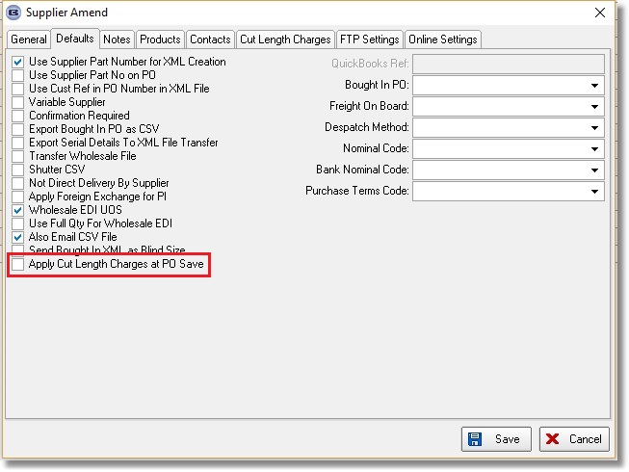

5224. PO XML Bought In

There is a new flag held against the supplier called ‘Send Bought In XML as Blind Size’ which defaults to false. If true, the sizes in the XML file are now in blind size.

A new tab for ‘Defaults’ has been created in the supplier form and all flags moved to there.

5257. Order Processing > Orders > Duplicate Message

Previously if ‘Disable Duplicate Cust Ref Check’ or ‘Disable Duplicate Cust Ord No Check’ is false in Administration > Parameters and a duplicate of either of these is entered, it just says there is a duplicate. It now also displays the order number, order date and products field for the existing record. The message says ‘The following duplicate [cust ref/cust ord no] has been entered: order number, order date, products.

5259. Quotation – Bespoke 31

The number of slats now prints on this quotation. This only applies to blind identifier = Venetian. The 'No Of Slats' appears to the right of 'Install Height'.

5261. Administration > Parameters Online

Notes in the Characteristics field now appear in the online order detail entry in the same way as they do in the desktop order entry. The notes that are held in Blind Types > Images > Notes also appear. There is a parameter for this in Parameters > Online called ‘Display Notes In Detail Line Entry’, which defaults to false.

5263. Purchase Order Enquiry

There is a new column called 'Order Entered By' in Purchase Order Enquiry. This is the operator who entered the PO.

5296. Order Processing > Orders > Detail Line Import

At the moment it is possible to import detail lines into an order. However the option defaults that get set for these may not be correct, since we created the functionality for roll up diameter, tube deflection and torque calculation.

There is a new parameter in Administration > Parameters > Order/Quotation Processing called 'Import Torque Etc Validation'. When the ‘Import’ button is used in Orders, it will then employ a function that will run through all the detail lines on the order and check roll up diameter, tube deflection and torque (if the flags are switched on in the blind type record).

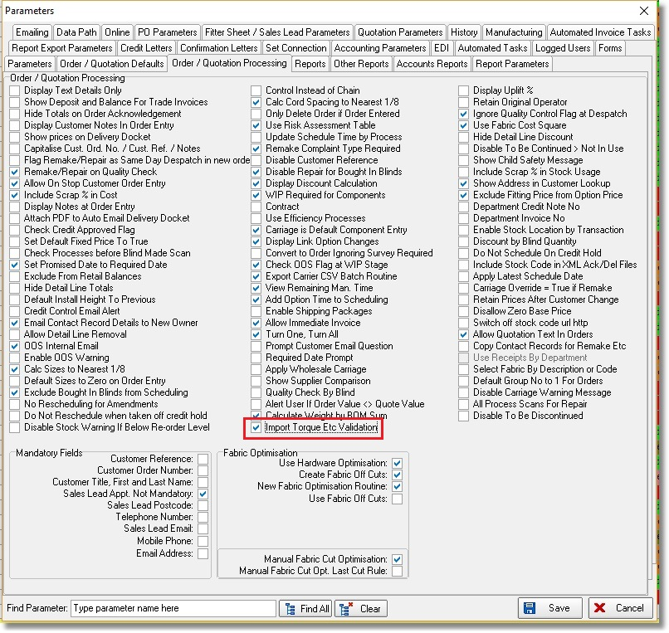

5302. Sales Files > Customers

There is a new flag in the customer record called ‘Hide Disc % On Documents’, which defaults to false. If true, it sets the ‘Hide Detail Line Discount’ flag to true in the order.

5303. Acknowledgement – Bespoke 70

- There is a column for ‘Disc %’ on this report.
- The options have been moved left to make room for the disc % column.
- The text ‘Unit Price’ has been removed.
- If ‘Show Deposit and Balance For Trade Invoices’ = true in the Totals tab, then the deposit and balance now print.

5304. Quotation – Bespoke 70

The changes in 5302 have been made in this report.

5305. Invoice – Bespoke 70

The changes in 5302 have been made in this report.

5306. Order Processing > Orders > Receipts

If Quickbooks accounting is switched on, there is now no need to enter a tax code in the receipt entry.

