Blindata Release Note 8.3.7 

10 March 2017

Bug Fixes and Enhancements

The following bugs were recorded in www.support.blindata.co.uk and have been resolved.

2275. Invoice VAT breakdown incorrect - invoice transfer to Styleline
2303. Label Print - Bespoke 70
2291. Dual Screens
2292. Advanced Spacer Selection
2296. Acknowledgement – Bespoke 70
2304. Works Order – Bespoke 70
2305. Order Processing>Order Enquiry Status field button

New Work and Customer Requests
5221. Suppliers > Surcharge %

There is a new field in this form called ‘Surcharge %’, which default to 0. When the bill of materials is generated the cost price is multiplied by the surcharge %. Also if a regular purchase order is created, the cost price is also be uplifted by the surcharge %.

5226. Stock Control > Currently Not In Use

There is a new flag called ‘Currently Not In Use’ in the stock record.

There is a new criteria in Stock Control > Reports > Stock Valuation, called 'Include Currently Not In Use' which defaults to true. If set to false it will exclude all the stock items where 'Currently Not In Use' = true.

5244. Administration > Accounting Utilities

If ‘Quickbooks Accounting’ is switched on, there is an option for ‘Create/Update Customer Details Into Quickbooks. This checks the department to make sure it is updating the correct Quickbooks company.

5270. Administration > Users

There is a new advanced permission for users so they cannot see cost prices or suppliers. The user is still able to edit a stock record but not see cost prices or supplier (in General tab or other tabs).

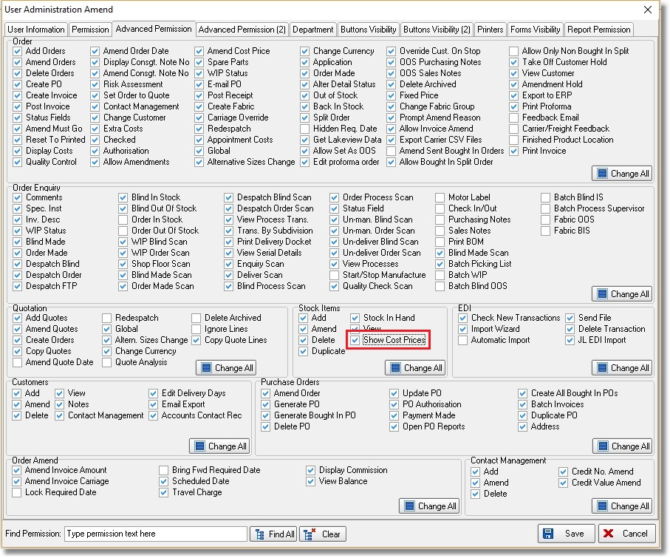

5274. Works Order – Bespoke 70

- Moved options and cutting sizes to right
- Extended the special instructions field right
- Insert ‘Fitting Instructions’.

5279. Emailing By Department

If email text is being picked up from the department record, the subject line now gets the company name from department.
The first letter of all words is now in upper case, currently “cust ref” is the only thing lowercase.

5280. Stock Control > Stock Items

At the moment there is an ‘Allow Horizontal Join’ held against the blind type record if the blind identifier = Roller. This flag is also available in the stock record if the blind identifier = Roller and the link option = Fabric.

The order detail entry now checks the fabric record to see if a horizontal join is allowed. If it is set to true in the blind type, then it will apply to all roller fabrics. If it is set to false in the blind type, then it will check to see if it is true in the fabric record.

5281. Stock Control > Fabric Group Setup

It is now possible to update the ‘Allow Horizontal Join’ in this form.

5283. Mandatory Group Number

There is a new field in the customer record called ‘Mandatory Group Number’, which defaults to false. If this is set to true, then the group number is mandatory in the quotation/order detail line entry.

5284. Sales Files > Customer Update

‘Mandatory Group Number’ is now a field that can be updated here.

5286. Order Processing > Orders > Location

If the lookup is switched on for ‘Location’ in the order detail entry, it is now possible to edit the existing locations in this form.

5287. Order Processing > Orders > Detail Line Entry

We have a number of customers who do not like the wider order detail line entry form.

There is a new parameter in Administration > Users called ‘Lessened View of Order Detail Screen’. If set to true then the central part of the order detail screen is hidden and add ‘Location’, ‘Instructions’ and ‘Fitting Instr’ are moved to the left side as simple controls.

This means individual users can set up the width of this form to suit themselves.

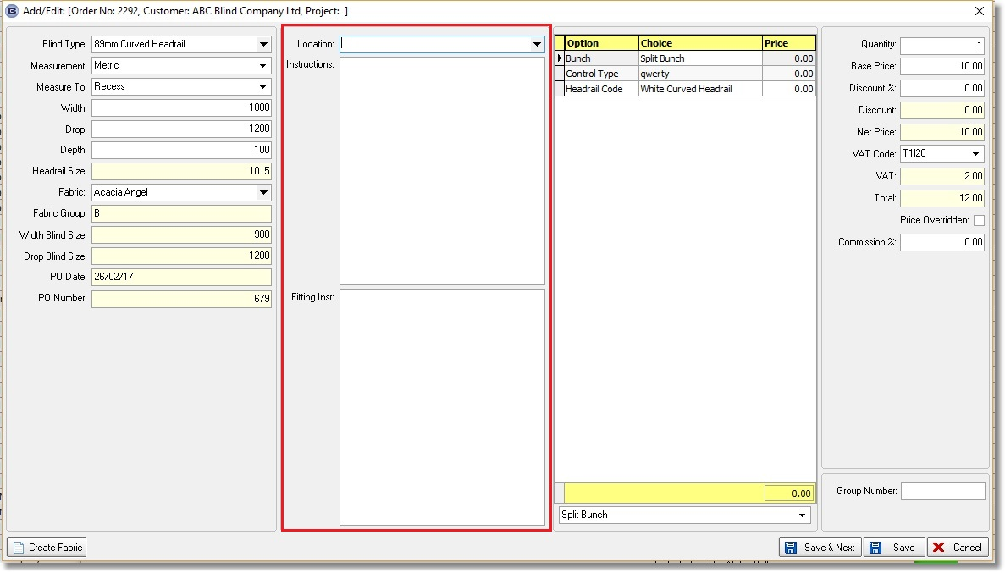

5288. Administration > Users

There is a option to ‘Copy Permissions’ from one user to another. There is now another button here called ‘Copy Column Choices’ which will copy all column choices for forms from one user to another.

5291. Invoice – Bespoke 70

There is a new invoice layout called ‘Invoice – Bespoke 70’. It has the same layout and rules as ‘Acknowledgement – Bespoke 70’, but also print the invoice number and the invoice date (instead of order date) in the header.

It takes the company details in the header from the department record and not from the ‘Company Details’ table.

It also takes into account the ‘Show Widths/Drops On Documents’ and ‘Hide Sales Tax On Documents’ customer parameters into account.

5293. System Tables > Departments

There is a new field in the department record called ‘EDI Account Code’ which defaults to null. If this field is filled, when a bought in PO EDI record is created, it uses this field instead of the ‘Account Code’ that is held in Administration > Company Details.

5294. Stock Control > Stock Items

There is a new flag in the stock record called ‘Out Of Stock’ which defaults to false. If this flag is set to true, then when the fabric is chosen in the order detail line, a message appears saying ‘This fabric is currently out of stock so there may be a delay in delivery’.

This has also been applied to specific online ordering sites.

