Blindata Release Note 8.3.6 

3 March 2016

Bug Fixes and Enhancements

The following bugs were recorded in www.support.blindata.co.uk and have been resolved.

2000. Emailing Order Ack
2175. Blindata Creation of New Calendar in Outlook 365
2190. Extra delivery sheets and packing slips reprinting with batch printing
2237. Channel Islands
2245. Are not being allowed to change Shade Position option
2256. Over riding price

New Work and Customer Requests
5206. Stock Items > Cutting Sizes

There is a new field in Stock Items > Cutting Sizes for ‘Measure To’ which will check the ‘Measure to’ in the order detail line. In the BOM if the stock item has a cutting size related to it, it will check to see if the ‘Measure To’ matches the one held against the cutting size.

If there is no ‘Measure To’ held against the cutting size, the existing functionality remains.

5255. Order Processing > Orders

The message that appears when the roll up diameter roll up diameter test fails has been changed.

It now specifies the option selection that contained the max valance diameter that was less than the roll up diameter,

It recommends changing the option selection to another that has a max valance diameter greater than the roll up diameter.

5256. Import From Excel > Stock Code Cutting Sizes

The ‘By Quantity’ field can now be imported.

5264. Production List > Box Blind Picking List

This report now only shows records where box blind = true and blind identifier = Wood.

The report is now sorted by customer then order number.

There are now columns added for colour and the ‘Blind no’ column is "1of X" and not blindID.

5272. Purchase Order Enquiry > Amend (Bought In)

There is now a ‘Notes’ button so notes can be added against individual blinds. This then opens a window (same as regular PO) so the user can type in text.

5273. Purchase Order Bought In - 8.5 x 11

The notes field that has been added in now appear on this report (below options).

5275. Order Processing > Orders

There is a new flag in the ‘Totals’ tab called ‘Price Total by Group.

5276. Quotation – Bespoke 70

If the new flag ‘Price Total By Group’ is switched on, the prices can be shown by total for each group.

5277. Acknowledgement – Bespoke 70

If the new flag ‘Price Total By Group’ is switched on, the prices can be shown by total for each group.

5278. Purchase Orders > Delivery Address

There is a new button on the ‘Purchase Order Enquiry’ form called ‘Address’. There is a flag to switch it on in Administration > Users > Button Visibility(2).

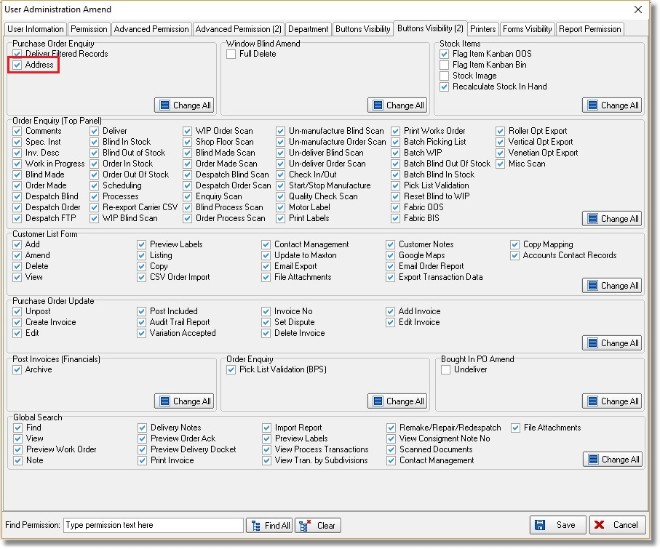
The address flag in Administration > Users > Advance Permission also needs to be switched on.

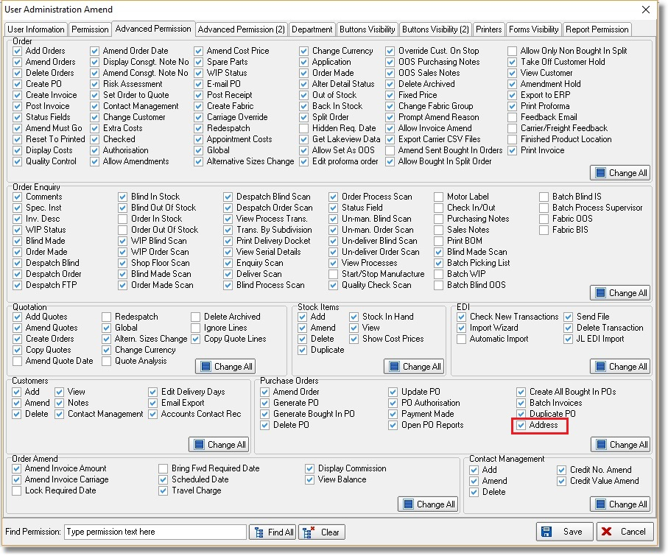

If these flags are switched on, it means the PO address for a PO can be amended by clicking on this button.

5290. Sales Files > Customer Update

There are now field choices to update ‘Trade Price Table’ and ‘Save Trade Price Record’.

5292. Invoice – Laser Print 11 Detail Lines

There is a new report parameter called ‘Get Company Details From Department’ in Parameters > Report Parameters.

If this is switched on, the company name, address etc will be taken from the department record instead of the ‘Company Details’ record.

