Blindata Release Note 8.3.3 

10 February 2016

Bug Fixes and Enhancements

The following bugs were recorded in www.support.blindata.co.uk and have been resolved.

1864. Sales Analysis Periodic Summary outputs incorrect
2005. Blind Change to WIP in Order Enquiry
2006. Online Portal
2026. Despatch Label Amendment
2027. Xero csv file
2052. Stock in Hand
2103. Stock Control > Stock Items
2104. Post Invoices > Mertex Export File

New Work and Customer Requests
5205. Label Print – Bespoke 33A

If ‘Box Blind’ = true in the blind type record, ‘No of slats’ no longer prints on this report.

5216. Order Processing > Orders > Post Receipts

This is relevant if Blindata accounting is switched on.

If something is entered in the ‘Lodgement No’ in the receipt record in the ‘Receipts’ tab in order entry, it is now updated into the ‘Ref’ field in the SR record.

5217. Sales Files > Reports > Customer Transaction Report

There is now criteria for Customer Class in this report.

5218. System Tables > Customer Class > Statement Flag

There is a new flag in the ‘Customer Class’ record called ‘Exclude From Statement’ which defaults to false.

If it is set to true, then a statement (in Sales Files > Reports > Statements) does not print for customers in that customer class.

5220. Administration > Parameters > Online

There is a new field in this form called ‘Online Holiday Message’. This message will then be displayed in certain online sites instead of the hardcoded message which currently appears occasionally (and we have to change each holiday time).

5228. Works Order – Bespoke 33B

A number of layout changes have been made to this report.

5229. Despatch Docket – Bespoke 64

The ‘Finished Producr Location’ now wrap round onto two lines.

If a component detail line has been entered, the Comments and Instructions field now print on this report.

5230. Works Order – Bespoke 64

The ‘Sidemark’ (Customer Reference) now prints underneath the customer.

5231. Post Sales Invoices To Quickbooks

There are two new parameters in Parameters > Accounting Parameters (if Quickbooks is switched on).

Post Cust ord no to PO number.
Post Cust Ref (Sidemark) to Memo.

If these are switched on, then these fields will be updated when sales invoices are posted.
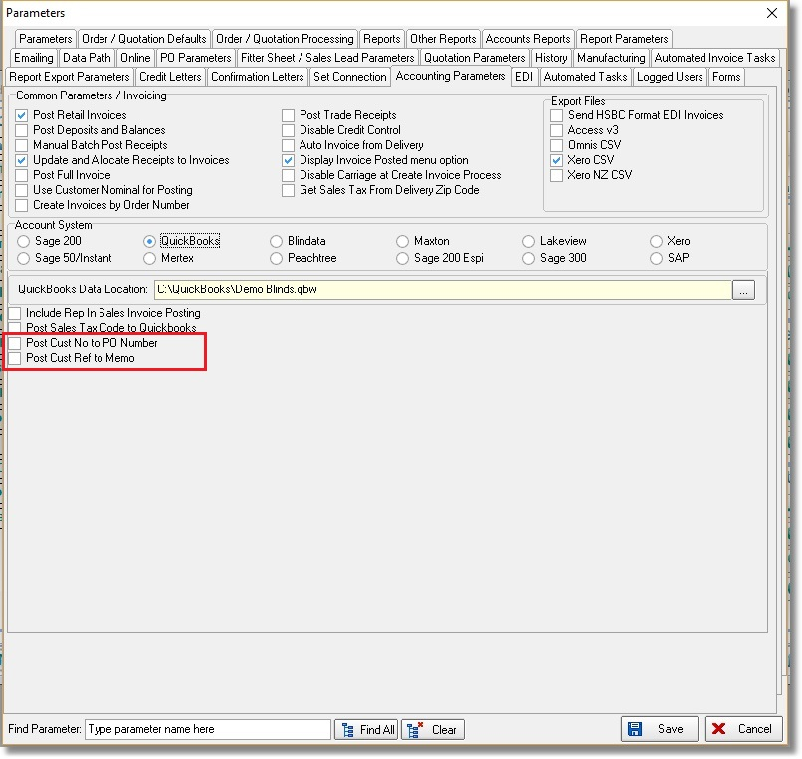

5237. Reports > System Reports > Man Process Types Barcodes

If a record is ticked as ‘Misc Scan’ in System Tables > Process Types, it now prints in this report.

