Blindata Release Note 8.2.7 

30 December 2016

Bug Fixes and Enhancements

The following bugs were recorded in www.support.blindata.co.uk and have been resolved.

1865. Optimisation Export File Amendments
1868. Issue with UPS XML File structure
1871. Acknowledgement - Bespoke 67
1877. Chain Length in Inches to Millimeters

New Work and Customer Requests
5134. Stock Control > Stock Transaction Entry

If ‘Use Stock Nominal’ is switched on in Parameters > Accounting Parameters, the following changes have been made.

1. A nominal transaction is also posted for fabric when stock is "Received" (Batch number is required, order# is must)

Inventory - Debit
COS - Credit

2. A nominal transaction is posted for all other stock items, when stock is "Received" or "issued" (Order# is optional)

Receipt
Inventory - Debit
COS - Credit

Issue
COS - Debit
Inventory – Credit

See specification document 5134.Stock adjustment.docx

5147. Order Processing > Quotations

Location should be an entry field in the quotation text entry.

5152. Multi Blind Torque Calculation

The torque calculation for a multi blind is different to that for a normal blind. If it is for a roller blind, the tubes are connected and os there will only be one motor. For a 1 on 1 blind, the torque calculation will be the same as a normal blind.

For each extra blind, the torque required will increase by a percentage. Therefore we need to hold a table for ‘2 on 1’, ‘3 on 1’ etc. The table is a tab in the blind type record (to be shown if ‘Check Torque’ and ‘Multi Blind Choice’ are both selected). There are two fields for entry – ‘Multi Blind Choice’ and ‘Torque % Increase’.

The torque calculation is only done once for the multi blind.

5154. ZIP Codes / Tax Rate

There is a new system table called ‘ZIP Code Tax Rates’. This has three fields: id, ZIP code (alphanumeric) and Tax Rate. The ‘Tax Rate’ looks up the Sales Tax Code (VAT code).

There is a new parameter in Parameters > Accounting Parameters called ‘Get Sales Tax From Delivery Zip Code’. This is only be visible if the Postcode/Zip code is set to ‘US Zip code’.

If this parameter is switched on, the sales tax code for the quote/order is taken from the Zip code that is entered for the delivery address ie it should find the sales tax code by looking in the ‘Zip Code Tax Rates’ table.

5158. Acknowledgement – Bespoke 67

See Redmine 1871.

5159. Works Order – Bespoke 67

The footer only appears on the first page of the report.

5160. Bought In / Manufactured Blinds

We have a customer that runs four companies and are going to have all four in Blindata, set up as different departments.

Company A is a retail company ie they sell blinds but do not manufacture any blinds themselves. Company B will manufacture some of the blinds for them and others will be manufactured by outside vendors.

All four companies will use the same blind types. When company A enters an order for a roller blind, they want to create a bought in PO for this roller blind. The vendor will be company B. The plan is that they create an EDI bought in PO, which is sent to the ftp server. It will then be imported as a sales order for Company B (the customer being Company A). This means there will be two sales orders on the system. The blinds will be made by Company B and then delivered to Company A.

The problem is that they are both sharing the same blind type. For Company A it is a bought in blind, but for Company B it needs to be a ‘Stock control’ blind. At the moment the blind type can only be set as one or the other.

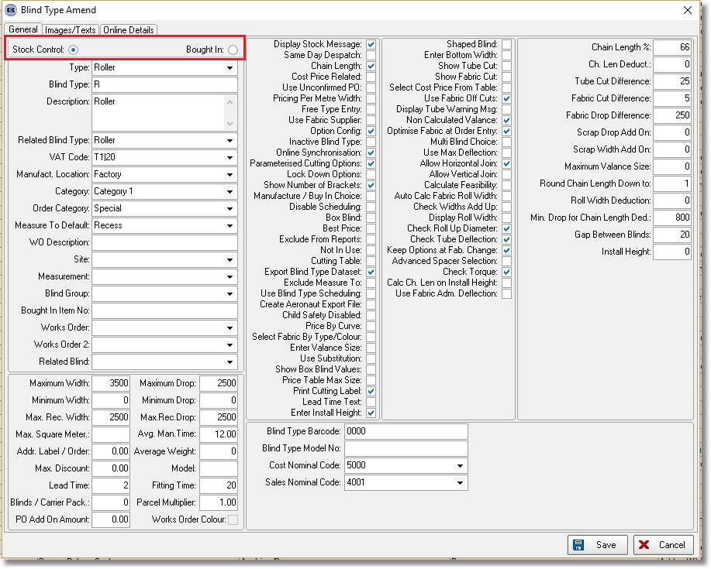

If you enable 'Manufacture / Buy in Choice' parameter in the blind type record, you can also use this blind type as 'Bought In'.
When adding a detail line for this blind, it is possible to select a supplier/vendor from the drop down list and create a Bought In PO from this.

This functionality has been modified in the following way:

A 'Supplier' drop down list has been added to the Department Edit screen.
When a detail line is entered for a blind and Manufacture / Buy in Choice = true then the department record is checked and the supplier selected automatically if a supplier is selected in Department.

5161. Purchase Order Enquiry > Departments

We now hold a department against a purchase order. If it is a bought in PO, then the department is taken from the sales order. If it is a regular PO, then the user is able to enter a department.

When posting purchase invoices to Quickbooks, the purchase invoice functionality looks at the department record to see which Quickbooks company it has to post to.

5162. Alternative Cutting Sizes Functionality

Because of the number of choices for clutch, springs, motors, tubes, end caps etc, the cutting size functionality has become very complicated. Therefore an alternative cutting size calculation has been created.
The system can now look at the choices in the BOM and calculate the cutting sizes from those.

There is a new flag in System Tables > Cutting Option called ‘Calc From BOM’ which defaults to false. There is also a new flag called ‘Calc By Drop’. If it is set to false, then the cutting sizes will be calculated as they are currently. If set to true, the new functionality will apply.

There is a new tab in Stock Items called ‘Cutting Sizes’. This has three fields: Cutting Option, Width Deduction, Drop(Height) Deduction. Multiple records can be added in this tab.

When an order detail line is entered, in the cutting sizes functionality, if ‘Calc From BOM’ = true, then the cutting size will be calculated by either:

Blind size width – the sum of the ‘Width Deduction’ field for each stock item in the BOM

or (if ‘Calc By Drop’) blind size drop - the sum of the ‘Drop Deduction’ field for each stock item in the BOM

The only thing I have not worked out is which of the width or drop to use, but in reality this will always be for a width calculation.

5163. Roll Up Diameter

A further change has been made to the roll up diameter functionality. It has been pointed out that there could be more than one option choice that has a ‘Max Roll Up Diameter’ eg a valance and a bracket may both have restrictions on how thick the roll up diameter can be. This means we need to alter the change we made in dev 5139. Instead of looking for the ‘Max Roll Up Diameter’ in one stock record (identified by the option name ‘Code’), the system now looks at the ‘Max Roll Up Diameters’ for all the option choices and selects the lowest one that is not zero.

If all option choices have ‘Max Roll Up Diameter’ of 0, then a message will appear saying ‘At least one option choice should have a maximum roll up diameter’.

5165. Label Print – Bespoke 67

Some more changes need to be made to this label layout. The options now wrap round (back to the way it was).

5166. Stock Enquiry

There are now column choices for ‘Quickbooks SI Ref’ and ‘Quickbooks PI Ref’ (if Quickbooks accounting is switched on).

5167. Sales Files > Customers

There is now a column choice for ‘Quickbooks SI Ref’ (if Quickbooks accounting is switched on).

5168. Blind Types > Blind Type Setup > Label Control

Recently we added sequence numbers to the ‘Options’ in Label Control. The same thing has been done for ‘Cutting Sizes’.

5169. Label Print – Bespoke 70

Removed the top ‘Measure To’ and replaced it with ‘Free Type’.

5170. Quotation – Bespoke 70

The following changes have been made.

The full header only appears on the first page.
All special instructions text now print – it was being cut off previously.
The totals at the bottom have been altered.

