Blindata Release Note 8.2.6 

23 December 2016

Bug Fixes and Enhancements

The following bugs were recorded in www.support.blindata.co.uk and have been resolved.

- 1825. Xero CSV File Output Fix
- 1858. Quote - Estimated Shipping Date
- 1870. Incomplete processes

New Work and Customer Requests
5140. System Tables > Carrier File Layout

A customer has created a new carrier file layout for a XML file, but the file created needs to have a different name. It should be in the format 08_93008612DDMMYYhhss.xml. This is AccountCodeddmmyyhhss.xml.

There are two new fields in the carrier file layout, the first being the ‘Name Format’ and the second bring ‘Account Code’. The first field will have the choice of OrderNo.xml or AccountCodeddmmyyhhss.xml and the second will hold the account code.

5141. Import From Excel > Customer Update

‘Show Prices On Delivery Docket’ is now a column choice.

5142. Sales Files > Customer Update

There is a new form called ‘Customer Update’. This works in the same way as ‘Fabric Group Update’ except it is for customers.

The ‘Customer Update’ form has default columns of Customer Name, Account Code, Postcode, Country, Area, Rep, Department, Trade Type, Despatch Method, Price Table, Nominal Code, VAT %, Measure To, Metric/Imperial.

In the bottom left there should be two fields ‘Field Name’ and ‘Option Choice’. It is possible to select all the fields above (except Customer Name and Account Code).

5143. Blind Types > Blind Type Setup > Label Control

There is now a way of stopping a label from printing if certain options are chosen. This can be done by using the ‘Non Print Item’ in the stock record.

This will relate to all label prints that use this functionality.

If all the options selected for the label have ‘Non Print Item’ = true, then the label should not print.

5144. Blind Types > Blind Type Setup > Label Control

Options

There is now a field for sequence number in this form – this will determine the order in which the options are printed on the label.

Cutting Sizes

A cutting size will not print if it is zero.

5145. Order Processing > Orders > Turn One, Turn All

Turn one, turn all is now applied to group numbers within the order

5146. Pricing > Option Price Enquiry

There is now an extra column for stock code so we can price options based on a combination of options and put the price in the first option.

For example, a ‘Control Type’ of ‘Cord & Chain Operated’ might be selected, which may have an option price. But if ‘Chain’ = ‘Chain No10 Gold’ is selected, this could alter the price of the ‘Control Type’ option.

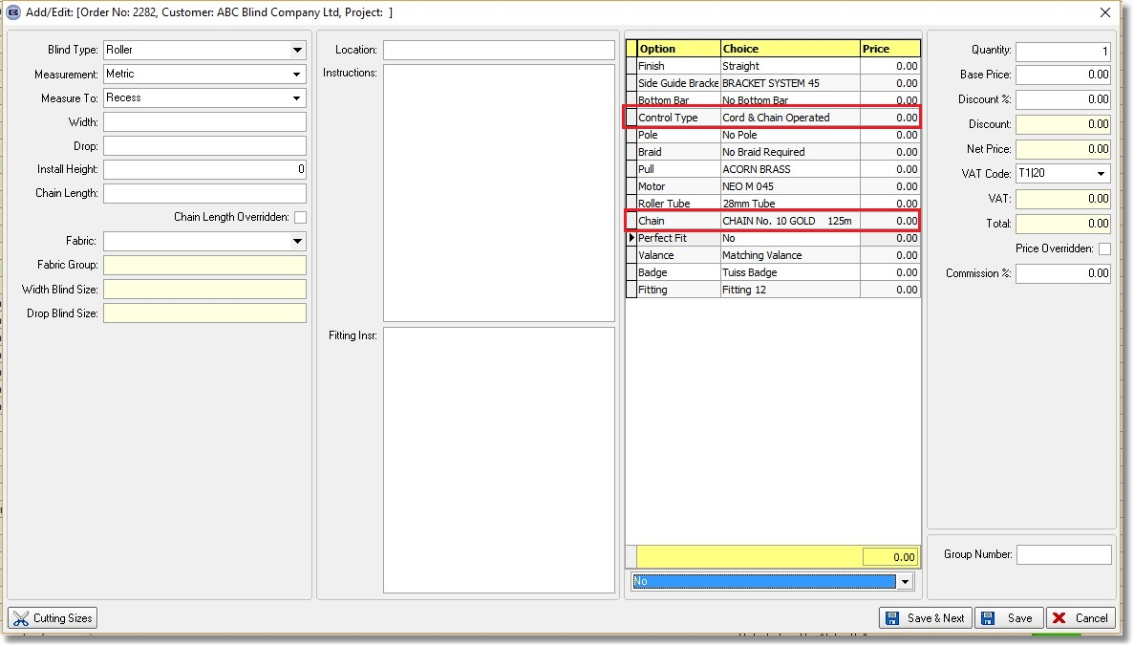
There is now an extra option in ‘Option Price Enquiry’ to hold a price for a combination of options.

If the new field is let blank, then the option pricing will work as it currently does. If there is an option price with a blank in the new field, it’s price would get overridden in order detail entry if there was another option price with a combination of options.

5148. Quotation – Bespoke 70

There is a new quotation report called ‘Quotation – Bespoke 70’, which is based on ‘Quotation – Bespoke 60.

5149. Works Order – Bespoke 70

There is a new works order report called ‘Works Order – Bespoke 70’. See Redmine 1833.

5150. Label Print – Bespoke 70

There is a new label print report called ‘Label – Bespoke 70’. See Redmine 1833.

5151. Quotation – Bespoke 67

There is a new quotation report called ‘Quotation – Bespoke 67’. This has a similar layout to ‘Acknowledgement – Bspoke 67’ but is a quotation.

5153. Acknowledgement – Bespoke 34

If an order has a despatch method where the ‘Collection flag is switched on, ‘To Be Collected’ now prints in the delivery address. This is the same change as was made in dev 5097 for the delivery docket.

5155. Import From Excel > Stock Update

There are now columns for importing ‘Image 1 URL’, ‘Image 2 URL’, ‘Image 3 URL’.

5156. Works Order Label Blind Size 2.1

For a component detail line entry for a cut length fabric, ‘CUT SIZE’ now appears in bold.

