Blindata Release Note 8.2.5 

16 December 2016

Bug Fixes and Enhancements

The following bugs were recorded in www.support.blindata.co.uk and have been resolved.

1182. Fabric Process
1270. Credit Notes added against an order not populating to "All Contact Records" screen
1325. New Purchase Order Bought In Layout (Bespoke 52)
1675. Fabric Roll width
1801. Amendments to the Sales Analysis Export
1828. Tube deflection
1829. VB Works Order XYZ Calculation
1835. Carriage on purchase orders
1837. Acknowledgement - Bespoke 67
1838. Works Order - Bespoke 67
1839. Invoice - Bespoke 67

New Work and Customer Requests
5095. Order Processing > Orders > Order Amend Enquiry

There is now an advanced permission button for ‘Print Invoice’ in Administration > Users. It defaults to true.

5096. Order Processing > Orders > To Be Discontinued

If a fabric is flagged as ‘To Be Discontinued’, a message appears in the order detail entry. We have a user who does not want the message to appear so there is a new flag in Parameters called ‘Disable To Be Discontinued’ flag. This flag defaults to false – if set to true, the message is not displayed.

5126. Sales Analysis > Sales Analysis Export

The following fields have been added to the sales analysis export file:

1. Order No.
2. Order Date
3. Operator Name (please check this populates for an order created from a Quote)
4. Discount %
5. Rep
6. Product Nominal Code
7. Customer Account Currency
8. Customer VAT No.

Other amendments:

1. The “Cost Value” is in the Base Currency only
2. The “Margin” and “Margin %” calculations are based on Base Currency values only.

5127. Post Sales Invoices / Credit Notes

This change is only applicable if Mertex Accounting is switched on.

For each line on the CSV, the data in columns AV, AW and AX now populate to the next available “free” VAT Analysis section (columns AM to AU, which make up 3 VAT analysis sections).
The VAT analysis section always fills from left to right across the page, as a blank VAT Analysis section followed by one with data causes an error in Reflex.
The extra columns have been removed from the transfer file, so the last column on the file is column AU (VAT Amount for code 3).

5128. Archive Enquiry > Contact Management

If a contact management record is created against a posted invoice, and a credit note is then raised against that invoice, the credit note number is then held against the contact management record. If a further credit note is raised against the same invoice, the new credit note number is also added to the contact record.

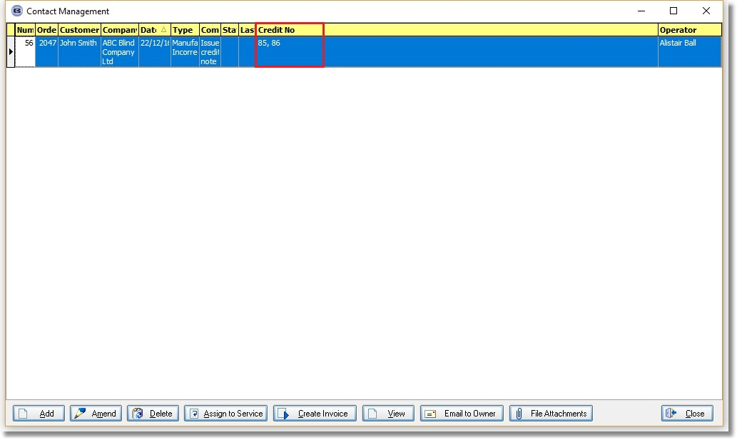

5129. Invoice – Bespoke 52a

There is a new invoice layout called ‘Invoice – Bespoke 52a’.

5130. Order Processing > Orders

This change affects the stock warning functionality.

There is a new parameter called ‘Display Stock Warning If Below Re-order Level’ which defaults to false. This will not affect the existing stock warning logic if the amount calculated is below the stock in hand. If the flag is set to true and the amount calculated takes you below the re-order level but above stock in hand, then the message will not appear.

5131. Order Processing > Orders

There is a new button on the ‘Order Amend Enquiry’ form called ‘WIP Processes’. If this is selected, then the information that prints in the report ‘WIP Incomplete Process Report’ prints but only for the filtered records on this form.

There are also options for sorting by "Order no", Date, Processes.

5132. Stock Control > Reports

There is now criteria for ‘Stock Type’ in the following inventory reports.

1. Stock Usage Report
2. Stock Purchase Analysis (by Value and Qty)
3. Stock Valuation

5133. Reports > Sales Analysis

There is new criteria for ‘Stock Type’ in the miscellaneous reports.

Sales Analysis by
1. Category
2. Blind Type
3. Blind Type by customer
4. Fabric
5. Product
6. Day Book by Category
7. Order
8. Order Category by Customers

5135. Order Processing > Orders

The ‘Products’ column, if it is displayed, now also shows the sum of the products at the bottom of the form.

5136. Stock Items > Unit Of Sale

The ‘Unit Selling Price’ is now updated if the ‘Unit Price’ or ‘Price’ is adjusted in the ‘Unit Of Sale’ tab.

5137. Stock Items > Online Category

There is a new system table called ‘Online Category’. It is now possible to hold multiple online category records against the stock item, so there is a new tab in the stock record called ‘Online Category’.

There is now a new option in Import From Excel called ‘Online Category’. This imports from a spreadsheet that contains two fields, ‘Stock Code’ and ‘Online Category’.

5138. Works Order – Bespoke 42

Removed ‘Blue’ boxes
Material in Stock
Materials Ordered
Materials Checked
Re position ‘Red’ QC CHECK boxes
QC CHECK 2 – above QC CHECK 3
QC CHECK 1 – above QC CHECK 2
Re name ‘RED’ QC CHECK boxes
QC CHECK 1 – Fabric Cut
QC CHECK 2 – Product Assembled
QC CHECK 3 – QC CHECK
New Information: - in area of ‘Blue’ outline
For MIXED Manufactured Orders Only – Added

Quantity / Product / Fabric Description of all blinds on order.

Quantity / Product / Fabric Description
1 R Polka Dots B/O Candy Pink
1 R Splash Poppy
1 L89 Atlantex 89 Cream
3 L89 Vitra B/O Cream

5139. Roll Up Diameter Calculation

An alteration has beenmade to the specification for this. Previously when the roll up diameter was calculated, it was checked against the ‘Max Valance Diameter’ which is held against the tube. It is now checking the calculated roll up diameter against another option.

We therefore now hold a new ‘Code’ in the ‘Option Name’ records called ‘Max Diameter’. The program then checks the roll up diameter against this option stock code instead of against the tube.

Also ‘Max Valance Diameter’ has been renamed to ‘Max Roll Up Diameter’.

