Blindata Release Note 8.2.2 

25 November 2016

Bug Fixes and Enhancements

The following bugs were recorded in www.support.blindata.co.uk and have been resolved.

1325. New Purchase Order Bought In Layout (Bespoke 52)
1545. Posting Purchase Invoice creates multiple files, with a duplicate invoice line
1619. Label alteration
1734. Order Processing > Orders > Detail Line Entry > Create Fabric
1744. Order Processing > Orders

New Work and Customer Requests
4403. Purchase Order Enquiry > Regular PO

If you enter a purchase order detail which is a replacement for another PO (eg fabric arrived flawed), then it is now possible to link this PO to the original sales order.

We can do this by unticking this field in Regular Purchase Order Enquiry > Detail Line context menu.

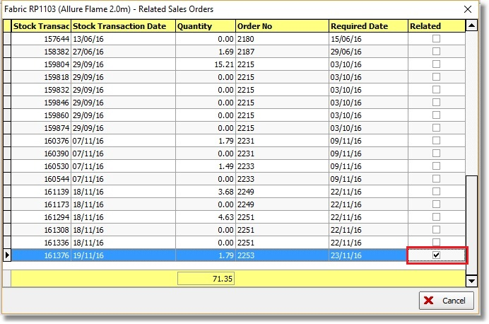

If this is unticked then it can be related to another detail line in a new regular PO. If this this field is unticked, it is recorded as a PO history record. It is also recorded as a history record in the related sales order ie that it was ‘unrelated’ from one PO and then ‘related’ to a different one.

4618. Administration > Maintenance > Update Price Tables

There is now a routine to change price tables in the customer record and in Stock Items > Unit Of Sale. This is in Administration > Maintenance.

The new option is called ‘Change Price Tables’. If this is selected, a small form with two fields should be displayed. The fields should be called ‘Existing Price Table’ and ‘New Price Table’. Both will have lookups to the price table table.

When these fields are filled, a further form appears with buttons for ‘Unit Of Sale’, ‘Customer’ and ‘Both’.

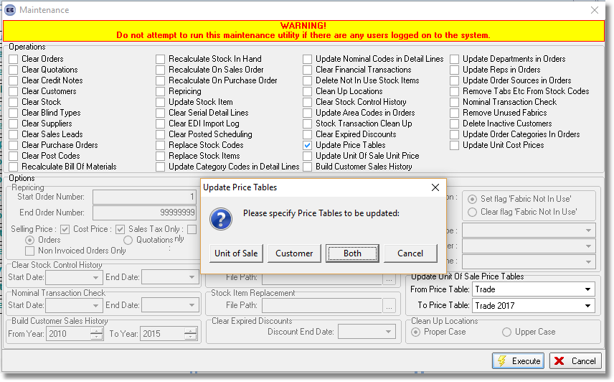

4807. Purchase Order Enquiry > Generate Regular PO > Generate

There is a new PO parameter in the system called ‘Ignore Sales Orders In Generate PO’, which defaults to false. If it is set to true, then the PO generation function only compares 'stock in hand' with (Re-order Level - On Purchase Order) amount.

5075. Blind Type Dataset Export / Import

When exporting datasets it now include the chain length fields from the blind type record.

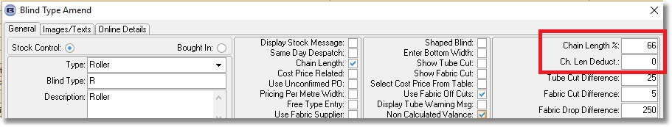
Also the child safety option records are exported from Blind Types > Child Safety Rules.

The Import From Excel > Blind Type Dataset functionality has also been altered to import the above.

5076. Order Processing > Orders > BOM Form

When viewing the BOM in a sales order there is now a column choice added for 'On Purchase Order'.

5079. Production List > Wood Slat Report

There is a new report called ‘Wood Slat Report’ which shows, for wood blinds, how many slats are required for a day’s production. This can be filtered by required date (enter Start and End Required Date) and Blind Type lookup and has the following columns
date req, order number, Customer, slat colour, width, slat amount

This report is grouped by slat colour and has a total slats figure at the bottom.

It only looks at records where blind identifier = Wood. The report is in Order Processing > Production List.

5080. Reports > Receipts By Date

The option ‘Group By Fitter’ has now been enabled.

5091. Cutting Sizes > Formula

There is now an alternative way to set up box blinds in blind types.

Instead of using the ‘Box Blind Slat’ and ‘Box Blinds’ tables, we can use the ‘Link Options’ to find the correct box blind to use. We can also use the Blind Types > Cutting Sizes > Formula to calculate the ‘Cut Each End’ and ‘Add/Deduct Slats’ amounts. To make the formula easier to work out, the following work has been done.

There are two new fields in the stock record, ‘Box Width’ and ‘Box Drop’. These are only required if the option name has the code ‘Box Blind’ against it in Option Names. These will contain the same data that is in the ‘Width’ and ‘Drop’ field in System Tables > Box Blinds.

The ‘Box Width’ and ‘Box Drop’ fields are now choices in the formula so we can then easily calculate these cutting sizes:

Cut Each End: (Box Width – Width)/2
Add/Deduct Slats: Ceiling((Box Drop – Drop)/21.4)

It is now also possible to import fields ‘Box Width’ and ‘Box Drop’ in Import From Excel > Stock Update.

5093. Invoice Printing / Emailing

One customer sends out invoices both by print and email. At the moment the print functionality looks at System Tables > Invoice Type to see how many invoice copies to print – this is correct. But the invoice email functionality also looks at this table and will email multiple copies if multiple records are set up. For ‘Invoice – Bespoke 35’ only, it emails one invoice per order, regardless of the number of records set here.

5094. Reports > Sales Analysis > Sales Analysis by Fabric Amount

There is a new sales analysis report called ‘Sales Analysis by Fabric Amount’. The records are grouped by ‘Supplier’ and then by ‘Fabric Type’. The columns show Stock Code, Fabric Description, Blind Quantity, Fabric Usage (in measurement units).

This report only show records where link option = Fabric.

5097. Delivery Docket – Bespoke 34

If the despatch method is ‘Collection’ ie the Collection flag is set to true in the despatch method record, then the delivery address on this report is blanked out and replaced with ‘To Be Collected’.

5098. Order Processing > Orders > Weight

Previously when a weight was calculated for a fabric in the BOM, it was based on the linear quantity for the fabric * weight. It now calculates the area of the fabric used, and works out the weight based on that.

To ensure this change works properly, we now hold the weight of the fabric (in Stock Items > Characteristics tab > Specific Weight) as kg/m2 for metric and lb/in2 for imperial measurements.

5099. Senses / Nexus Spacer Calculation

Eclipse have made a small change to the way they calculate the spacers. This has been updated in Blindata.

The main thing that has been changed are the lengths of each of the spacer links. The Table below shows the deductions.

 | 89mm |  |  | 127mm
 | Original Size | New Size | Deduction | Original Size | New Size | Deduction
A | 76 | 75.60 | -0.40 | 115 | 114.35 | -0.65
B | 74 | 73.45 | -0.55 | 112.5 | 111.90 | -0.6
C | 72 | 71.70 | -0.3 | 110 | 109.75 | -0.25
D | 70 | 69.45 | -0.55 | 107.5 | 107.20 | -0.3

