Blindata Release Note 8.2.3 

2 December 2016

Bug Fixes and Enhancements

The following bugs were recorded in www.support.blindata.co.uk and have been resolved.

1551. Venetian Optimisation File
1686. Works Order Fix - SV (Missing Data)
1745. Import From Excel > Discounts
1746. Quotation Bespoke 65B Amendment
1747. Xero CSV File Output Amendment
1752. Number of Blades Calculation - multiple methods
1763. Square Metre Pricing
1768. Post Receipt / payment
1771. Works Order - Bespoke 31
1777. Works Order - Bespoke 67

New Work and Customer Requests
4997. Tube Deflection

A customer has said that the tube deflection should look at the fabric record. Some fabrics will allow a larger tube deflection than others. We therefore have made the following change.

There is a new flag held against the blind type record called ‘Use Fabric Admissible Deflection’, which defaults to false. If it is true, then the deflection logic is as follows.

The tube deflection will be calculated as it normally is. This is the amount that the tube will bow by in the middle. But to decide if the fabric will roll up and down properly on the tube, we need to know the angle of the bow ie we need to calculate the angle based on the width of the blind and the tube deflection.

The admissible deflection field in the fabric record will therefore hold an angle.
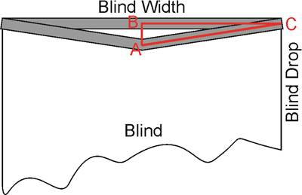

In the example screenshot above, the grey area is a tube in the normal position and with deflection.
Thus we have a right angle triangle ABC. AB is ‘Calculated Deflection’, BC = Blind Width / 2. Therefore ‘tg(BCA) = AB/BC = Calculated Deflection * 2 / Blind Width’.
But this is a tangent of angle BCA. The angle itself equals to ‘BCA = arctg(Calculated Deflection * 2 / Blind Width)’.
This is the angle that can be held in the ‘Admissible Deflection’ field of the fabric.

5100. Wholesale PO Orders to Eclipse

It is now possible to send a csv file to Eclipse. Here is a sample of the file:

S145,83191,24/11/16
RE0310,BANLIGHT DUO FR NAVY R/B,20,METRE
RE0311,BANLIGHT DUO FR GREY R/B,20,METRE
RE0321,BANLIGHT DUO FR LIME R/B,20,METRE

At the moment when we email a wholesale order to Eclipse, it sends a pdf of the order. It can also send the csv file as an attachment. There is a new parameter in the supplier record called ‘Also Email CSV File’ which default to false. If true, it will also attach the csv file. If ‘Use Supplier Part No’ is switched on in the supplier record, it will put the supplier part number in the stock code.

5101. Quotation – Bespoke 69a

There is a new quotation layout based on ‘Quotation – Bespoke 46’.

5103. Works Order Label Print Blind Size 2.1

When Global enter a component detail line for a cut length fabric, the label now prints a specific layout.

5108. Blind Details > Blind Types

The following fields are now column choices in the blind type enquiry form:

Blind Group
Notes
Image 1 URL
Image 2 URL
Image 3 URL
Benefits
Options
Specifications

5114. Stock Control > Stock Items

There are now column choices for ‘Image 1 URL’, ‘Image 2 URL’, ‘Image 3 URL’.

