Blindata Release Note 8.1.9 

7 November 2016

Bug Fixes and Enhancements

The following bugs were recorded in www.support.blindata.co.uk and have been resolved.

938. Is there an inventory parameter to turn off picking list?
1403 Production Documentation > Works Order - Bespoke 42
1591 How to stop Bought-in PO created when order not checked
1621. Our stock quantities look / are incorrect
1631. Order Processing>Orders>Add Order
1640. Ref: 5023
1650 Order Processing > Orders

New Work and Customer Requests
4928. Stock Control

There is a new flag in the stock record called ‘Reduce Stock By Rounded Up Amount’. This is required for the following reason.

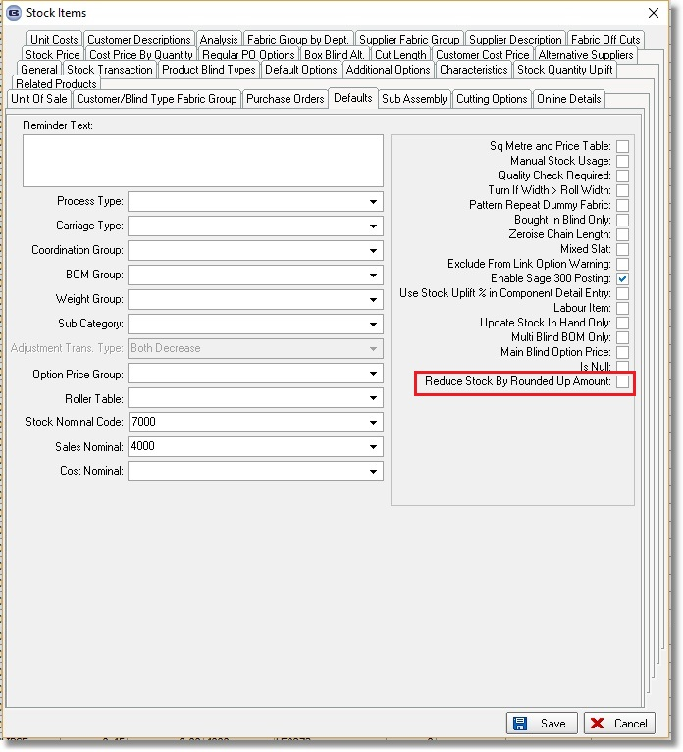

Let’s say a sales order has a BOM sales order transaction for 1.17 metres of fabric. But the fabric can only be ordered in minimum amounts of 0.1. Therefore a purchase order of 1.2m will be created.

At the moment, when the blind is made, 1.17m will be reduced from stock. This leaves an amount of 0.03m because 1.2m was ordered. In reality this will be thrown away.

If the new flag is set to true (it defaults to false), when the blind is made and the stock transaction is deducted from stock, it is first of all rounded up to the next minimum order quantity. Therefore in this case the quantity in the stock transaction would be 1.2m and the stock will be reduced by that amount.

If there is more than one blind in the order, then it does not matter, because the fabric quantity will be held in the BOM for the first blind (it will have been optimised).

The new field is an import choice in Import From Excel > Stock Update.

Let’s take an example where there are 3 separate sales orders, all for the same blind type and fabric, with respectively 1 blind, 2 blinds and 3 blinds in them. The BOM for each blind is calculated as follows:

First Order: 1.23m
Second Order: 1.61, 1.11, 1.56
Third Order: 0.56, 0.56, 1.98

A PO will be generated for this fabric and will calculate that 8.61m of fabric needs to be ordered. This gets rounded up to 8.7m because there is a minimum order quantity of 0.1.
At the moment after all of these blinds are made, the system will say that there is still 0.9m in stock, when in actual fact this will be thrown away.

When the PO is created, we know which sales orders are related to it. Therefore every time a blind is made, it checks to see if all other blinds are manufactured (ie there will be a date issued against the stock transaction) and if it is the last blind that is manufactured, it creates a stock adjustment record for the difference.

5039. Invoice – Bespoke 2

If ‘Use Department Filter’ is switched on, the company name in the top left (which currently comes from ‘Company Details’ comes from the Department record.

5040. Order Processing > Orders > Receipts > Receipt Print

If ‘Use Department Filter’ is switched on, then the registered office information at the bottom of the page is taken from the department record. ‘Reg. Company No’ has been added as a field in the Department form.

5043. Automated Tasks

There is now an automated task for importing ‘Customer Stock Discounts’.

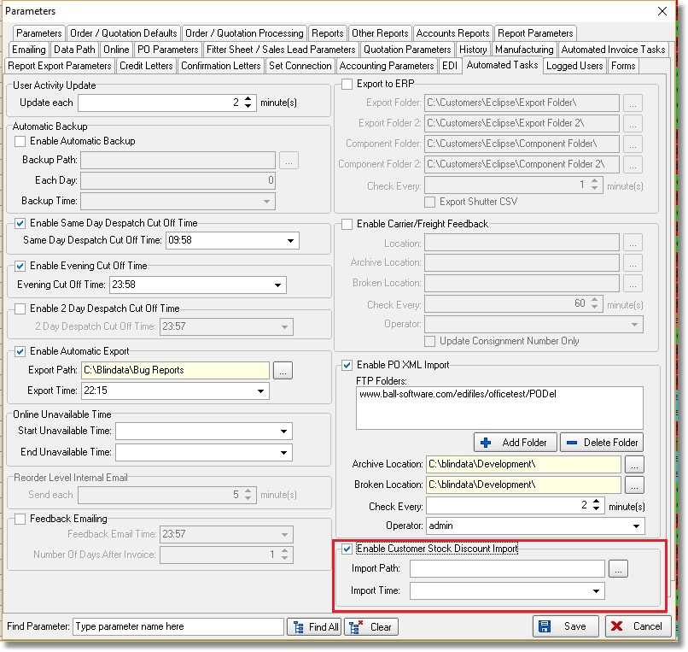

There is a new flag called ‘Enable Customer Stock Discount Import.
There are also new fields for the ‘Import Path’ and ‘Import Time’.

5046. Acknowledgement – Bespoke 52A

There is a new report called ‘Acknowledgement – Bespoke 52A based on ‘Acknowledgement – Bespoke 52.

5047. Picking List 1

If a stock item has the flag ‘Non Picking List’ set to true, then this item will not print on this picking list.

5048. Order Processing > Quotations

There is a new column choice for ‘Order No’ in the Quotation Enquiry form. This will obviously only be available for quotations that have been turned into orders.

5049. Order Processing > Orders > Set Order To Quote

When this button is used, the order is changed back to a quotation, but a new quotation number is created. There is now a choice to revert back to the original quotation. This is required if a quotation has been accidently changed into an order.

If ‘Retain Converted Quotations’ or ‘Use Quotation Revision’ is switched on, this functionality does not exist.

5066. Automated Tasks > Export To ERP

When the export is done for a component order, the ORDQT field is always filled with the ‘Unit Quantity’ amount from the order detail line.

5068. Label Print – 3 ½ x 1 Standard

All the label now print in bold.

