Blindata Release Note 8.1.8 

28 October 2016

Bug Fixes and Enhancements

The following bugs were recorded in www.support.blindata.co.uk and have been resolved.

956. Re: Installation Height On Wood Tickets
1583. Invoice template used when using the "Email Invoice" buttons
1584. Scheduling for "Buy in/Manufacture Choice" from Quotations
1604. Order Processing > Orders > Vanes Only
1607. 4993 - WIP incomplete process report

New Work and Customer Requests
5002. Order Enquiry > Blind Process Scan

This relates to Redmine 525. When the box blind is scanned, it should be validated ie it should check the box blind selected against the box blind stock id. If it matches, then all is ok, otherwise a message appears saying 'The wrong box blind code has been scanned' and it is not possible to proceed.

There is a new Button Visibility(2) flag for the Order Enquiry section called ‘Pick List Validation (BPS)’, which defaults to false. If it is set to true, then the Order Enquiry > Blind Process Scan ‘ form will display a button called ‘Pick List Validation’. If this button is clicked, the ‘Pick List Validation’ form will appear and the user can scan the label to check that the correct box blind has been chosen. The validation checks the supplier barcode held against the box blind stock item with the barcode that is on the box.

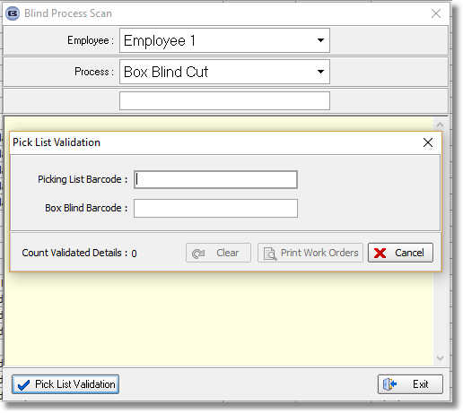

5005. Order Enquiry > Blind Process Scan

If an order is entered and the ‘Repair’ flag is set to true, it means that the blind detail line can be entered using the ‘Repair’ button in ‘Window Blind Amend’. Regardless of how many ‘Man Process Types’ are set up in the blind type, as soon as the first process scan is done for one of these blinds, the status of the whole changes to ‘Order Manufactured’.
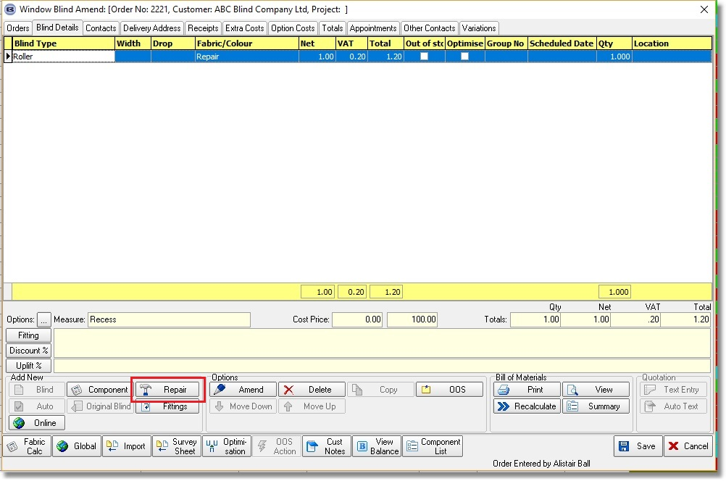
There is a new parameter called ‘all Process Scans For Repair’ which defaults to false. If true, then the scan for a repair detail line behaves the same way as a normal blind detail line ie process transaction recorded, blind status and order status are changed when all processes are complete.

5007. Order Processing > Orders > Global

The Global function has been amended to take into account the child safety rules in combination with multiple changes of options. The chain length is now recalculated each time.

5029. Pleat Count

It is now possible to calculate the number of pleats according to options that have been chosen as well the fabric.

In Administration > System Tables, the Pleat Calc Options table has been adjusted to now include a column for fabric description. This is not a mandatory field.

5030. Torque Calculation

This now works for wood blinds. Therefore the same functionality that has been applied to rollers is applied if the blind identifier = Wood. This is because we have a customer that puts a motor into a wood blind. The formula is:

Calculated Torque = (Weight * (1 + Friction Percent))

5033. Order Processing > Orders

There is a new button on the ‘Order Amend Enquiry’ form called ‘Finished Product Location’. This has an advanced permission and it brings up a new field called ‘Finished Product Location’.

5035. Order Processing > Orders

There is new functionality in Blindata to not allow order detail saving if specific options are selected. This is similar to the existing 'Is Null' column against 'Blind Types > Blind Type Setup > Measure To' used at the moment.
There is a new field in the 'Stock Items > Defaults' tab called ‘Is Null’ which defaults to false. If it is set to true, then if this option is selected in the order detail entry, when it is saved, a message will appear saying ‘This option, [option description], cannot be selected’.

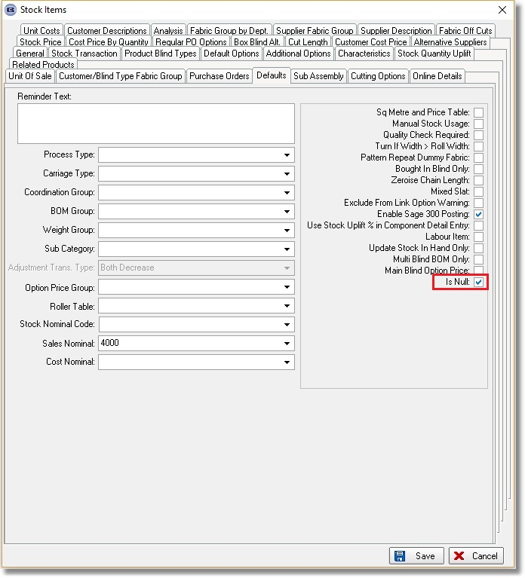

5036. Label Print – Bespoke 33B

A new label layout has been created called ‘Label Print – Bespoke 33B. It prints on A4 and has the same top and bottom margins and has 3 blinds per page.

5037. Stock Control > Reports > Stock Take Differences

Previously this report looked at the StockTransaction table and printed out records that had an amount in the Adjustment field (just the last one). The report was a bit confusing and has been changed.

Firstly there is now date criteria for the report – a start and end date. This looks at the Stocktake Date in the Stock Transaction table. Only records that have dates between the start and end date entered will appear.

The report currently shows in the 3 right hand columns: current stock in hand, Difference and % Difference. These have been replaced by Stock In Hand (from the stock adjustment record ie the amount in the quantity field in StockTransaction record), Difference (pluses and minuses should be the other way round), % Difference (calculated as (adjustment/quantity)*100.

5042. Invoice – Bespoke 35

In the bottom right of the invoice, the text now says ‘GST Number’, not ‘HST Number’.

5044. Label Print – 4 x 1 Bespoke 52

‘Blind Id’ now prints instead of ‘Serial Id’ here:

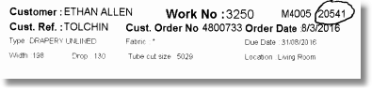

5045. Works Order – Bespoke 52

previously this report was printing a page for each serial id. It now prints a page for each blind id. The quantity will therefore be the quantity held in the order detail line, and not always 1.

