Blindata Release Note 8.1.6 

13 October 2016

Bug Fixes and Enhancements

The following bugs were recorded in www.support.blindata.co.uk and have been resolved.

1411. Order Acknowledgement Fixes
1449. Carriage Pop Up Window at Create Invoice Stage
1450. Customer Quote - Email Text
1451. Emailing Invoice Issues
1452. Xero CSV File Due Date Fix
1455. Delivery Docket Types
1478. Works Order Fix - WV
1479. Works Order Fix - VB
1480. Works Order Fix - Vanes Only
1481. Works Order Fix - SV
1482. Roller Optimisation File Fix
1483. Vertical Optimisation File Fix
1519. Emailing a credit note from system
1523. administration>parameters

New Work and Customer Requests
4729. Project Management Report
There is a new report in Reports > System Reports called ‘Project Management Report’. This shows the following fields:

Project – this is the project and the orders are grouped by project.
Quantity – the number of blinds
Shade Type – this is the blind type description and records are grouped within the project.
To Production – this is the order status – these records are grouped by blind status.
Install Target – this field was not available, so we have created a new field in the Totals tab of the order called ‘Install Target Date’. It appears below the ‘Projects’ lookup and only appear if ‘Project Management’ is switched on in Parameters > Quotation Parameters.

As well as printing this report, it is possible to save it as a spreadsheet – which can be done in ‘Save’ (diskette item).
The report shows all live projects ie where there are orders that have status before ‘Invoice Posted’ and there is a project tied to the order.

4772. Delivery Docket – Bespoke 65

Adjustments have been made to this report according to the specification.
5017. Pricing > Price By Square Foot

We can now hold the price by square foot in Pricing > Square Metre Pricing. At the moment a square metre price can be held in the Pricing > Square Metre / Linear Pricing table.

If ‘Imperial Setup’ is switched on, this now says ‘Square Foot / Linear Width Pricing’ and the price is held as a square foot price. In Order Processing > Orders, if there is a price here, it is calculated based on the square foot of the blind, not the square metreage.

5018. Label Print – Bespoke 67

The number of vanes now prints on the label if blind identifier = Vertical or Vanes Only.

5019. Label Print – Bespoke 68

This report now prints in ‘Free Type’ order then order no order.

5020. Invoice – Bespoke 22A

Some layout changes have been made to this report.

5021. Order Processing > Orders

In the form that is displayed when the ‘Global’ button is selected, the following changes have been made:

- Added Location column and made form wider.
- When an option is selected here, the options that appear on the ‘To Option’ lookup to the right of this field now only display stock codes that relate to the blind type and option name selected in ‘From Option’.

5022. Purchase Invoice CSV

If the accounting system is set up as ‘Maxton’, there is a new option to send a purchase invoice csv file when a purchase invoice is posted.

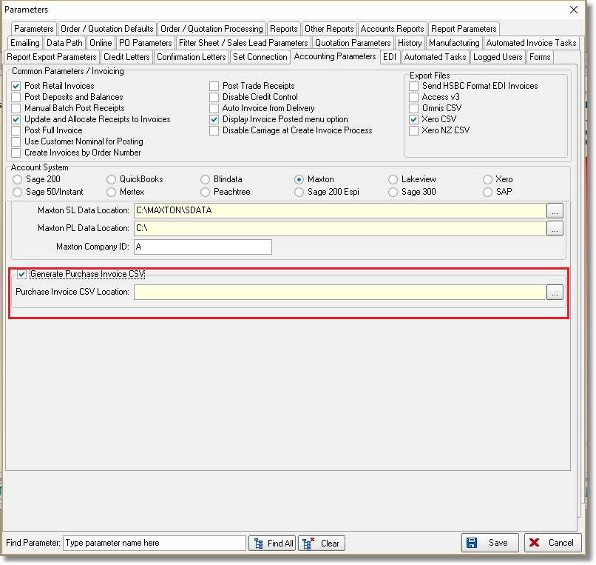

5023. Purchase Order Reports

We introduced a field in the stock record called ‘Supplier Description’ If this field is filled, it now prints on regular purchase orders instead of the normal stock description. This is now applied to all regular purchase order reports.

5025. Acknowledgement – Bespoke 64

Previously the detail lines were printing in group number order. They now print in batch number order ie the order in which they have been entered.

5027. Fitter Sheet – Bespoke 64

The font size for the contact email has been reduced and the box size for the contact email on the fitter sheet extended.

