Blindata Release Note 8.1.7 

21 October 2016

Bug Fixes and Enhancements

The following bugs were recorded in www.support.blindata.co.uk and have been resolved.

1544. PO not printing properly when using "Alternative Supplier"
1559. EDI file – View
1569. Sending wrong Invoice format when we email directly out of Blindata
1576. Order Processing > Orders > Vanes Only

New Work and Customer Requests
4993. WIP Incomplete Process Report

There is a new report in Reports > System Reports called ‘WIP Incomplete Process Report’.

The new report shows processes that have not been carried out for orders that are WIP but are not yet fully manufactured.

The report is grouped by order number and then shows the number of incomplete processes for each process.

Order No Customer Process Quantity

123456 Blind Co Ltd Fabric Cut 3
Tube Cut 5
Headrail Cut 2
143434 Newco Ltd Fabric Cut 1
Tube Cut 1

4994. Received POs Not Yet Invoiced

There is a new report to show POs that have been received but not yet invoiced. This is held in Stock Control > Reports. The report should display all the PO detail lines where quantities have been delivered but not yet invoiced.

The report is grouped by purchase order, and shows supplier, stock code, stock description, quantity, cost price.

There is a total cost price for each PO and an overall total.

5003. Stock Control > Fabric Group Setup

There is a new field choice in the bottom left hand of this form: Unit Cost / Unit Of Sale / Product Blind Type. This will allow records filtered in the main screen to have records added or deleted in the tabs for ‘Unit Cost’, ‘Unit Of Sale’ and ‘Product Blind Types’.

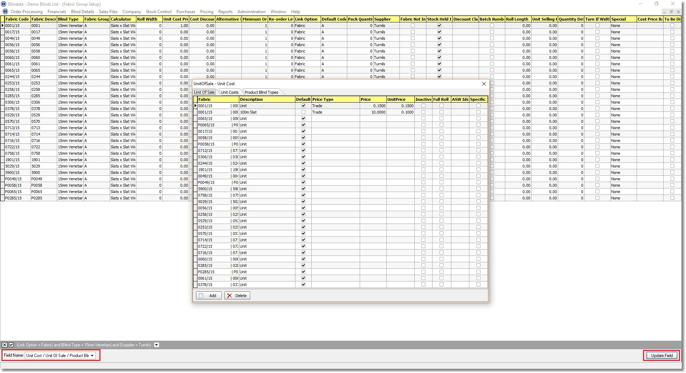

5004. Sales Analysis By Width and Drop Range

The overall total of blinds within the grid and also totals against each line and each column now print on this report.

5006. Stock Control > Stock Transaction Entry

There is a new field in Stock Control > Stock Transaction Entry called ‘Unit Of Sale’. It is now possible to select different Units so that we can deduct and add in boxes, lengths, metres, unit, feet etc.

5010. Works Order – Bespoke 15

The field ‘Notes 2’ now prints instead of ‘Notes’.

5011. Acknowledgement – Laser Print (Letterhead Logo)

‘Required Date’ now says ‘Delivery Date’ unless there is a fitting appointment in which case it says ‘Install Date’, and in this case also prints the time and fitter. The fitter replaces the ‘Despatch Method’.

5012. Works Order – Bespoke 42

Some items at the bottom of the report have been removed and replaced by '1 L89, 2R etc' and also an indication that a different fabric has been used for the same blind type ie if there are 2 blinds entered with the same blind type but different fabrics, this is shown.

5013. Works Order – Bespoke 42

The order of this report is now by blind type, WO Control > Free Type, fabric code, order no. We therefore ignore the 'Group By Fabric'.

5016. Pricing > Multi Blinds

We have a customer that prices multi blinds on the main blind ie ‘Multi Blind Pricing’ is switched on. They want to be able to uplift this price based on the number of blinds in the multi blind. Therefore a new table has been created which holds the blind type, multi blind choice, % uplift, fixed charge. This is held in Administration > System Tables.

When the detail line for the main blind is saved, and ‘Multi Blind pricing’ is switched on, it looks at this new table and applies either the % uplift or the amount uplift depending on what has been entered.

5032. Dashboard (Bar Graph)

At the moment the ‘Today Sales Target’ and the ‘This Week Total Sales Target’ is the sum of the rep daily targets. This has been replaced with the ‘Daily Sales Target’ from Company Details and the sum of the ‘Daily Sales Target’ for ‘This Week Total Sales Target’.

5034. Order Processing > Archive Enquiry

There are now column choices for customer ‘Address Line 1’, ‘Address Line 2’, ‘Address Line 3’, Address Line 4’, ‘Postcode’ (State/Zip Code) and ‘Order Source’ in the Archive Enquiry form.

