Blindata Release Note 8.1.4 

30 September 2016

Bug Fixes and Enhancements

The following bugs were recorded in www.support.blindata.co.uk and have been resolved.

1440. Administration>Import from Excel
1463. Stock Items

New Work and Customer Requests
5014. Automated Tasks

We created functionality in devs 4702 and 4765 to be able to update the status of purchase orders, but I have discovered a problem. Let’s take the example of Customer A and Customer B.

A blind order is entered in the customer A online system and is imported to the Customer A Blindata.

This sales order creates a purchase order which is then sent to Customer B via EDI.

An order acknowledgement XML file is then be sent back to Customer A. At the moment it can only be sent to a Customer B ftp folder.

When the blind is despatched, a despatch docket XML file is sent to Customer A. At the moment it can only be sent to a Customer B ftp folder.

There is an automated task in Administration > Parameters that we created to import these XML files but it can only access the ftp connection that is set up in Administration > Parameters > Set Connection.

We now hold the customer ftp connection details against the customer record here. When the automated task is run to send the XML files, it will send them to these locations.

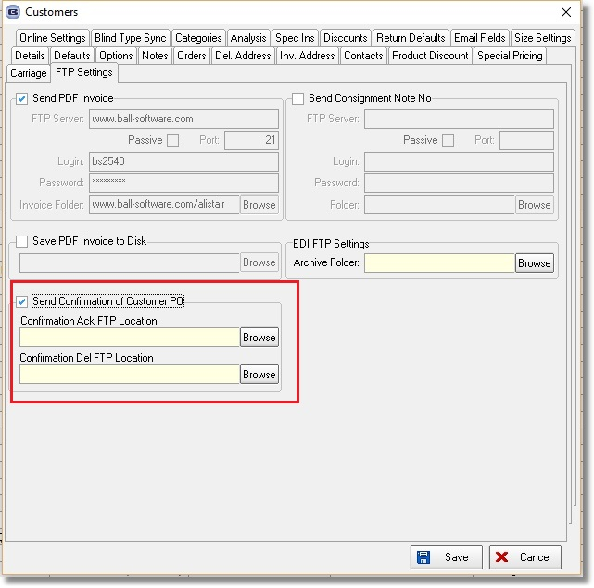

5015. Senses / Nexus Vanes Calculator

We did a dev item recently (4919) to calculate the spacers for Nexus/Senses headrails on vertical blinds. This is calculating the spacers correctly but it was not picking up the number of vanes. Instead of it looking up the number of vanes table, we can calculate it by adding the spacers. For a single bunch blind it is the total of the spacers + 1, for split bunch it is the (total +1) * 2. In this example, the total should be 16. It therefore stores this figure in the number of vanes field in the order detail line table so the fabric calculation etc will work.

This is only required for Nexus/Senses headrails. When it finds the spacers that have to be used, it updates the ‘Number Of Vanes’ field.

