Blindata Release Note 8.1.2 

12 September 2016

Bug Fixes and Enhancements

The following bugs were recorded in www.support.blindata.co.uk and have been resolved.

72. Report
1169. Stock Control > Fabric Group Setup
1208. Order Acknowledgment Form – WS
1210. Invoice Fix
1217. Address Label Amendments
1359. Alternative supplier part numbers
1375. Blind Options Pricing Resetting
1384. Order Detail Entry

New Work and Customer Requests
4983. Order Processing > Orders > Order Amend Enquiry

There is a new button on this form (with a button visibility flag in Administration > Users > Button Visibility) called ‘Xero CSV’. This will create a Xero CSV NZ file for all filtered records.

4986. Order Processing > Orders

At the moment if a customer is selected that is set as trade type = ‘Including Tax’, the user has to enter a required date. This can be changed using a new flag in the customer record that called ‘Enable Reqd Date Calc’ which defaults to false. If true, it will use the same functionality for calculating the required date as an ‘Excluding Tax’ customer.

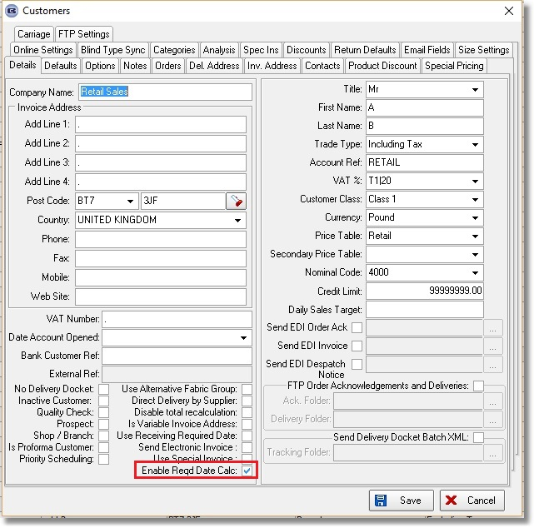

4987. Multi Blinds

If there is only one blind in a multi blind (ie 1 on 1 is selected) and ‘Multi Blind Pricing’ is switched on in the blind type, the price is not zeroised for this blind.
The tube deflection now only works for the multi blind, not the main blind.
The torque now works for only the main blind, not the multi blinds.

4989. Option Price Enquiry > Formula

The ‘Valance Width’ and ‘Return Length’ fields have been enabled in the formula form.

4990. Purchase Order Bought In – Bespoke 52

There is a new bought in PO layout called ‘Purchase Order Bought In – Bespoke 52’. This is page size A4 and has a layout similar to ‘Purchase Order Bought In – 8.5 x 11.

4992. Works Order – Bespoke 67

The works orders are now grouped by manufacturing location ie there is a new page for each location.

5008. Invoice – Bespoke 35

If Trade Type = ‘Including Tax’ or ‘Show Deposit and Balance For Trade Invoices’ = true, the deposit and balance now appear on this invoice.

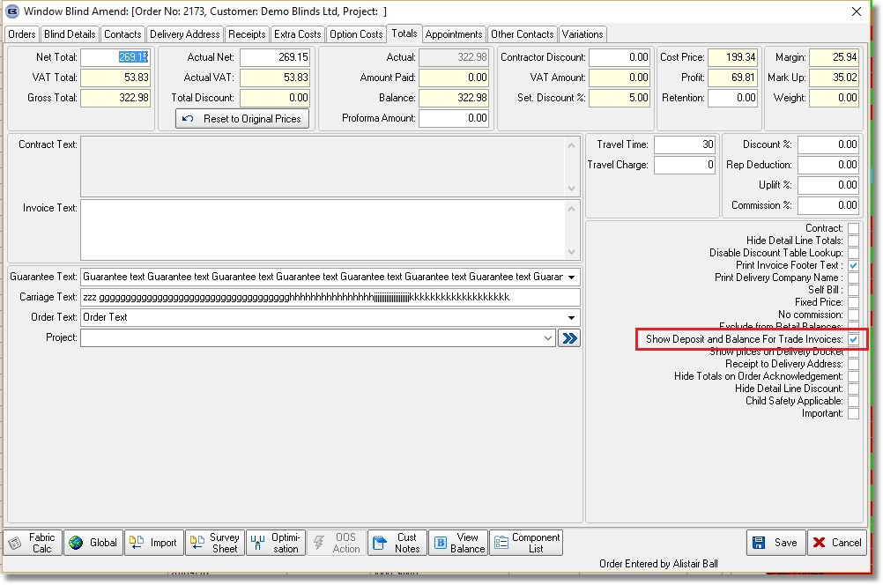

W266. Order Entry

It is now possible to enter detail lines for blind identifiers = Cushions, Valances and Tiebacks.

