Blindata Release Note 8.1.3 

23 September 2016

Bug Fixes and Enhancements

The following bugs were recorded in www.support.blindata.co.uk and have been resolved.

922. Sales Analysis Weekly Detailed Summary Report Amendments
1180. New Invoice Layout Not Displaying Correct Information
1316. Works Order Fixes / Amendments
1395. Fitters Sheet Fix
1412. Packing Slip Amendment
1437. Works Order - Bespoke 67

New Work and Customer Requests
4944. Label Print – Bespoke 67

There is a new label print report called ‘Label Print – Bespoke 67’. The labels are 4” x 1” and have different layouts depending on the blind identifier.

This uses the same principal as ‘Label Print – Bespoke 68’ (where options and cutting size print fields can be determined in ‘Label Control’.

When labels are printed out, they are sorted by order number, blind type, Free Type (from Label Control).

4984. Roller Fabric Optimisation

There is a new button on the Order Processing > Order Enquiry form called ‘Roller Opt Export’. There is a button visibility flag for this in Administration > Users > Button Visibility.

When this button is selected, it exports all filtered records into a spreadsheet which has the format that is in Roller Optimisation file in Redmine 895.

4985. Vertical Fabric Optimisation

There is a new button on the Order Processing > Order Enquiry form called ‘Vertical Opt Export’. There is a button visibility flag for this in Administration > Users > Button Visibility.

When this button is selected, it exports all filtered records into a spreadsheet which has the format that is in Vertical Optimisation file in Redmine 895.

4988. Multi Blind Option Pricing

It is now possible to select the option price for the main blind but not for the multi blind. At the moment if ‘Multi Blind Pricing’ is switched off, the blinds are priced based on the blinds that are auto created. But there may be cases where there needs to be a price for an option (eg valance) in the first blind entered. There is now a flag held against the stock item to do this. The flag is called ‘Main Blind Option Price’ and defaults to false. If true, the option price is applied to the main blind but not the others.

Please note this only applies if ‘Multi Blind Pricing’ is switched off. If ‘Multi Blind pricing’ is switched on, then all of the price is in the main blind.

4991. Stock Control > Reports > Stock Issues By Product By Month

There is a new report called ‘Stock Issues by Product By Month’

This has a similar layout to ‘Sales Analysis By Product By Month’, except it shows quantity issued instead of value sold.

There are criteria flags for ‘Warehouse Stock’ and ‘Factory Stock’, but these flags are only shown if ‘Use Factory Stock’ is switched on.

4995. Company > Financials > Export Transactions

There is a new button on this form called ‘Export Transactions’. This allows a user to export all filtered records to an Excel file. The records exported are not just be the records on the form – it they include all the nominal transactions associated with the filtered records ie it includes the transactions you can see when you right click and choose ‘Transactions’.
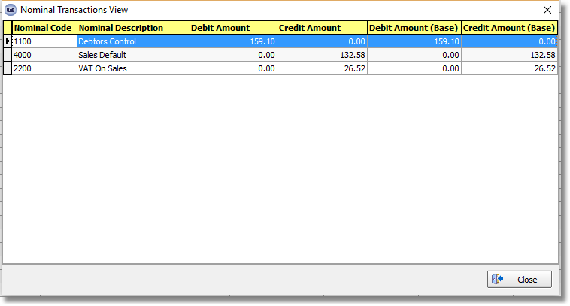

4996. Company > Financials

If the country is set to USA or Canada, the reports for Trial Balance, Profit & Loss and Balance Sheet are all page size 8.5” x 11”.

4998. Pricing > Option Discounts

There is now a column for a ‘Option Price’. The option discount can therefore be either a discount % or an actual price but not both.

In the order detail line entry, the program checks the discount % first – if that is 0, then it uses the ‘Option Price’.

5000. Stock Control > Stock Items

There is now a 'Cost Price Band' in the General tab of the stock record. This can then be used for finding the correct cost price (instead of the 'Price Band') for a bought in blind when an order detail line is entered. If it is blank, then the existing functionality will still work.

There is also a field for this in 'Stock update' and also a field choice in 'Fabric Group Setup'.

5001. Order Processing > Orders

There is a new parameter called ‘Calc Chain Length On Install Height’, which defaults to false. If it is set to true, and the install height > 0, then the chain length is calculated on the install height rather than the drop of the blind.

5009. Stock Control > Fabric Group Setup

There is a new column choice for ‘To Be Discontinued’. It is also a field choice in the bottom left for updating.

