Blindata Release Note 8.1.0 

2 September 2016

Bug Fixes and Enhancements

The following bugs were recorded in www.support.blindata.co.uk and have been resolved.

1297. Fabric scrap calculation
1310. Import From Excel > Vertical Slats
1311. Roll Up Diameter Functionality
1319. WO: Label 210mm x 200mm

New Work and Customer Requests
4960. Suppliers > Wholesale EDI File

There is a new flag in the supplier record called ‘Full Qty For Wholesale EDI’ which defaults to false. If it is set to true, then when the XML file is created the quantity will be set to the same value as full quantity ie it will be the quantity from the PO, not the unit quantity.

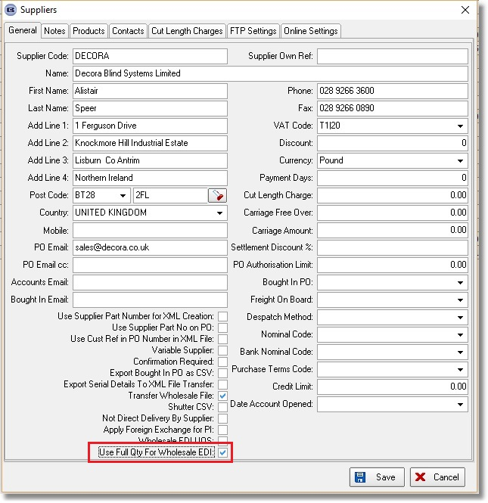

4966. Works Order Label Blind Size

If the ‘Enable Serial No Shop Floor System’ parameter is switched on, then the barcode that prints is the serial id and not the blind detail line id.

4971. Label Print – Bespoke 68

It is now possible to determine which options and which cutting sizes print on specific labels. There are two new buttons in Blind Types > Blind Type Setup > Label Control called ‘Options’ and ‘Cutting Sizes’.

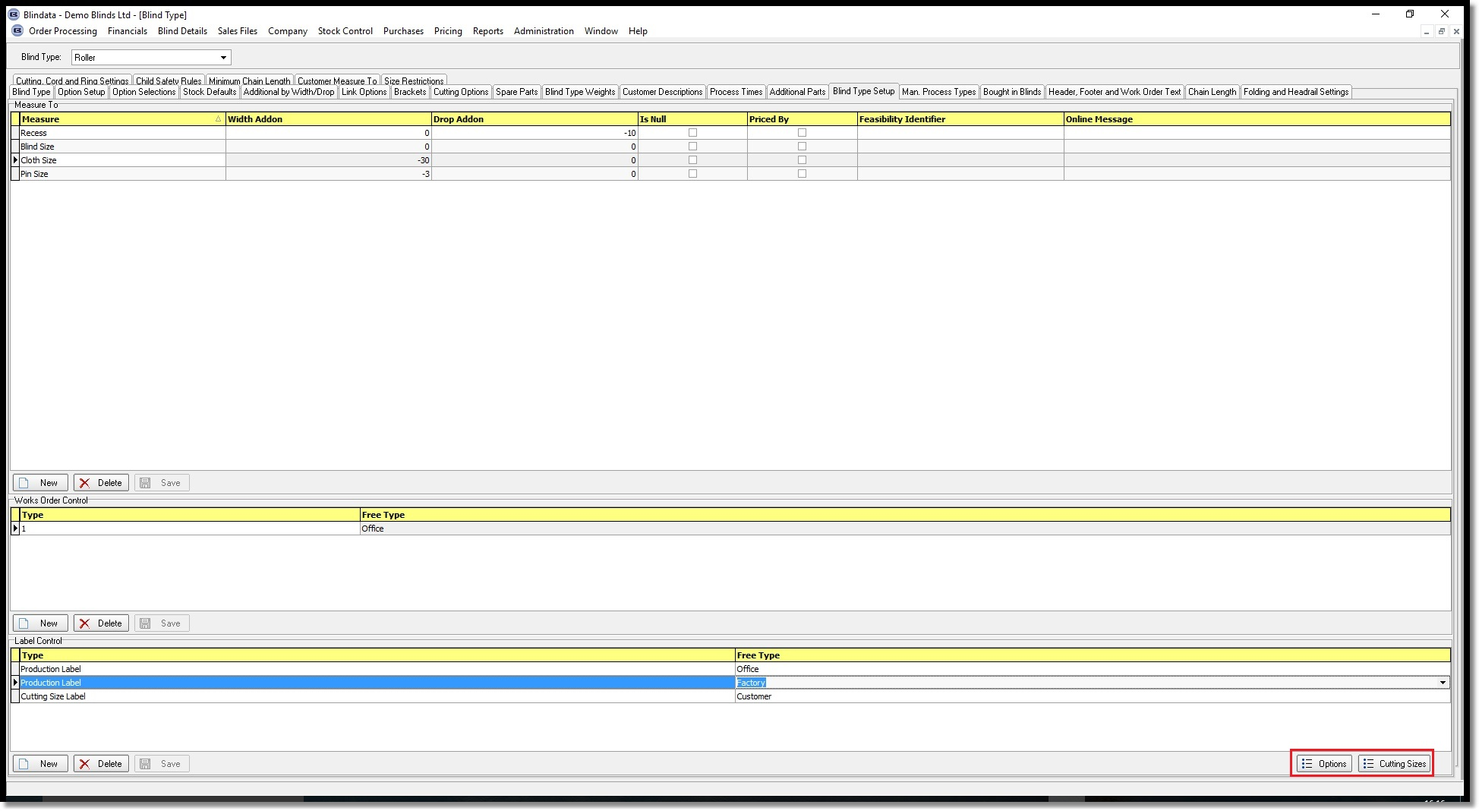

These two new buttons can control which options and cutting sizes print on which labels. It is therefore possible to have multiple labels for an order detail line, with different options and cutting sizes printing on them. The label report will then look at these tables and if there are options or cutting size records in them, will print them on the respective labels.

If there are no options set up here, then the options that print will revert to those that are flagged to print in Blind Types > Option Setup.

4976. Stock Take Entry / Import

It is now possible to enter the cost price of a stock item when a stock take entry is done. This can happen in two places:

- Stock Take Entry – there is a new field in this form for ‘Unit Cost Price’. This defaults to the unit cost price that is held against the stock record. When the record is saved, the cost price is held in the stock transaction record.
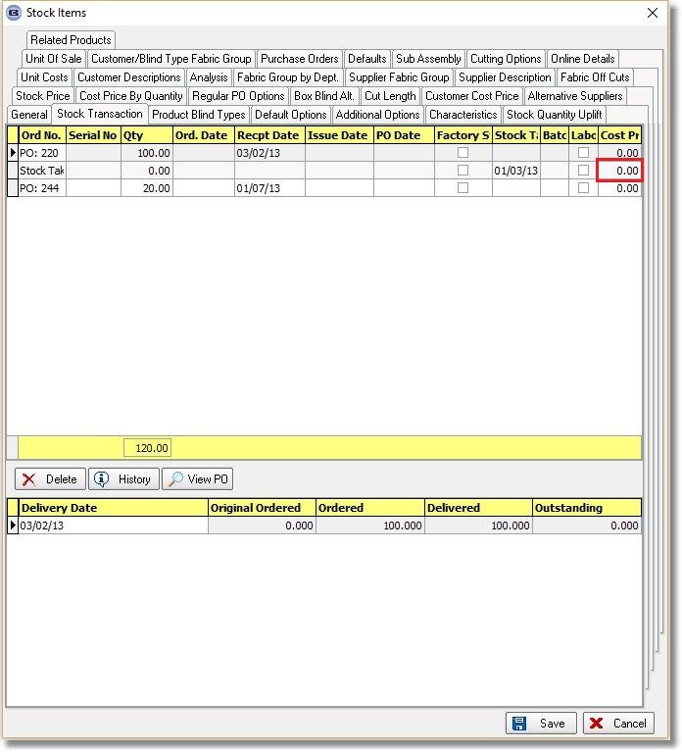
- Stock Take Import – there is a new column for ‘Unit Cost Price’. If this is filled, then the unit cost price is updated to the ‘Cost Price’ in the stock transaction record that is created when the stock take import is done.

4977. Stock Control > Stock Reports > Stock Valuation FIFO

This report has been changed so the stock valuation calculation can be done from the last stock take stock transaction (if necessary).

Let’s say we have the following stock transactions held against a stock record.

Ord No Date Quantity Cost Price
PO 01/04/16 100 3.50
Stock take 30/04/16 95 3.00
PO 30/06/16 20 2.50
PO 31/07/16 50 2.40

Let’s say the current stock in hand figure is 100. Using the FIFO method of costing, this means we have the following

30 at cost of 3.00
20 at cost of 2.50
50 at cost of 2.40.

The stock valuation is therefore 260.00.

4978. Invoice – Bespoke 66

A number layout changes have been made to this report.

4979. Suppliers > Wholesale EDI UOS

If this flag is switched on, wholesale EDI unit of sale records will also be split up for pleated fabrics.

4980. Automatic Import At EDI Enquiry

Previously a detail line would only import automatically if the stock code AND the description are identical. This has been changed so it will import if the stock code is identical. It will not matter if the description is different.

This only applies to wholesale orders.

