Blindata Release Note 8.0.5 

29 July 2016

Bug Fixes and Enhancements

The following bugs were recorded in www.support.blindata.co.uk and have been resolved.

1090. po 975-line numbers starting over
1095. Item Ref on Works Order mapped incorrectly
1098. Text overwriting on Proposals and totals not being there
1101. Component Picking List and Change of Order Status
1105. Text overwriting and total price not showing

New Work and Customer Requests
4919. Senses Vertical Calculator

The new Eclipse Senses vertical calculator has been incorporated in the order detail line entry. These new headrail systems (Nexus, Nexus Slim, Sense, Senses Slim) will replace the Impala headrail system in the near future.

Eclipse have a spreadsheet that gives the calculations and these have been replicated (with the permission of Eclipse) in Blindata.

The blind type record needs to be set up with the following flag switched on. This will then display these extra fields.

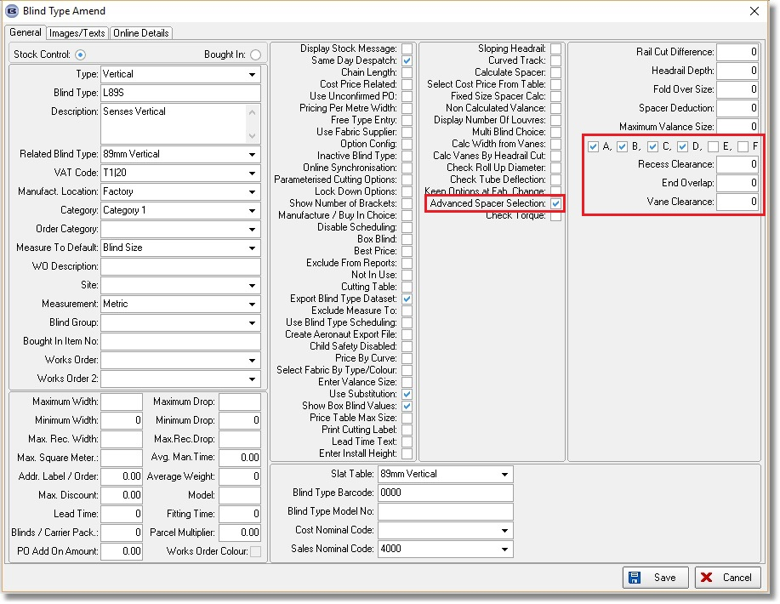

The following codes need to be set up against option names in System Tables > Option Names.

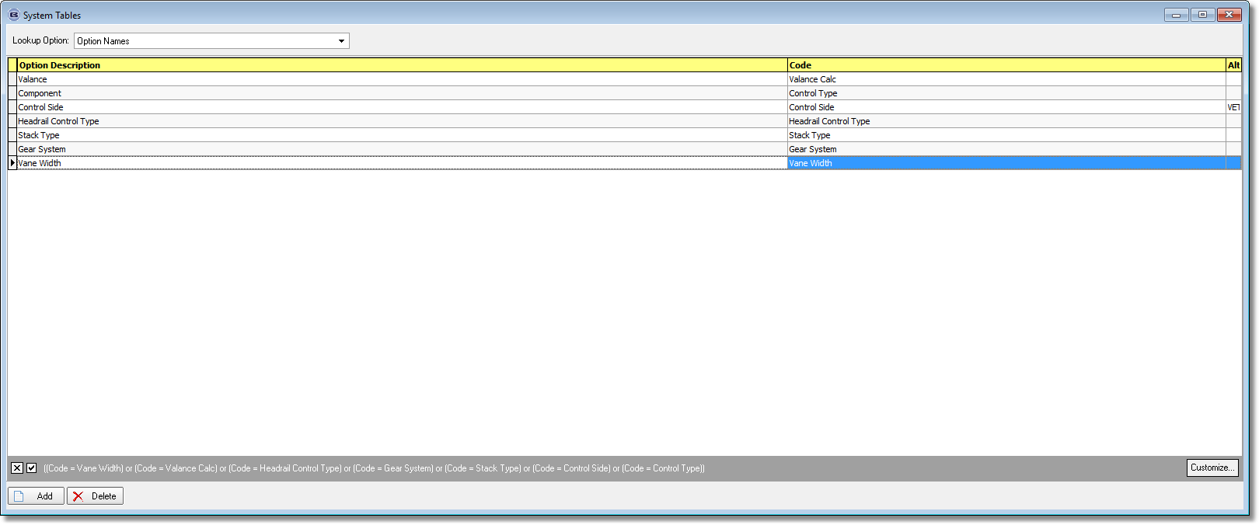

The following choices need to be set up in System Tables > Headrail Control Code.

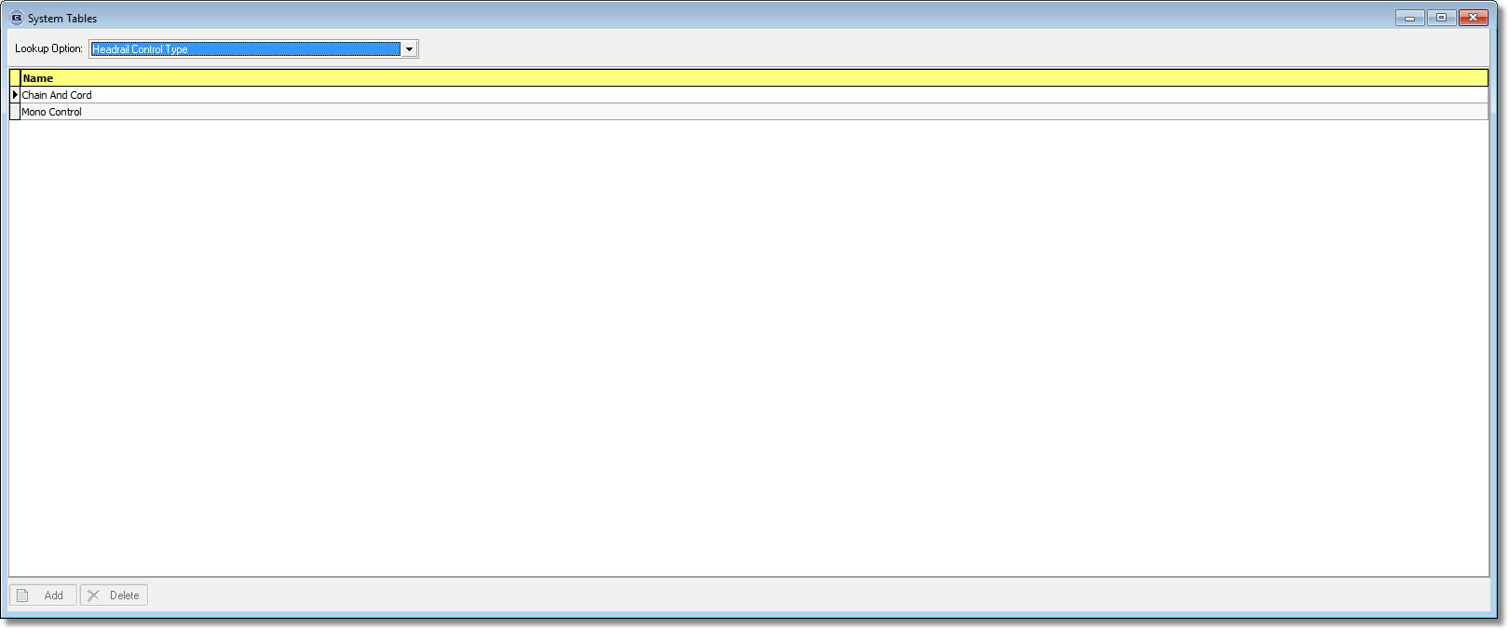

In the stock records, the items that are set up as link option ‘Headrail Control Type’ have to then have the correct headrail control type set up against them.

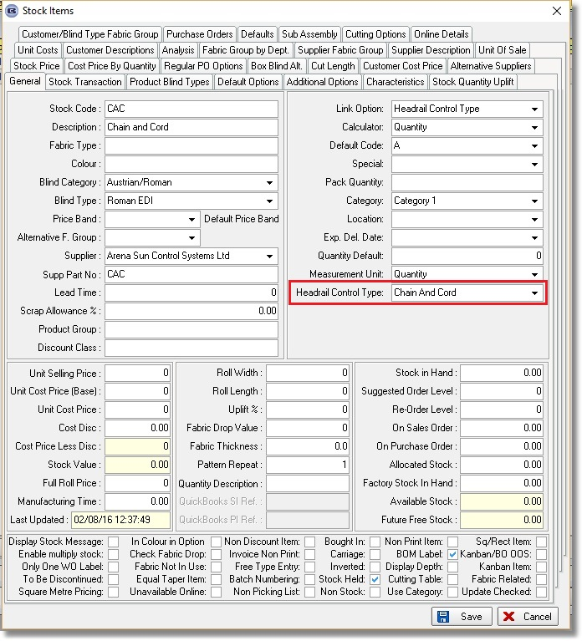
This needs to be repeated for all the other codes ie Control Side, Gear System, Stack Type and Vane Width.

Once all of this is set up, the option names should then be set up against the blind type.

Finally you will need to add in the new headrail systems in System Tables > Headrail Slat Table.

The Eclipse spreadsheet order entry looks like this and the following in Blindata should match.

- Option set up in blind type.
- Blind type setup
- Blind type setup

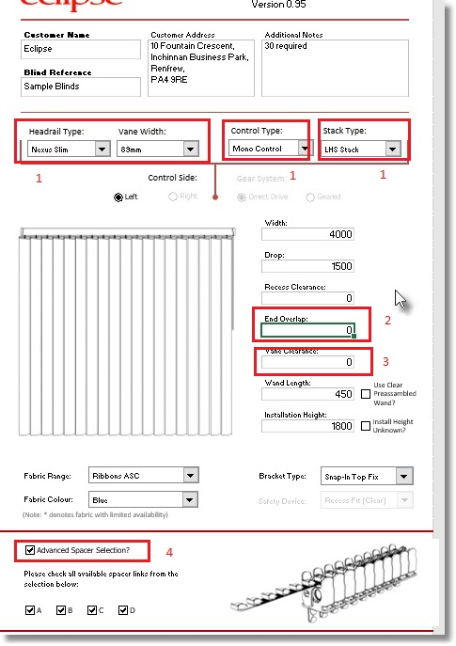

There are two main calculations that are done – the first is to calculate the pitch ie the headrail width that is going to be used, the second is to calculate the combination of spacers depending on the width calculated.

4920. All Contact Records (Ctrl/T)

This form now has all the same column choices as the contact record form that is displayed in Order Processing > Orders > Contact Management button.

4921. Purchase Invoice Create

When a purchase invoice is created (either individually in Purchase Order Enquiry > Update or in Purchase Order Stock Enquiry > Batch Invoice > Create Batch Invoice), and if ‘Purchase Invoice Number’ is switched on in Parameters, the ‘PI Sequence Number’ is filled with the next ‘Purchase Invoice Number’. When the invoice is being created a window now appears saying ‘Purchase Invoice Sequence Number is 123456 (or whatever the number is)’.

4922. Purchases > Post Purchase Invoices

This form now also display purchase invoices that have been created in ‘Purchase Order Enquiry > Update’ and also ‘Purchase Order Stock Enquiry > Batch Invoice > Create Batch Invoice’. They are held in a separate tab

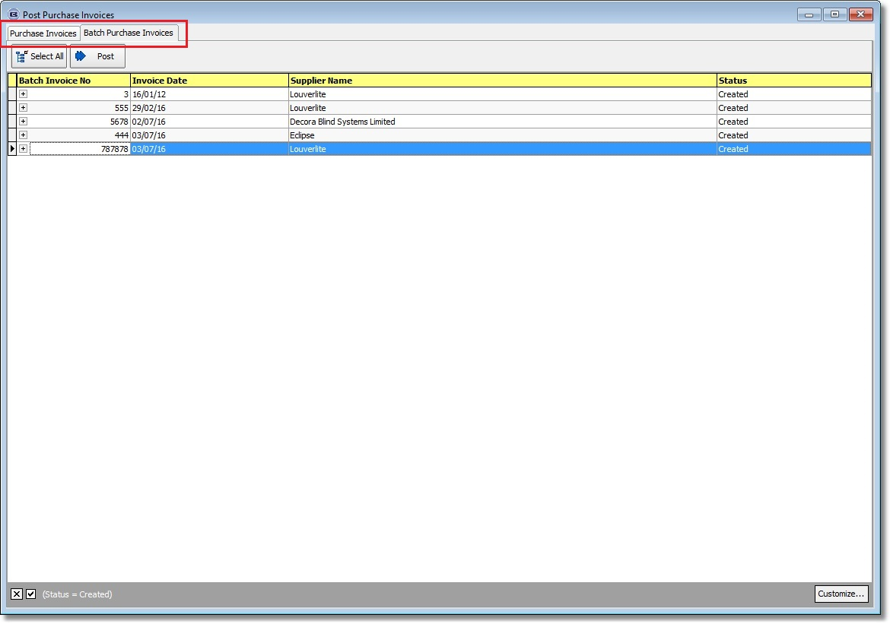

4935. Label Print – Bespoke 68

If ‘Customer Label’ is set up in Blind Types > Blind Type Setup > Label Control, then a label now prints out with the company name and address details on it.

Also if the ‘Label Control’ is for a production label and blind identifier is ‘Venetian’ or ‘Wood’ we the ladder web spacing is printed on the label as well.

