Blindata Release Note 8.0.4 

25 July 2016

Bug Fixes and Enhancements

The following bugs were recorded in www.support.blindata.co.uk and have been resolved.

961. Bill Of Materials
1037. Sales Invoice Template - Page Numbering
1043. Texts on quotations
1063. Packing slip for 1671-pricing showing
1065. Cutting option "Alto de tela 2" appears in label but the calculated number doesn´t
1072. Archive Orders / Orders > Context Menu > Create Credit Note
1073. Invoice - Bespoke 66
1077. Reports > Purchase Analysis
1082. Cost Price Set Up
1084. Error message when selecting "Preview Work Order"
1085. Multi blind pricing

New Work and Customer Requests
4887. Order Processing > Orders > Fabric Off Cut

At the moment it is possible to print a report that shows a list of fabric off cuts in Stock Control > Reports > Fabric Off Cuts. It is now also possible to save the location of an offcut against a blind detail line.

Therefore we need to be able to edit a serial detail line, and be able to enter the location of the offcut – this means that the bill of materials quantity should be reduced to zero for the fabric in that blind.

The location can be edited in the serial detail line in Order Processing > Orders > Context Menu > View Serial Details.

We have made the following changes:
We have added new editable column in Serial Detail Line screen.
It is visible if Parameters > Quote/Order Processing > Use Fabric Off Cuts is enabled.
It allow the selection of the fabric off cuts location (only if the detail size is correct).
If fabric off cut location is selected then BOM quantity for this fabric is reset to 0.

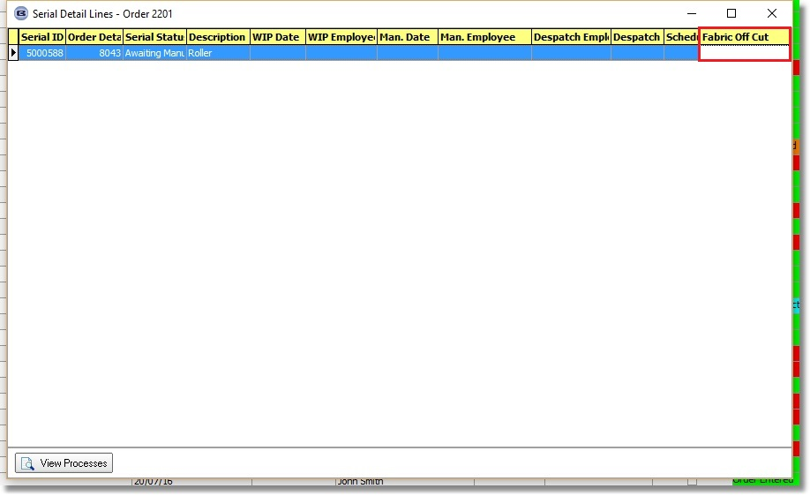

The location of the offcut can now be printed on ‘Works Order – Bespoke 46’. It is printed in brackets after the fabric description in the top two labels and the big label.

4912. Order Processing > Orders > Multi Blind BOM

If a multi blind is entered (when ‘Multi Blind Choice’ = true and ‘Multi Blind Auto Create’ = true), the bill of materials records should not be created for the overall blind detail line.

However, there could be an exception to this. Therefore there is a new flag in the stock record called ‘Multi Blind BOM Only’, which defaults to false. If it is set to true, then a BOM record is created for the overall blind, but not in the automatically generated detail lines.

4913. Order Processing > Orders > Window Blind Amend

The layout of this form has been altered so that special instructions and fitting instructions can be fully displayed. This in turn has made extra room in the left hand column for more fields.

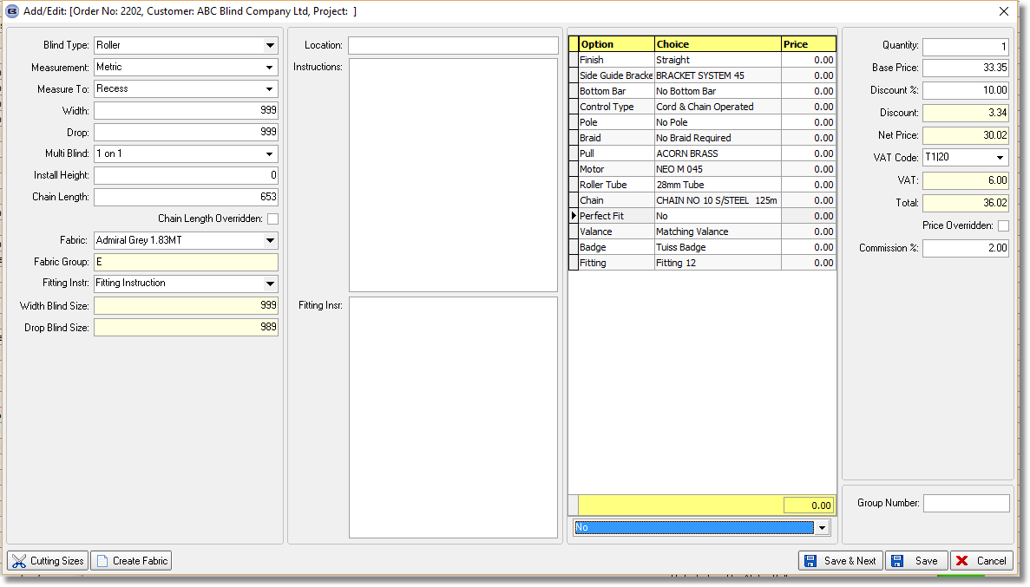

4917. Order Processing > Orders

Previously we had two parameters for ‘Mandatory Fields’ in Parameters. There are now two more fields added to this: Mobile Phone and Email Address. If either of these fields are ticked (and they default to false), then a message appears in the order entry to say the field needs to be filled.

4918. Administration > Parameters > Accounting Parameters / Invoicing

This tab has been renamed ‘Accounting Parameters’ instead of ‘Accounting Parameters / Invoicing’.

If ‘Blindata Accounting’ is switched on, then there is a new parameter visible called ‘Use VAT Cash Accounting’, which defaults to false.

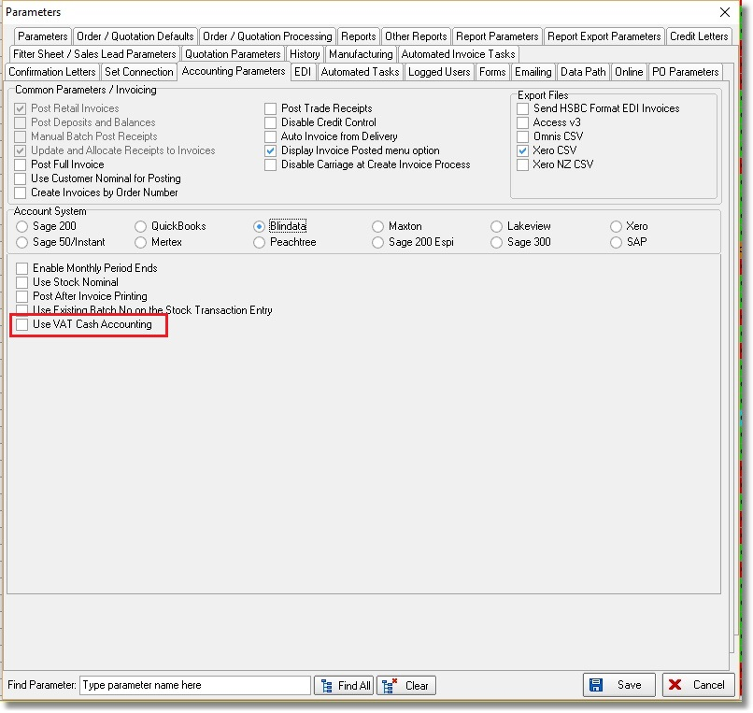

If ‘Use VAT Cash Accounting’ is set to true, this has an impact on the way the VAT return is done. At the moment the VAT return date is based on the date of the sales invoice (or credit) and the date of the purchase invoice (or credit). If VAT cash accounting is used, then the VAT return calculation is done when payments are made, for both sales receipts and purchase payments.

The following forms and reports have been changed if ‘Use VAT Cash Accounting’ is set to true.

Financials > VAT > VAT Return

This now look at receipt and payment transactions rather than sales or purchase invoices or credits.

Calculate, Reconcile and Print functions have all been amended. All 3 VAT return reports have also been adjusted.

4924. Import From Excel > Blind Type Fabric Groups

The field ‘Stock Image URL’ has been added to the ‘Blind Type Fabric Groups’ import.

