Blindata Release Note 8.0.0 

24 June 2016

Bug Fixes and Enhancements

The following issues were recorded in www.support.blindata.co.uk and have been resolved.

633. Backups not being created
788. Company>Chart of Accounts
863. Wholesale EDI Import
870. Survey Request - Projects

New Work and Customer Requests
4854. Order Processing > Orders

If a fitting appointment is made against an order, if there is no contact name (title, either first or last name) against the order, a message appears saying to enter one.

We have a customer who does not want this message to appear and wants to be able to enter the appointment.

Currently we have a parameter called ‘Customer Title, First and Last Name in Parameters > General (Mandatory Fields). If this is not switched on, then it is possible to save the appointment without having a contact name.

The same principal now also applies to the ‘Telephone Number’ mandatory field. If it is set to false, then it is possible to save the appointment without having a telephone number against an order.

4855. Order Processing > Orders

There is a new button to print a summary report from the ‘Order Amend Enquiry’ form. This has the same layout as the quotation summary report.

4856. Order Performance Report

There is now a report to record performance for orders.

At the moment we can hold contact records against orders. Any number of contact records can be held against an order, but we want one of these contact records to be an ‘Outcome’ record.

Therefore there is a new field in the ‘Contact Record Type’ called ‘Outcome’, which is a true/false field and defaults to false.

When a contact record is saved against an order, it is only possible to have one contact record that has ‘Outcome’ set to true against it.

There is a new report created called ‘Order Performance Report’ in Reports > System Reports. This has criteria of ‘Start Date’ and ‘End Date’ and shows the percentage of records for each outcome.

4857. Administration > Import From Excel > Discounts

There is a new flag in this form called ‘Update Discount End Dates’. If this is set to true, then when a discount record is about to be imported, there is a check to see if there is an existing record. If so, the end date for the existing record is changed to the date entered on this form.

4872. Works Order – Bespoke 52

It is now possible for a blind type to print two different works orders every time. There is a new field in the blind type record called ‘Works Order 2’. If this is filled, then a second works order will print out for the blind type.

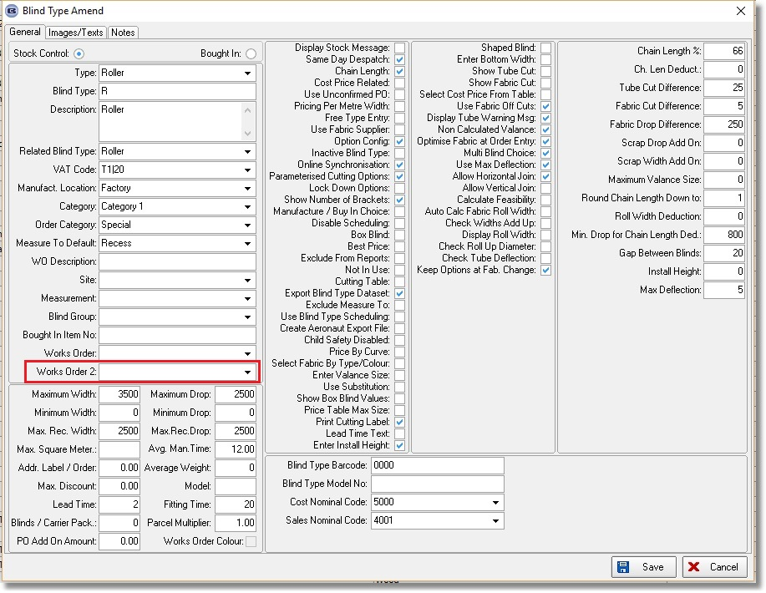
An image can now be held against a stock record which will then print on this report. The field it is held against is in the Characteristics tab. The field can be held as a filename or as a http image, depending on whether the following parameter is switched off or on.

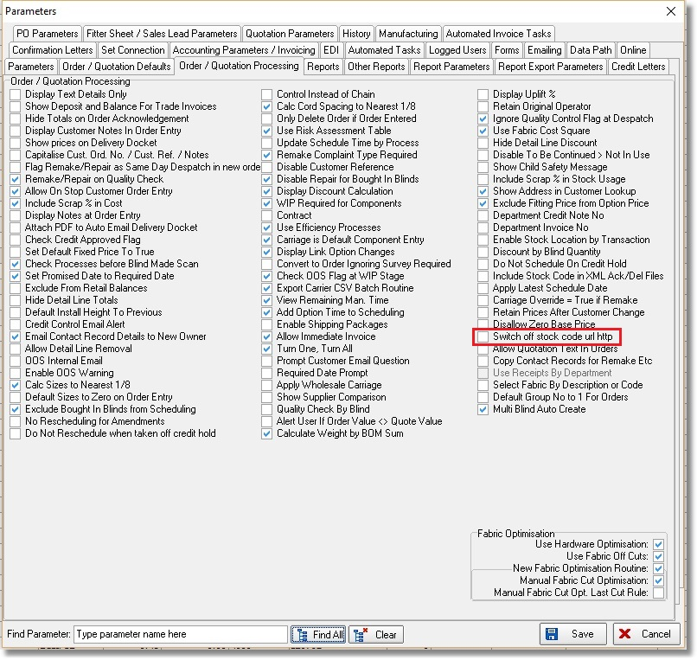

Stock code record:

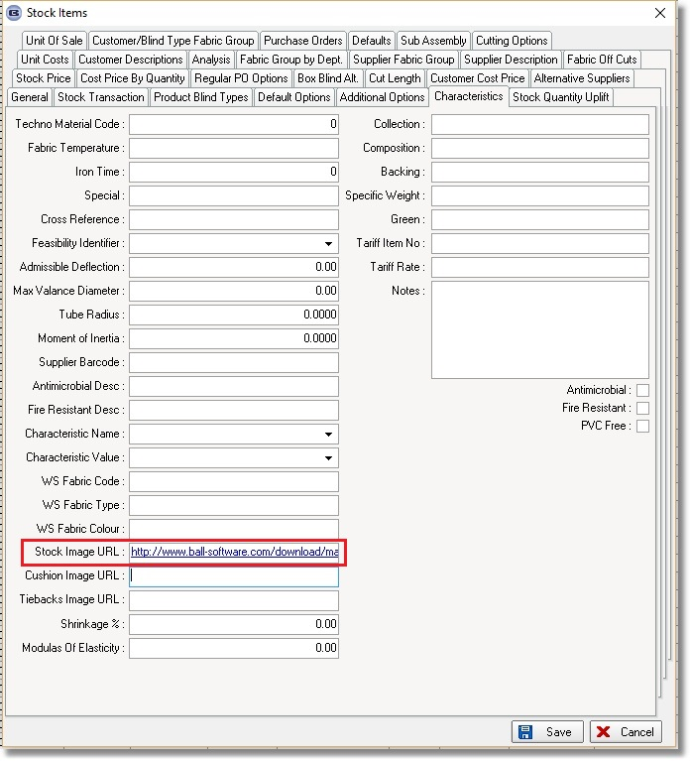

4878. Fitters Sheet / Sales Leads > General Report

If ‘Diary Depatment Filter’ is swiched on in Parameters, then only fitters sheets for the department the user has access to print out.

4879. Order Processing > Orders > Order Entry > Appointments

If ‘Diary Depatment Filter’ is swiched on in Parameters, then only employees for the department the user has access to vcanbe seen in the employee lookup.

4880. Works Order – Bespoke 64 / Bespoke 64a

The ‘Rep’ and ‘Dispatch Method’ now both print on these reports, below the date.

4881. Order Processing > Archive Enquiry

It is now possible to view the order detail line in ‘Archive Enqury’. Previously you could view the order header but not the detail line. There is a ‘View Detail Line’ choice in the context menu for ‘Window Blind Amend’ in Archive Enquiry.

4883. Reports > System Reports > Order Book Report

The columns on this report have been adjusted so they do not overlap.

4884. Acknowledgement – Bespoke 57

There is a new order acknowledgement report (and pdf) called ‘Acknowledgement – Bespoke 57’ which is based on ‘Acknowledgement – Bespoke 34’. It does not show the required date (which is displayed as ‘Delivery Date’ and does not show any notes.

4885. Works Order - Label 7

It is now possible to print two machine barcodes on this report

If ‘Techno TS2000 Bar Code Required’ is switched on in Report Parameters, the barcode now prints (if blind identifier = Vertical).

If ‘Print Roller 2D Barcode’ is switched on in Report Parameters, the barcode now prints (if blind identifier = Roller).

