Blindata Release Note 8.0.1 

4 July 2016

Bug Fixes and Enhancements

The following issues were recorded in www.support.blindata.co.uk and have been resolved.

945. The cornice blind type does not seem to be referencing the correct price when I use the parameter "Use Pricing Width".
931. Purchase Analysis
881. SMTP settings
876. Quotation Issue

New Work and Customer Requests
4889. Dashboard (Bar Graph)

The weekly sales target is now the sum of the day totals for 'Daily Sales Target' and 'Wholesale Daily Sales Target'. This also take into account holiday dates ie they are not included.

4902. Purchase Order Enquiry > Amend

When a bought in purchase order is delivered, it is now possible to enter a GRN number (in the same way we do for a regular PO).

4903. Purchase Order Stock Enquiry

There is a new PO parameter called ‘Include Bought In PO in Batch Invoicing’ which defaults to false. If true, then both regular and bought in purchase orders will appear on the ‘Purchase Order Stock Enquiry’ form.

There is a new column for ‘Type’ in the ‘Purchase Order Stock Delivery’ so the user can see what is a regular and what is a bought in PO.

4904. Purchase Order Enquiry > Amend

If a GRN is entered for a PO for a supplier and it has already been used for a previous PO for that supplier, a message appears saying ‘This GRN has already been used’ and gives the user the opportunity to change it or to continue with the same number.

4905. Purchase Invoice Create

If ‘Purchase Invoice No’ is switched on in Parameters, then when the purchase invoice is created (in both Purchase Order Enquiry > Update and in Purchase Order Stock Enquiry’ the sequential purchase invoice number that is being used is displayed on the form.

4906. Mertex Purchase Invoice CSV File

If the sequence number is 2, the field is filled as PIB000002 ie it starts PIB and then has six numeric characters, filling with 0 if the Blindata sequence number is less than six characters.

Supplier invoice number – this does not have PI at the start and is just the purchase invoice number eg 2.

This layout is the same for invoices that are posted from either ‘Purchase Order Enquiry’ or ‘Purchase Order Stock Enquiry’.

4907. Purchase Invoice Analysis Report

This report now only prints one record per PO detail line. Some changes have been made to the report according to the specification.

It is now possible to export this report as well. There is a button on this form to export the file as a Excel document.

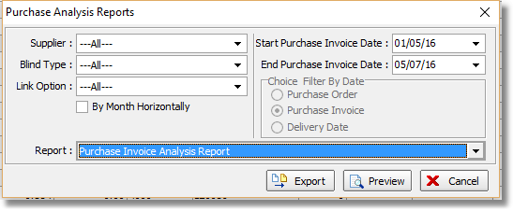
The following sequence of fields is used in the export file:
Column # | Field
1 | Supplier Code
2 | Supplier Name
3 | Supplier Currency
4 | Purchase Invoice Sequence Ref.
5 | Supplier Invoice Ref.
6 | Supplier Invoice Date
7 | Purchase Invoice Posting Date
8 | Purchase Order No.
9 | Purchase Order Date
10 | Supplier Delivery Note Ref.
11 | Delivery Date
12 | Date Confirmed to Stock
13 | Stock Code
14 | Stock Item Blind Identifier
15 | Stock Item Blind Type
16 | Stock Item Nominal Code
17 | General Ledger Amount
18 | Currency Amount
19 | VAT Code
20 | VAT amount
21 | Invoice Net Amount
22 | Invoice VAT Amount
23 | Invoice Total Amount

4914. Techno TS2000 Barcode

The Techno barcode is picking up the correct information from Blindata.

The fields are as follows:

Maximum length –
Minimum length – always 0000
Number of louvres – number of vanes
Material – uses code from Stock Control > Characteristics > Techno Material Code
Louvre’s width – set to 089
Order – order_id from Blindata
Position – set to 001, 002, 003 etc for each blind in the order
Type of work – always 01.

