Blindata Release Note 9.6.3 

23 August 2019

Bug Fixes and Enhancements

The following bugs were recorded in www.support.blindata.co.uk and have been resolved.

8379. Hiding Blindtype Options
8383. Blindata Stock Balance
8407. Bespoke label
8411. Outstanding order showing balance which does not exist
8420. Processing > Orders
8436. Order Processing > Orders
8439. Order Processing > Orders > Import

New Work and Customer Requests
6674. PO XML File Field Restrictions

There are now parameters for rmoving certain fields from the PO XML file. These are held in a new tab in Administration > Parameters called ‘PO XML File Fields’.

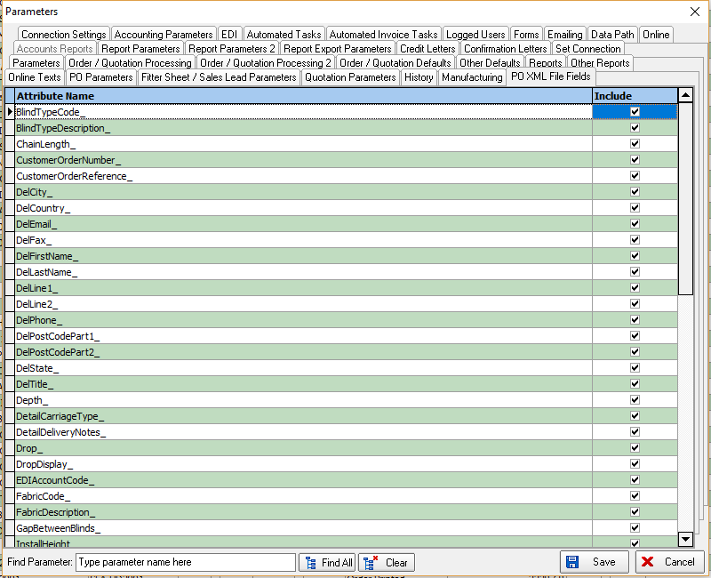

6703. PO XML File Creation

There is a new parameter in Sales Files > Customers called ‘Add Cust Acc Code to PO XML’ which defaults to false. If set to true, the customer account code will be added to the PO XML file.

6704. System Tables > Customer Default Options

In System Tables > Customer Default Options there is a new column added for ‘Blind Identifier’. It is now possible to add a customer default for the blind type or the blind identifier.

6709. Invoice – Bespoke 18

The Commercial Invoice and Invoice for Payment have been split into two separate documents. In ‘Select Reports’ there are now choices for Commercial Invoice and Invoice for Payment – previously there was only a choice for ‘Invoice For Customs’.

6710. Box Blind Cutting Instructions

There is a new column called "Outer Chann" which will display the outer channel cutting size (see hardware cutting sheet).

6711. Invoice – Bespoke 18

Invoice terms are now picked up from invoice terms in the totals tab.

6713. Invoice – Bespoke 18

This relates to the prices that are printed in words.

Cents was in lower case ie cents –changed to Cents
Dirhams – was printing words in pounds / pence – fixed.

This was also the case for the order acknowledgement.

6714. Order Processing > Global Search

There is a new option to copy a quotation to a new quotation from this form.

6715. Blind Types > Link Options

There is now an option to copy a link option to another blind type.

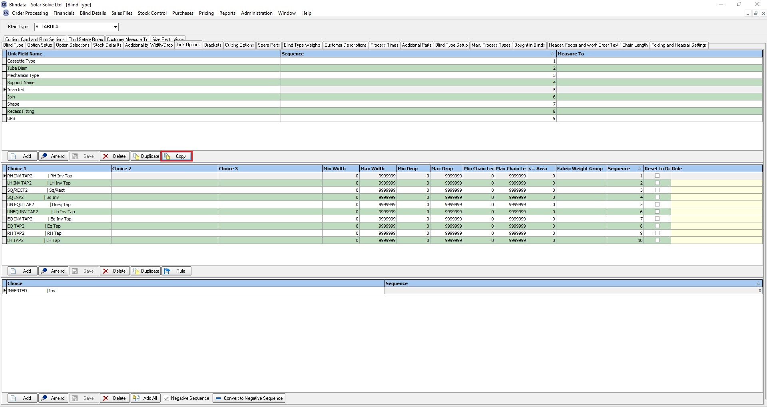

6716. Imperial Measurements

If the ‘Bottom Width’, ‘Small Height’ and ‘LH Offset Width are entered in imperial, they will now appear on the hardware cutting sheet report in metric.

6717. Order Processing > Order Entry

There is now a field for ‘Invoice Company Address’ in the order entry, above the invoice address. This will only be active is ‘Is Variable Invoice Address’ = true in the customer record.

6721. Online Quotation / Order Acknowledgement

There are now options to determine the online quotation and order acknowledgement reports online.

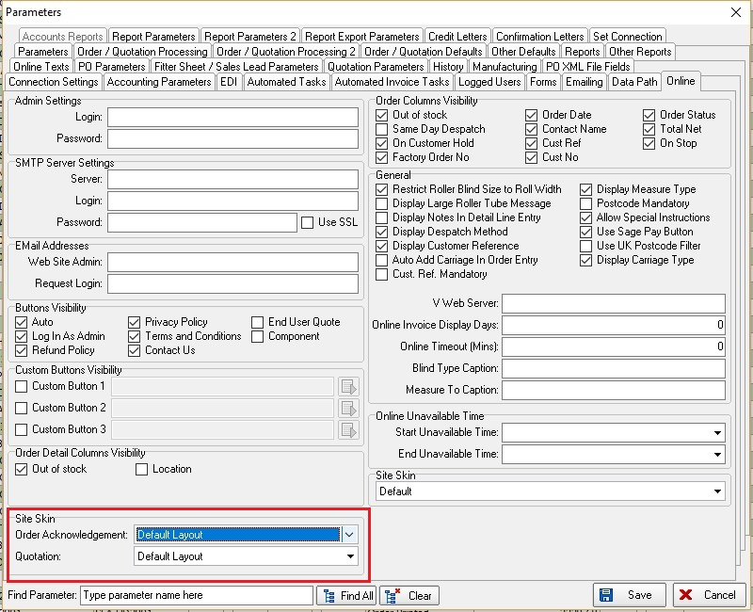

6722. Import From Excel > Velux Code Blind Types

There is now an import routine for importing records to this table.

6726. Order Enquiry > Blind Process Scan

There is a new field in the OrderDetail table called ‘Process Status’. When a process scan is done, as well as writing a new process transaction record, it updatse the process in the ‘Process Status’ field.

The ‘Process Status’ field is also be a new column choice in ‘Order Enquiry’.

6727. Order Enquiry > Roller/Vertical/Venetian Opt Export

Extra options are now exported when these buttons are used. See Redmine 7913.

6728. Order Amend Enquiry > Xero CSV Export

Two changes have been made to this file. See Redmine 8055.

6729. Label Print – Bespoke 47

There is a new report based on ‘Label Print – 3 ½ x 2A’. It print barcodes for the ‘Blind ID’ and for the ‘Serial ID’ on it. The ‘Made By’ has been moved to the bottom left of the report and the ‘Blind ID’ barcode prints above the ‘Serial ID’ barcode.

