Blindata Release Note 9.6.0 

2 August 2019

Bug Fixes and Enhancements

The following bugs were recorded in www.support.blindata.co.uk and have been resolved.

7753. Quotation Report Layout Request (Bespoke 83)
8063. Option prices in quotation
8203. Discount by Qty Query
8218. Re #8167 Rounding Issue on Vat Value Line
8228. unable to emaI invoices
8241. error when allocating payments against invoices

New Work and Customer Requests
5435. Roman Pocket Spacing

We have a customer who wants to be able to calculate pocket spacing for Roman blinds. There is a new system table called ‘Pocket Spacing’. This has fields for id (which refers to Austrian/Roman records in ‘Slat Description’, Drop, Pocket Spacing 1, Pocket spacing 2 through to Pocket Spacing 8. There are also fields in this table called ‘Number Of Pockets’, ‘Distance From Top’ and ‘Bottom Hem Marking’.

There is a method of importing this data from a spreadsheet, which has the same fields in it. The import is called ‘Pocket Spacing’ and is in Administration > Import From Excel.

There is also a new field in the blind type record if blind identifier = Austrian/Roman called ‘Use Pocket Spacing’ which defaults to false.

There is another new field in the blind type record if the blind identifier = Austrian/Roman’ called ‘Pocket Spacing’ which looks up the ‘Slat Description’ record in System Tables. This is only displayed if ‘Use Pocket Spacing’ is true.

It is now possible to create txt file that is generated from the ‘Order Enquiry’ form using a button called ‘Pocket Spacing File’. This has an advanced permission button.

The file generated is in this format.

Text file name: #123456.txt
# is the start character
123456 is variable order number
.txt is text file

Content

- “FILENAME” should exactly match the name of the requested software model in the Stores list

- The number of ”POCKET DISTANCE” should equal “NUMBER OF POCKETS”. This is a variable per order

- “POCKET LENGTH” is depth of pocket*2. Minimum value is 20, Maximum value is 40

- “MODE” is always set to 0

- “BOTTOM HEM MARKING” Marker line for bottom hem. Distance from the top of the blind to the marker line. If value = 0 marker is inactive
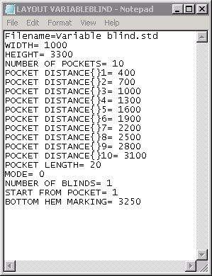

WIDTH = Width Exact
HEIGHT = Drop Exact
NUMBER OF POCKETS = ‘Number Of Pockets’ taken from ‘Pocket Spacing’ table according Drop >= Drop Exact.
POCKET DISTANCE{ }1 = ‘Distance From Top’ + Pocket Spacing 1 (both from Pocket Spacing table where Drop >= Drop Exact.
POCKET DISTANCE{ }2 = ‘Distance From Top’ + Pocket Spacing 1 + Pocket Spacing 2
Etc
POCKET LENGTH = Pocket Spacing 1 *2
MODE = 0
NUMBER OF BLINDS = Quantity from detail line
START FROM POCKET = 1
BOTTOM HEM MARKING = Bottom Hem Marking from ‘Pocket Spacing’ table.

If ‘Use Pocket Spacing’ = true, a barcode now print on ‘Works Order - Label Blind Size’. This is:

Barcode on order ticket
Barcode type: Code 128-B
Content: Order number (without any start character)

Example: Order number= 123456

Barcode: 

6482. Order Processing > Orders > Online / Web Service

Some improvements have been made to the functionality for finding a blind in order detail line entry.

There is no longer a separate button called ‘Online’, the functionality is included in the ‘Blind’ button now.

It is no longer necessary to enter a supplier before selecting a blind type in the order entry.

The selling price for the blind is still found by looking in Pricing > Price Table Enquiry and using ‘Supplier Code’ and ‘Supplier Blind Type Code’.

We will find the correct cost prices for the blinds because we can hold the ‘Online Authentication’ username and password to access the correct cost prices in the supplier Blindata database.

6566. Xero Integration

It is now possible to integrate Blindata to Xero using the Xero API.

Ideally we want to be able to post sales invoices, post sales receipts and allocate to sales invoices, and thirdly post purchase invoices. At the moment it is only possible to post sales invoices one at a time.

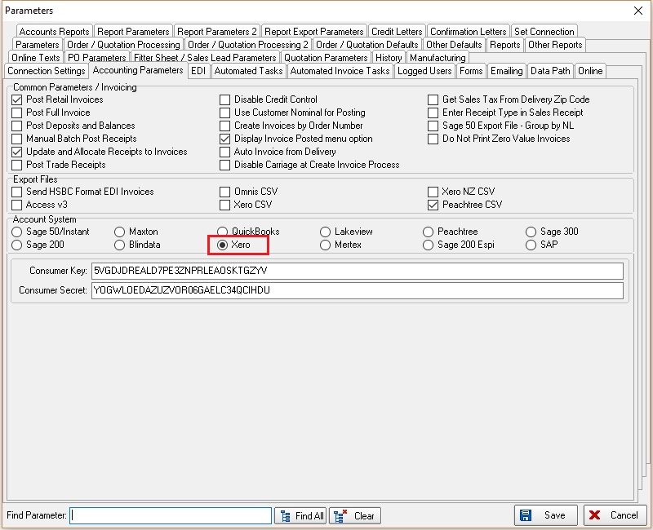

6593. Order Processing > Orders > Number Of Widths

For blind identifier = Curtain, it is now possible to enter number of widths to 1 decimal place ie 1.5. The number of width field will always be 1, 1.5, 2, 2.5, 3, 3.5 etc.

We also need to know whether a curtain is a single or pair. If it is a pair then the number of widths will be a whole number. It can only be a half size of width if it is a single.

There is also a decimal place in the ‘Number Of Widths field in Pricing > ‘Vanes Price Table’.

We changed the field NumberOf widths from Int to Real and changed the relevant code and stored procedures. We also changed NumberOfWidths field in the VanesPrice table to Real from Int.

6672. Automated Task Exe

There is now more room for the customer order number on the daily status report. Also this report now prints on 8.5 x 11 page size.

6675. Online Order Entry

Some adjustments have been made to the End User Quote functionality for online customers.

If the mark up % is used, the unit price and customer discount are no longer shown.

If Overall Price is used the VAT is now shown.

6679. Order Enquiry > Blind Process Scan

There is a new parameter related to bar code scanning called ‘Serial Scan Multi Transactions’ which defaults to false.

If this new parameter is switched on, ‘Blind Process Scan’ in Order Enquiry now has the following functionality.

The user is able to scan first serial id for an order detail line and if quantity on that order detail line is > 1, a prompt is brought up to ask for the quantity. Once entered correctly, process transactions will be written for all serial detail lines associated with that order detail line.

6680. Blind Details > Blind Types

There is a new flag called ‘Average Time Per Width’ in the blind type record. This will then be used for scheduling ie if a curtain or cushions uses 3 widths and the ‘Avg Man Time’ is set to 30 minutes in the blind type record, the scheduled time will be calculated as 90 minutes.

6682. System Tables > Dimension Codes

There is now a field choice for Quantity in the Formula. This is so we can handle products where more than one can be cut from a roll width. The ‘Quantity’ field is the quantity in the order detail line.

6684. Order Enquiry > Process Scan Matrix (Filtered)

There are now columns in this form to show ‘Order No’, ‘Customer Company Name’.

6686. Order Processing > Order Enquiry

The Repair flag in the order record is now a column choice.

6687. Order Processing > Orders > Drop Ship

If ‘Drop Ship’ is true in the despatch method (in System Tables > Despatch Method), the ‘Direct Delivery By Supplier’ flag in the order is set to true by default.

6688. Stock Items > Measurement Unit

We now hold measurement units for ‘Square Feet’ and ‘Square Metre’ in the ‘Measurement Unit’ field. This will now impact on the calculations made in the bill of materials if a formula is used which includes an item with these measurement units.

6690. Quotation > Detail Line Entry

If a blind type is ‘Bought In’ and also ‘Cost Price Related’ = true, the cost price can now be entered manually and saved.

This price is also saved in the order when the quotation is converted to an order.

6696. Pricing > Square Metre / Linear Width Pricing

The following fields have been enabled so they can be used in the pricing formula in Square Metre / Linear Width pricing.

