Blindata Release Note 9.4.9 

17 May 2019

Bug Fixes and Enhancements

The following bugs were recorded in www.support.blindata.co.uk and have been resolved.

7600. Inventory Shortfall Questions
7601. Developement #6520 - Label Special Instructions Printing
7614. paper size from A4 to letter
7642. Customer Transaction Report sort
7658. Invisible path error

New Work and Customer Requests
6402. Mixed Orders

There is now a ‘Mixed Order’ flag' on orders to denote there is a mix of different Blind Types on an order and/or different colours of a Blind Type in an order.

This 'Mixed Order' flag is available as an optional column in the Order Enquiry (Ctrl+E) screen.

6512. Suppliers > Purchase Order Enquiry

There is a new field in the ‘Purchase Order’ header form called ‘Supplier Promised Delivery Date’ and also for ‘Supplier Confirmed Despatched Date’. These fields are already column choices in ‘Purchase Order Enquiry’.

6553. Remittance – Bespoke 79

The check no. - date - amount now align properly horizontally.
The check verbiage amount now line ups and prints next to word "Pay"
The Payee now prints next to the "To the order of"

6554. Invoice – Bespoke 79

If the blind identifier = Vanes Only, the number of vanes now prints in the Width column instead of the width.

6559. Order Processing > Orders

It is now possible to select an invoice address in the same way as the delivery address can be selected in the order entry header form ie there is a new tab in the order entry form called ‘Invoice Address’ which is only displayed if ‘Is Variable Invoice Address’ is set to true in the customer record.

6560. Next XML File Import

It is now possible to receive XML file format (our format) from a sftp site, which is then imported to Blindata.

This means we need to hold the sftp details against the customer record. When the EDI import is done, it will now look at the ftp folder in Administration > Parameters > EDI and also in the folder set up in the customer record.

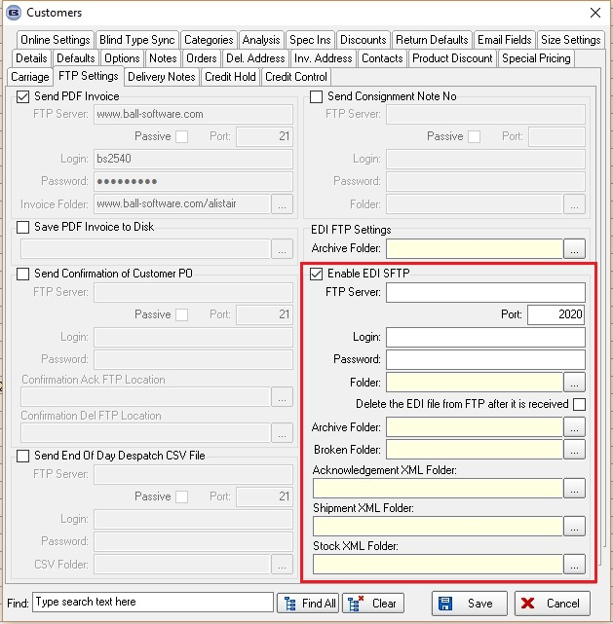

6561. Next XML File Creation

It is now possible to export XML files for Next according to specifications received. See dev item above.

The sftp connection settings for each of these files that are sent are held in the FTP Folder tab in the customer record in new fields for sftp.

6564. Online Order Entry

The functionality described in Redmine 7555 (where the option can be linked to the ‘Measure To’) has also been applied to the online order entry.

6567. Invoice – Bespoke 37

Some amendments have been made to ‘Invoice - Bespoke 37’. See Redmine 7599.

6568. Purchase Order Regular – Bespoke 37

The cost price shown is now the ‘Cost Price’, not the ‘Unit Cost’.

6572. Acknowledgement – Bespoke 73

If ‘If Metric Use Centimetres’ is switched on, the sizes on this report will appear in centimetres.

The date format is now correct.

The ‘Despatch Method’ now prints in the header.

The fabric supplier now prints in brackets after the fabric description.

The fabric price (entered in the detail line) now prints after the fabric supplier.

The ‘Number of Widths’ now prints if blind identifier = Curtain. This prints to the right of the fabric price.

The header for making price now prints (if blind identifier = Curtain or Roman).

The Lining quantity now prints (if Lining option has been selected) in brackets after the lining option.

6573. Works Order – Bespoke 73

If ‘If Metric Use Centimetres’ is switched on, the sizes on this report now appear in centimetres.

6574. Works Order – Bespoke 72A

Some amendments have been made for this report – see Redmine 7575.

