Blindata Release Note 9.3.6 

15 February 2019

Bug Fixes and Enhancements

The following bugs were recorded in www.support.blindata.co.uk and have been resolved.

6918. On Credit Hold
6928. Hide detail line discount flag in quotation record not working - bespoke 70
6941. Blind Type Fabric Group
6944. Sales Reports>Aged Debtors Analysis(summary)
6955. Order Processing > Buy In / Manufacture
6976. Adding Carriage at the Invoice stage of a delivered Order

New Work and Customer Requests
6318. Online Order Entry

For vertical blinds online, the number of vanes is now calculated and displayed.

6319. Blind Types > Control Length

At the moment we can specify a chain length by a formula in Blind Types > Chain Length tab. However this only works for certain customers. There is now another column in this form for ‘Option Choice’, so if a particular option is chosen in the order detail line, the chain length is recalculated.
If there is no option choice set in this form, then it will work in the way it currently does.

6355. Administration > Export Data > Discounts

There is a new option to export ‘Discounts’. This has the same file format as the new discount import (see dev 6213).

6363. EDI Import > Minimum Sizes

If ‘Imperial Setup’ = true in Parameters, there was an error when checking minimum / maximum widths and drops – it was converting to millimetres, and if the inches entered were lower than the ‘Minimum width’ or ‘Minimum Drop’, a message appeared saying the blind is too small. This has been resolved.

6365. EDI Import > CompAccCode

The outer customer code has been changed to 20 characters.

6367. Online Ordeing

The following actually relates to all USA online ordering sites. All desktop versions will be set up as ‘Imperial Setup’ = true.

If ‘Imperial Setup’ = true,
‘Customer Reference’ now says ‘Sidemark’
‘Customer Order No’ now says ‘PO Number’
‘Fabric’ now says ‘Material Color’.
‘Make Selection’ is in color.

If Parameters > Online > ‘Display Measure Type’ is set to false, then ‘Measurement’ does not appear in the online order detail line entry – it will always be Imperial. (We already hide the ‘Measure Type’ in the order header entry).

6376. Order Processing > Orders > Status Field

It is now possible to edit invoice number in the ‘Status Field’ form. There is an advanced permission button to do this called ‘Edit Invoice Number’.

This will create an order history record as well.

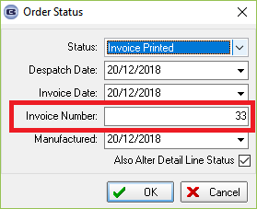

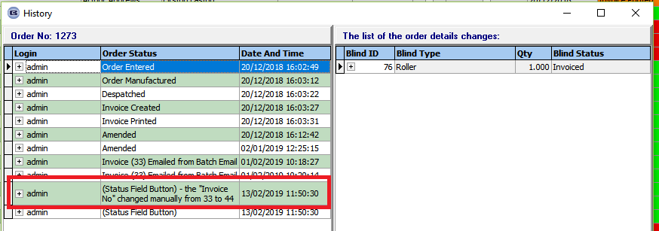

6378. Post Invoices

If an order has no invoice date, it is no longer possible to post it. A message appears saying ‘This invoice has no invoice date so cannot be posted’.

6384. Online Order Entry

The ‘Replace Base Price’ function in ‘Option Price Enquiry’ is now included in the online detail line entry pricing.

6386. Sales Files > Post Receipt > Automatic

A rounding issue sometimes caused there to be a 0.01 outstanding on invoices when a receipt was allocated to an invoice.

This in turn led to an incorrect message asking if an unallocated receipt should be posted.

Both issues have been resolved.

6388. Invoice – Bespoke 72

The invoice company name is now the ‘Customer Company Name’ and not the ‘Delivery Company Name’.

The ‘Customer Order No’ has been added to the header. This goes beneath the ‘Cust Ref’ so this will make the header slightly larger.

6390. Acknowledgement – Bespoke 72

The ‘Customer Order No’ has been added to the header. This goes beneath the ‘Cust Ref’.

6391. Delivery Docket – Bespoke 72

The ‘Customer Order No’ has been added to the header. This prints beneath the ‘Cust Ref’.

6392. Credit Note – Bespoke 72

The ‘Customer Order No’ has been added to the header. This goes beneath the ‘Cust Ref’ so we have made the header slightly larger.

