Blindata Release Note 9.3.4 

2 February 2019

Bug Fixes and Enhancements

The following bugs were recorded in www.support.blindata.co.uk and have been resolved.

6620. Incorrect price returned for component using component group list when a stock code has three price types in the unit of sale tab
6668. Bespoke 70 Invoice - Display text detail only and price total by group
6774. Options within order duplicating totals on works order - Bespoke 72
6858. fabric group setup
6860. Import From Excel > Audit Transactions

New Work and Customer Requests
6339. Sales Files > Customers > Email Fields

There are two new fields called ‘Invoice Email 2’ and ‘Invoice Email 3’. If these are filled, then when invoices are emailed, they are copied to these addresses as well. This applies to Order Processing > Orders > Email Invoice and also to Financials > Invoice Batch Print.

6345. Order Processing > Orders > Buy In / Manufacture

If an order has been entered with a detail line for a blind type that has ‘Stock Control’ = true and ‘Buy In / Manufacture’ = true and the detail line is saved as a ‘Bought in’ blind, the cost price is displayed on the right hand side, as it does for a normal bought in blind.

6347. System Tables > Department Nominal Codes

If ‘Use Department Nominal Codes’ is switched on, the sales nominal code for a blind type is taken from the ‘Department Nominal codes’ table.

For a bought in blind, we now do the same for the cost nominal code. There is a new field in the ‘Department Nominal codes’ form called ‘Cost Nominal Code’.

This 'Cost Nominal Code' is taken from the 'Department Nominal codes' in Purchase Order Enquiry > Update if ‘Use Department Filter’ is switched on.

So if there is a 'Cost Nominal Code' in the 'Department Nominal Codes' table for that blind type it uses that, otherwise it uses the existing logic, which is to use the 'Cost Nominal Code' in the blind type record. This is only for bought in blinds.

6348. Fitters Sheet / Sales Leads

There is now a button on this form so employees can be filtered by department. The form defaults to show ‘All’ but then has a filter by department.

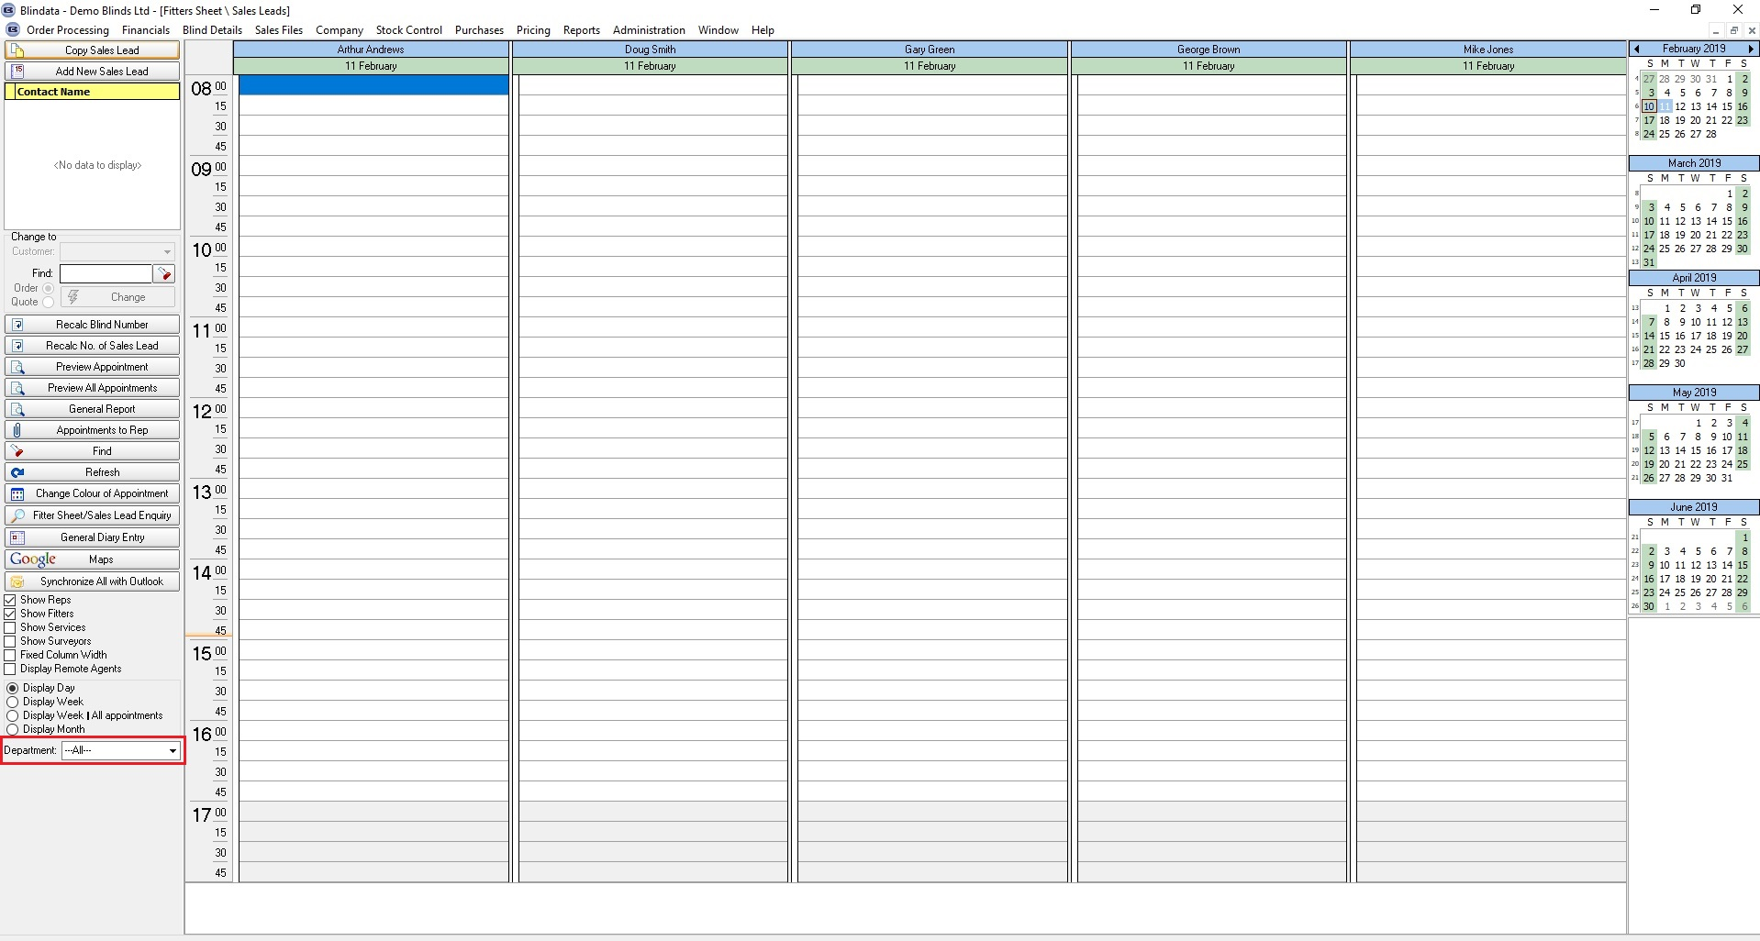

6350. Maintenance > Clear Product Blind Types

This has been amended so it only removes records where link option = Fabric.

6352. Acknowledgement – Bespoke 34

There is now more room for the products to appear. Previously the field was cut off.

6353. Works Order – Bespoke 34A

The Location field is n longer in bold, it is a font size smaller and prints in a larger space.

6358. Sales Files > Reports > Sales Invoice Payment Report

Invoices which are for dates before the start and end date for this report now appear if the receipt falls between the start and end date.

