Blindata Release Note 9.2.9 

28 December 2018

Bug Fixes and Enhancements

The following bugs were recorded in www.support.blindata.co.uk and have been resolved.

6611. Parameters > Use Landed Cost In BOM
6576. Bespoke 70 quote - Display text detail only and price total by group
6527. URGENT - Error in Customer Update from Mertex in LIVE SYSTEM

New Work and Customer Requests
6283. Blind Details > Blind Types

There is now a new context menu option called ‘History’. All changes to the blind type record are recorded and displayed in this ‘History’ form.

6284. Stock Control > Reports > Out Of Stock Sales Orders

This report now only shows orders where order status = ‘Order Entered’ or ‘Order Printed’.

6285. Order Processing > Orders

There is now a column choice for ‘Delivery Notes’ in the Order Amend Enquiry form.

6286. Quotation – Bespoke 52

The ‘Hide Detail Lines’ flag in the quotation record now works with this report.

6287. Works Order – Bespoke 75

We now display the total number of blinds on the order on this report and also the breakdown by blind type.

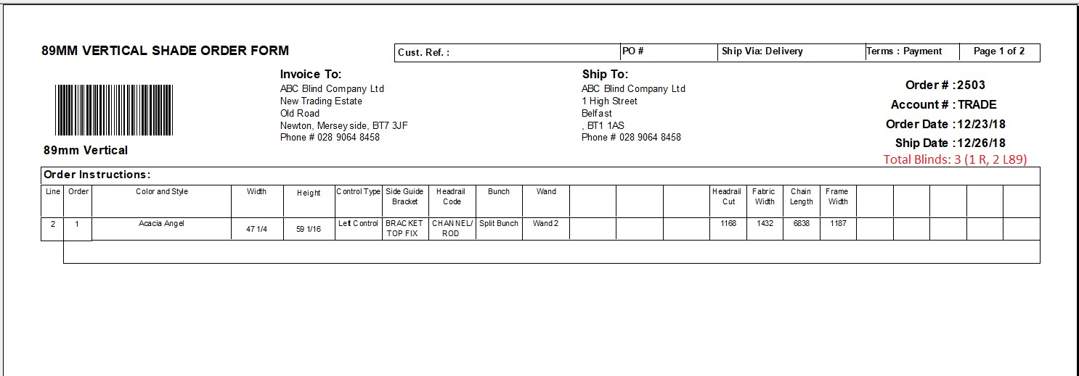

6289. Works Order – Bespoke 80

There is a new works order layout called ‘Works Order – Bespoke 80’, which is based on ‘Works Order – Bespoke 70.’. The only difference is that all the sizes entered for a shutter now appear, so all the fields in red boxes now appear here on the lhs of the works order (1).

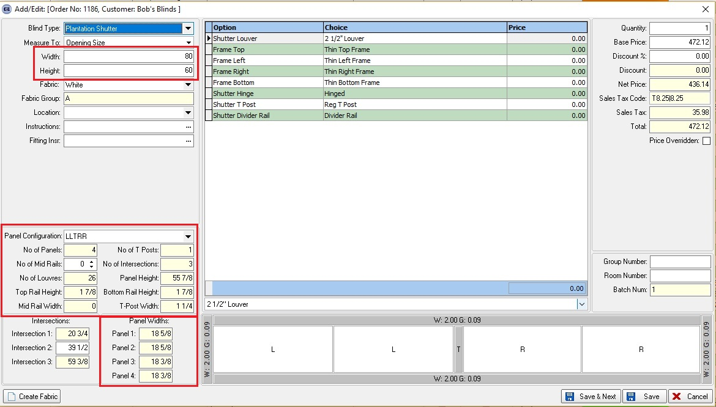

The cutting sizes for shutters also appear in the right hand section for cutting sizes (2).

Not in List. Shutter Entry Fixes

1. Fixed Validation at Shutter Formula entry for Shutter Cutting Sizes.
2. Fixed Frame sides displaying.
3. Fixed Configuration initialization.
4. Fixed Shutter Cutting Size > Quantity calculation.
5. Fixed Adding records to Shutter Cutting Options tab (Formula validation added).

