Blindata Release Note 9.2.6 

7 December 2018

Bug Fixes and Enhancements

The following bugs were recorded in www.support.blindata.co.uk and have been resolved.

New Work and Customer Requests
6234. Projects > Attachments

It is possible to add an attachment to a Project. It is also possible to display a ‘Project attachment’ button on the ‘Order Amend nquiry’ form. There is an button visibility flag for this in Adminiatration > Users.

6242. System Tables > Extra Cost Reason

There is a new system table called Extra Cost Reason

6264. Order Processing > Order Enquiry

There is a new context menu choice called 'Process Scan Matrix(Filtered) which will show the process scan matrix for all filtered records in Order Processing > Order Enquiry. This is displayed in the same style of form as the ‘Process Scan Matrix’ in Order Processing.

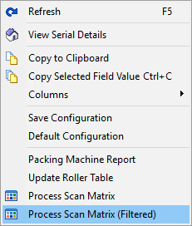

6268. Label Print – Bespoke 26

There is a new label print called ‘Label Print – Bespoke 26’ which is based on ‘Label Print – Bespoke 75’ but with a layout as follows;

6269. Label Print – Bespoke 67

The ‘Pleat Count’ now appears on this label if blind identifier = Pleated.

6271. Financial Reports > Outstanding Retail Debtors

The fields no longer overlap each other. The ‘Order Contact Name’ has been moved left a bit (increasing the width of the field) and then cut off instead of overlapping into the next field. The font has also been made smaller in the details section.

6275. Works Order – Bespoke 79

The ‘No. Of Vanes’ now prints if the blind identifier = Vertical or Headrail Only or Vanes Only.

