Blindata Release Note 9.2.5 

30 November 2018

Bug Fixes and Enhancements

The following bugs were recorded in www.support.blindata.co.uk and have been resolved.

6490. Stock Control > Reports > Stock Valuation
6491. Sales Files > Reports > Sales Audit Report
6492. Import From Excel > Audit Transaction Import

New Work and Customer Requests
6244. Quotations > Projects

There is now a ‘Contact Management’ button in the Projects form.

6255. Purchase Order Enquiry > Amend

This relates to regular purchase orders and the delivery of them. At the moment the ‘Amend’ button is used to do this and delivers the detail line that is being pointed at. The following form is then displayed.
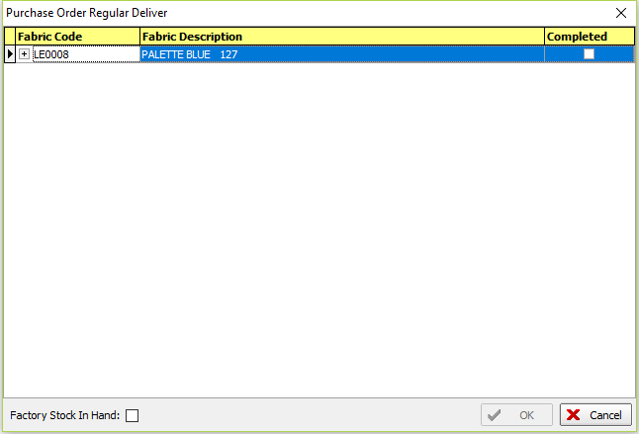

As well as pointing at the relevant detail line, it is now possible to scan the barcode for the item and this will then bring up the above form. There is a new button for this called called ‘Regular Deliver Scan’.

There is a new user permission for this button.

6261. Administration > Import From Excel > Process Times

There is now an import routine for 'Process Times' which updates records in Blind Types > Process Times tab. This will import fields for blind type, process type, man location, employee, width, drop, time.

If records already exist blind type, man location, process type and employee, they will be overwritten by the import.

6262. Label Print – Bespoke 33B

The special instructions on the right hand label were being overwritten by the cutting sizes, so have been moved down a line.

The carriage type has also been added to this label.

6263. Invoice – Bespoke 31

The 'Invoice Terms' now prints from the department record and not 'Company Details'.

6265. Pricing > Velux Price Table > Copy

This form now behaves in the same way as the ‘Global Price Uplift’ in Pricing > Price Table Enquiry.

If the following is selected, then all records for blind type = Velux Roller should be copied. See Redmine 5940.

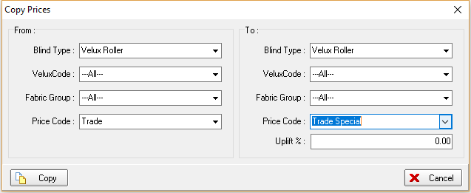

6266. Stock Control > Stock Transaction Entry

If the employee name is entered in the stock transaction entry, this is now saved in the stock control history record that is created.

