Blindata Release Note 9.1.8 

12 October 2018

Bug Fixes and Enhancements

The following bugs were recorded in www.support.blindata.co.uk and have been resolved.

6054. Adding new customer after software update
6149. Child Safety Rules
6150. Failed Customer Update from Mertex to Blindata
6178. Mixed orders (Bought-in and Manufactured) printing of works orders

New Work and Customer Requests
5990. Peachtree Sales Invoice Export

There is a new flag in Parameters > Accounting Parameters called ‘Peachtree CSV’. If this is selected, and the ‘Detail Lines Export’ button is used in Financials > Post Invoices, the layout of the export file is altered to the following.

Column Field
A Customer account code
B Invoice no
C Invoice date
D Always ‘FALSE’
E Delivery company name
F Del add 1
G Del add 2
H Del add 3
I State code and zip eg PA 15317
J Cust ord no
K Cust ref
L Invoice due date
M Rep
N Debtors control nominal code
O Leave blank for now
P No of detail lines
Q If tax line then = 0, otherwise Quantity from detail line
R Blank if tax line, ZDEPOSIT if receipt line, otherwise blind type description
S Tax code if tax line, ‘Deposit, Miscellaneous’ if receipt line, otherwise fabric description, option list
T sales nominal code from blind type record
U 0 if tax line, Unit cost from detail line, if receipt them total amount
V 0 = tax line, 1 = deposit, 2 = invoice
W Tax amount if tax line, Net amount, full amount if receipt
X Tax code if tax line, otherwise blank.

There are 3 types of record that could go into this export file. Column V determines what the line is.

0 – this is just for the tax part of the order detail line. Let’s say the detail line is for 100.00 and 20.00 VAT. The 20.00 will appear in this line.
1 – if there is a receipt entered against the order, then it should be held with a 1 against it. The amount exported will be the full amount ie including tax.
2 – this is the detail line amount, excluding VAT.

6093. Pricing > Velux Price Table

There is a new field in this form called ‘Price Uplift %’, which defaults to 0. If an amount is entered, then the price should be uplifted by this %, in exactly the same way as it is done in ‘Global Price Uplift’ in Pricing > Price Table Enquiry.

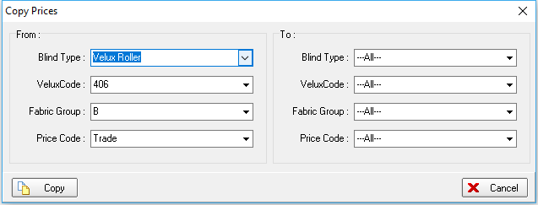
6159. Rework Cost Report

Some improvements have been made to this report.

There is now criteria to select this by Department or Rep and also group by Department or Rep.

There is an option to export this report to an Excel sheet with extra fields in it. These are the same fields as currently are there (Order No, Original Order No, Customer, Original Cost, Rework cost, Net Price, Overall Cost) plus Department, Customer Reference, Products, and then if there is a contact record tied to the order ‘Contact Action’ and ‘Further Details’.

6163. Order Amend Enquiry > Quickbooks Export File

The value in the field “Txn Status” has been changed from 0 to NON (only if the tax rate = 0), also the blind type description now goes in the “Item Ref” field (instead of the current line no).

