Blindata Release Note 9.1.6 

28 September 2018

Bug Fixes and Enhancements

The following bugs were recorded in www.support.blindata.co.uk and have been resolved.

6023. Error when adding new customers
6040. Works Order - Bespoke 76
6042. Order close
6052. Setting Up A New Account
6054. Adding new customer after software update
6083. Order Processing > Orders

New Work and Customer Requests
6120. Order Processing > Orders > Create PO

When the Create PO button is selected – it creates the Regular PO and then processes for the EDI transaction exactly the same as the bought in. It now updates the Order status to order printed even if there are only Wholesale blinds on the order and flags the PO as sent.

The functionality now works the same way as it currently does for a bought in order. It therefore also works the same way if there is a bought in PO and regular PO created from the same sales order and also if there is just a regular PO created.

This has been done by introducing a new flag in the stock record called ‘Single Regular PO’. This field can also been seen in the component order detail line entry if the permission is switched on in Administration > Users > Forms Visibility > Components Form.

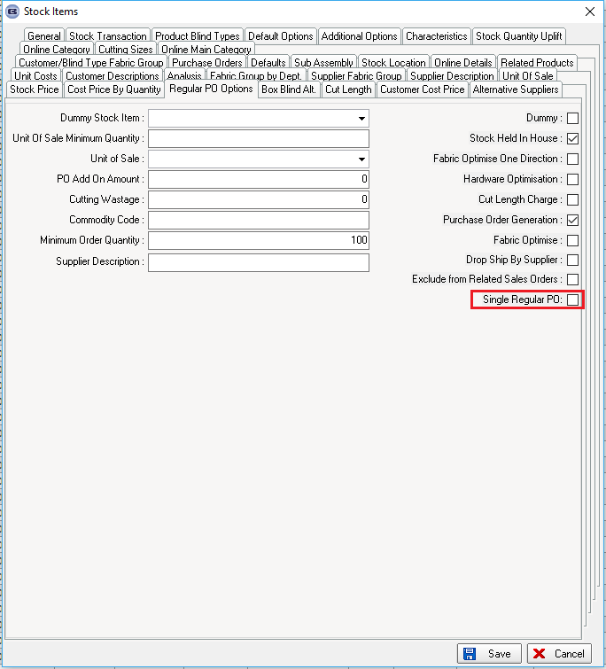
6151. Works Order – Bespoke 79

A new works order has been created called ‘works Order – Bespoke 79’, based on ‘Works Order – Bespoke 76’. See Redmine 5791.

6152. Acknowledgement – Bespoke 79 (Partly – without Handling Fee)

A new order acknowledgement report has been created called ‘Acknowledgement – Bespoke 79’ based on ‘Acknowledgement – Bespoke 70’.

6153. Label Print – Bespoke 79

A new label print report has been created called ‘Label Print – Bespoke 79’ based on ‘Label Print – Bespoke 74’.

6154. Delivery Docket – Bespoke 79

A new delivery docket report has been created called ‘Delivery Docket – Bespoke 79’ based on ‘Delivery Docket – Laser Print 8.5 x 11’.

