Blindata Release Note 9.1.5 

21 September 2018

Bug Fixes and Enhancements

The following bugs were recorded in www.support.blindata.co.uk and have been resolved.

5603. eCommerce | Max lengths available on Fabric
5914. Still Slow
5951. Unattended Online Sync
5994. Stock take history
6014. Order Processing>Orders>Orders

New Work and Customer Requests
6096. Sales Files > Customers > Email Fields

There are now 4 extra email fields here called ‘Order Ack 2 Email’, ‘Order Ack 3 Email’, ‘Order Ack 4 Email’ and ‘Order Ack 5 Email’. If these are filled, when an order acknowledgement is emailed, it is also copied (as a CC) to these email addresses.

6132. Rework Cost Report

There is a new report in Reports > System Reports called ‘Rework Cost Report’.

This has criteria by start and end order date, rep, department

The report has columns for order number, original order number, customer, original cost, rework cost, net price and ‘Overall Cost’, which will be the net price – original cost – rework cost.

This report should only show orders where either Rework = true or Repair = true.

6133. Rework / Repair / Redespatch

There are now new flags for ‘Contact Record for Repair’ and ‘Contact Record for Redespatch’ in Administration > Parameters, below the existing ‘Contact Record for Remake’ flag.

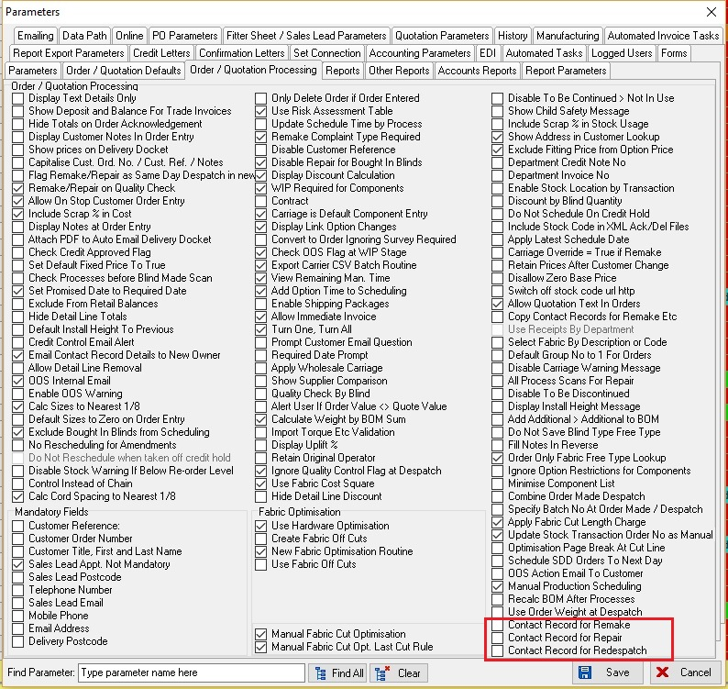

6135. Roll Out Production List

There is now a ‘Notes 2’ column on this report.

6136. Production List Summary By Day

There is now a choice to group this by blind group as well as by blind identifier. There is a new criteria to group this report by either ‘Blind Identifier’ or ‘Blind Group’. The default is by blind identifier.

6138. Archive Enquiry

There is now a column choice for Notes 2.

6140. Label Print – 88mm x 35mm

Moved blind type up a line, so there is room to print Spec Ins at bottom in bold.

6150. Stock Control > Reports > Stock Valuation

There is a new criteria on the ‘Stock Valuation’ report called ‘Current Cost Only’ which defaults to false. If it is false, then the cost prices (and landed cost prices) are taken from the stock transaction record if ‘Batch Numbering’ = false and from the batch record if ‘Batch Numbering’ = true. If ‘Current Cost Only’ = true, then the cost price is only be taken from the stock control general tab for both cases.

