Blindata Release Note 9.1.4 

14 September 2018

Bug Fixes and Enhancements

The following bugs were recorded in www.support.blindata.co.uk and have been resolved.

5913. Exporting Sales Analysis from Azure
5914. Still Slow
5916. works order print
5934. bespoke 77 picking
5936. Global
5930. Wild and erroneous variations in Stock Valuation

New Work and Customer Requests
6106. Sales Files > Customers

There is a new tab on the customer form called ‘Credit Hold’. This will allow the user to take multiple orders off credit hold at once.

6111. Customer Delivery Times

There are now default start and end delivery times held against the customer record.

The order now also holds a start and end delivery time, which default to the times in the customer record, but it should be possible to edit these. They are held in the delivery address tab in the order form.

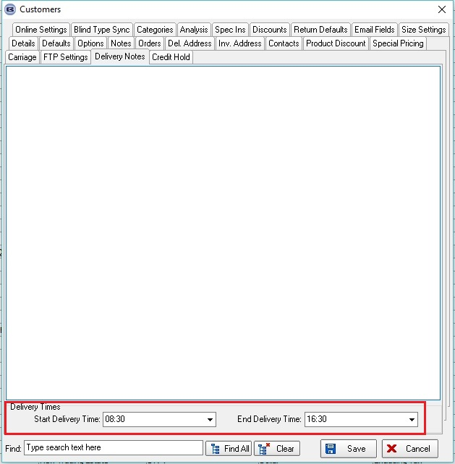

6112. Order Processing > Orders

There is a new flag held against the order (in first tab) called 'Disable Postcode Despatch Method', which defaults to false. If true, the despatch method will not look up the despatch method held against the postcode record.

6113. Import From Excel > Postcodes

The Import From Excel > Postcodes import has been amended so we can import 'Despatch Method' and 'Carriage Type'.

6114. Order Processing > Orders > Split Order

When an order is split, and if there is data in the ‘Notes’ field, there is now a question ‘Do you want to copy the notes to the new order?’ with a Yes or No prompt.

6115. Customer / Supplier Account Codes

If Sage 50 is being using as the accounting software, then the customer and supplier account codes is now restricted to 8 characters.

6121. Stock Control > Reports > Stock Valuation

This report now takes up less space, as a result of the following changes

Extended the stock description if ‘Location’ is not chosen, so it is only printing on one line.

Cost price, quantity and stock value now only show to 2 decimal places.

6122. Stock Control > Stock Transaction Entry

On the stock transaction entry, the batch number is now saved in the stock transaction record as well as in the Batches record.

After completing a Stock Transaction Entry and taking 10 off stock, the total at the bottom the quantity field reduces this.

There is a new column choice called ‘ST Batch No’ added to Stock Transaction tab.

6123. Stock Control > Stock Take Entry

The manual stock take entry now updates the stock in hand figure correctly.

The batch number is also stored in the stock transaction record as well as in the batches record.

6124. Stock Items > Stock Transaction tab

The amount at the bottom of this form was adding receipts and issues. It now adds receipts but subtracts issues, and completely ignores stock take records.

6125. Administration > Maintenance

There is a new option called ‘Clear Stock Transactions’. This removes all stock transactions in the system. It also removes all batch stock transactions as well.

6126. Stock Control > Stock Enquiry

There is now a button for ‘Landed Cost’ so we can show the FIFO landed cost for filtered records. This should take into account batch transactions if there are any. There is an advanced permission flag for this button.

Each stock record should show the landed cost for that stock record (ie the sum of the batches for that record) and then there should be a total at the bottom of the form.

6128. Stock Enquiry > Stock Take Export

The stock take export file that is created using the ‘Stock Take Export’ button in the Stock Enquiry form now matches the ‘Stock Take Import’ file layout that is used in Stock Take Entry > Import.

This takes into account stock records that have batch transaction records as well.

