Blindata Release Note 9.1.1 

17 August 2018

Bug Fixes and Enhancements

The following bugs were recorded in www.support.blindata.co.uk and have been resolved.

New Work and Customer Requests
6076. Returned Cheques

There is now new functionality to handle returned cheques. A returned cheques is one that has been sent in by a customer, entered into an accounts system and then lodged with the bank. However the bank then return the cheque because there is not enough money in the customer’s bank account to cover the cheque.

There is a new button on Sales Files > Customers called ‘Write Offs/Returns’. This has an advanced permission button.

This button will allow a user to enter a transaction for a returned cheque. The relevant receipt should be selected as follows.

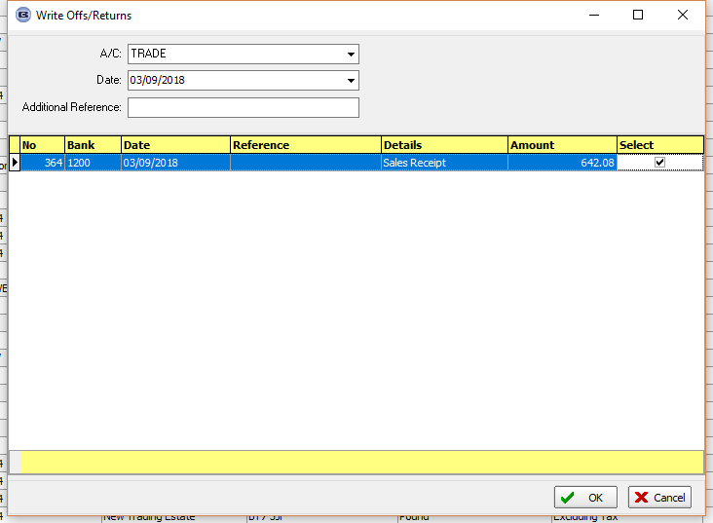

Once this has been selected, a new SP transaction will be created.

6078. Administration > Maintenance

If a customer alters the file attachment folder (in Administration > Company Details) there is now a routine to alter the file attachment links to the new folder. There is a new Maintenance option called ‘Reassign Attachment Folder’ which allows the user to enter the old and new folder and then change the folder for all file attachments.

6082. Order Enquiry > Deliver Order

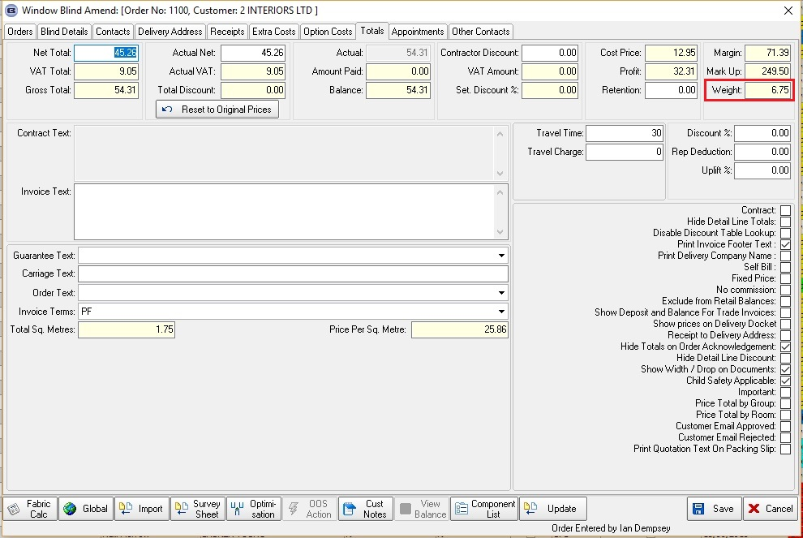

There is a new parameter called it ‘Use Order Weight At Dispatch’ which defaults to false. If it is set to true, the total weight of the blinds in the order is displayed in this window.

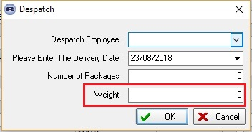

6083. EDI Import

If a blind type has been set to ‘Inactive’ or ‘Not In Use’ it is no longer possible to import a blind for this blind type in the EDI Import.

If an order has a blind type in it that is inactive, none of the blinds in the order will import. A new status called ‘Rejected’ has been created to deal with this.

There is also a new button called ‘Mark As New’ which will reset the transaction status to ‘New EDI Transaction’ so the record can be imported.

6084. Order Processing > Orders

We recently added a flag to a stock item called ‘Tick Price Overridden’. If this is set to true, then it ticks the Price Overridden flag in the order detail line entry. However it does this as soon as the fabric is selected. It is now done when the when ‘Save’ is selected – the reason for this is that option prices may get changed before the record is saved, and it kept bringing up a message that the ‘Price overridden’ button had been ticked.

6085. Stock Control > Fabric Group Setup

‘Non Discount Item’ is now a choice for a column and also for updating the field.

6086. Works Order – Bespoke 33B

The Benthin barcode has been moved up 2mm – because the numbers below it were not printing on the label – they went over the cut.

6087. Order Processing > Orders

If ‘OOS Action Email To Customer’ parameter is switched on, then these fields appear in the order detail line entry. These fields now only appear if the parameter flag is switched on and the order detail line is ‘OOS’.
