Blindata Release Note 9.1.2 

31 August 2018

Bug Fixes and Enhancements

The following bugs were recorded in www.support.blindata.co.uk and have been resolved.

5809. Purchases > Purchase order enquiry > Generate Regular PO
5826. Report totals
5831. Order Processing > Quotations
5839. Quotation - Bespoke 21 (email version)
5841. Error Printing Delivery Dockets
5848. WORLD orders printing 2 x Export Invoices for payment
5849. Cheque printing
5851. Reports
5864. Sales Invoices

New Work and Customer Requests
6088. Quotation – Bespoke 31

If there is a separate discount % for an option, it no longer shows the main discount % on the quotation. The same change should be made in ‘Acknowledgement – Bespoke 31’.

6089. Stock Items > Option Colour

At the moment there is a flag ‘In Colour In Option’. If this is set to true, then the option prints in red on ‘Label Print – Bespoke 33B’. It is now possible to print options out in different colours on this report so there is a new field in the stock record to define the colour. It is called ‘Option Colour’.

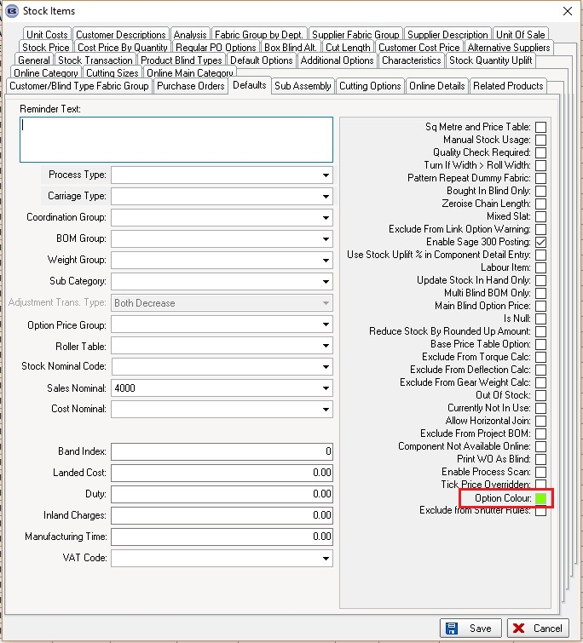

6090. System Tables > Velux Codes

There is a new field in Velux Code table called 'Supplier Velux Code'. There is also an option to import this new field - previously there was no import function for Velux Codes.

The ftp csv file that gets sent to Bloc (‘Ftp CSV Semi Colon Separated File’ = true in the supplier record) has been changed so it contains the Supplier Velux Code and Supplier Part No instead of Velux Code and Stock code.

6091. Invoice – Bespoke 31

We now hold the bank account name, bank account code and sort code against the department record and pull this from here on this invoice. These fields go in the footer of the invoice – previously they were taken from the Company Details record.

6099. Reports > Purchase Analysis > Purchase Order Analysis

The supplier name now also appears on this report.

6100. Quotation – Bespoke 34

The ‘VAT’ and ‘Total’ now appear in the footer of this report. This appears beneath ‘Total Net Value of Proposal’.

6101. Reports > Sales Analysis

If a user is set up so they cannot see cost prices (Users > Advanced Permission > Order Amend Enquiry > Display Costs = false), the cost prices no longer appear in the relevant sales analysis reports. Also the profit and contribution columns do not appear.

The following reports have been changed:

Sales analysis by all blind types
Sales analysis by blind group by blind type
Sales analysis by blind type
Sales analysis by blind type by BOM group
Sales analysis by customer
Sales analysis by customer by net
Sales analysis by product

