Blindata Release Note 9.0.3 

22 June 2018

Bug Fixes and Enhancements

The following bugs were recorded in www.support.blindata.co.uk and have been resolved.

5315. PO Labels for stock codes with 'Fabric' link option
5343. Work order bespoke 70 A / B Section and page numbers incorrect when BOM is split between two pages.
5364. Stock valuation report

New Work and Customer Requests
5958. Order Processing > Orders > Global

It is now possible to change a free text fabric in Global, and if the following flags are switched on, it also means being able to change pattern repeat, roll width and price.

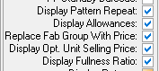

5962. Order Processing > Orders > Cust Own Fabric

If ‘Cust Own Fabric’ is chosen and ‘Replace Fabric Group With Price’ is true, the price will be 0 which means the base price will be 0, so we need to tick ‘Price overridden’ automatically.

Therefore there is a new flag held against the stock record called ‘Tick Price Overridden’ which defaults to false. If true, when the order detail line is entered, the ‘Price Overridden’ flag will be set to true automatically.

5984. Order Processing > Orders > Manual Scheduling

We have a customer that wants to manually enter schedule dates against blinds ie they will not be using ‘Production Scheduling’, they just want to be able to enter a date in the ‘Schedule Date’ field.

There is a new flag called ‘Manual Production Scheduling’, which defaults to false. If true, then the user is able to edit manually the ‘Schedule Date’ against an order detail line.

There is also a column choice for ‘Schedule Date’ in the ‘Window Blind Amend’ form and the field is editable.

5993. Purchase Order Enquiry

We have made a number of changes to the way this is working if ‘landed costs’ are included. This works for Cost Method ‘AVCO’, ‘FIFO’ and ‘Current Cost’.

This takes into account stock items where ‘Batch Numbering’ = true, account suppliers that are set up in non base currencies, and also ‘Landed Cost’, which is the cost price of the product + duty % and freight %.

Let’s take the following example. There is currently no stock in hand for this item, B02.08.50AL190150. There is a base cost price of 16.61 and a USD price of 22.09. This represents an exchange rate of 1.33 between Pounds and Dollars.

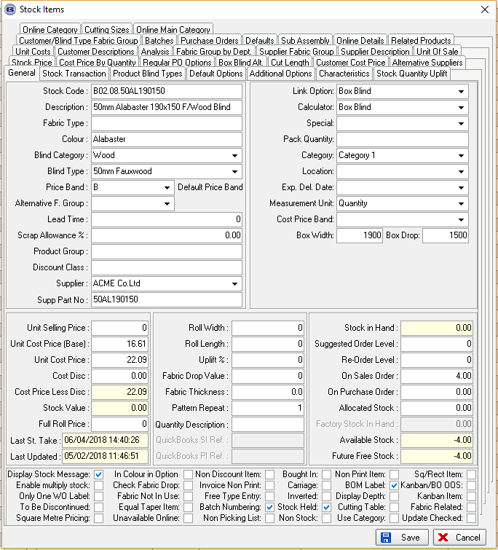

Let’s enter a regular PO for this product, but change the exchange rate to 1.20, have 6.25% duty and 3% freight.

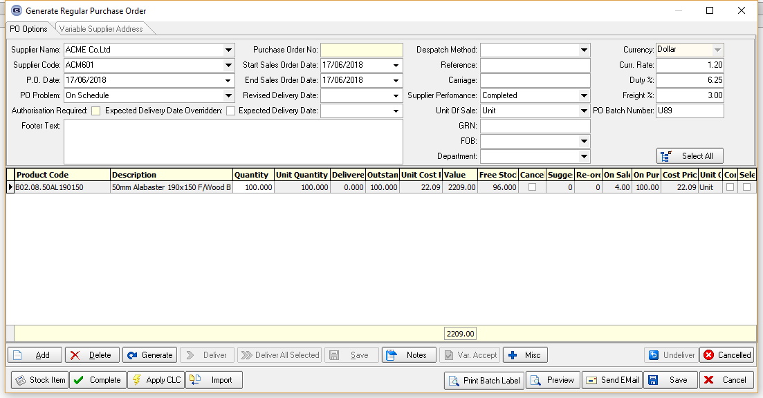

Once this is entered, the ‘On Purchase Order’ amount increases to 100, which is correct.

The PO then has to be delivered – this can be done in two different ways, either by individual line or all at once. Here is by individual line, and let’s say the dollar price remains the same. The price entered at this point is now the material currency cost ie 22.09.

Several other issues have been resolved.

- It has not updated the ‘Unit Cost Price’ and ‘Unit Cost Price (Base) in the stock record incorrectly.
- It has updated the cost price correctly in the ‘Stock Transaction’ record and a new field ‘Landed Cost’.
- It has updated the cost price correctly in the ‘Batches’ record, both Unit cost price and Landed Cost.

5994. Order Enquiry > Blind Made / Order Made

If a box blind in BOM is set up as ‘Batch Numbering’ = true, the ‘Stock In Hand’ amount and batch record stock in hand are now updated when ‘Blind Made’ or ‘Order Made’ is done.

See Redmine 5326.

5995. Picking List – Bespoke 70

There is a new report called ‘Picking List – Bespoke 70’, which is based on ‘Picking List – Bespoke 37’. There are two main differences required, though.

The ‘Serial ID’ barcode now prints in the detail line.

The detail lines that print out look at the flag ‘Only 1 WO Label’. If this is set to true then if the Quantity > 1 only 1 serial detail line prints and the barcode should be the serial id for the first one.

If ‘Only 1 WO Label’ = false, and Quantity > 1, each serial detail line prints along with each barcode.

5996. Order Enquiry > Blind Process Scan

Labels are now printing based on man process scans for blind detail lines and component detail lines.

For component detail lines there is a 'Tagging Label' that prints after the label that is triggered form the blind process scan. This has been disabled.

5997. PO Label – Bespoke 70

Labels will now print for stock items where the link option = Fabric.

5998. Quotation – Bespoke 70

Lines are now printing for component detail lines on quotations.

5999. Label Print – Bespoke 67

If the order detail line is set to ‘Bought In’, labels are not printed.

6000. Label Print – Bespoke 76

There is a new label print called ‘Label Print - Bespoke 76’. It should be 4” x 1.25” and is based on the same print rules as ‘Label Print – Bespoke 70 ie it checks the Blind Type Label Control > Options and Cutting Sizes .

6005. Works Order – Portrait Barcode

The install height now prints on this report, beneath the ‘Width’.

6006. Invoice – A4 Logo

The VAT rate now prints on this invoice in the footer section here. The VAT rate is taken from the VAT rate set up against the customer.

