Blindata Release Note 9.0.2 

15 June 2018

Bug Fixes and Enhancements

The following bugs were recorded in www.support.blindata.co.uk and have been resolved.

5072. eCommerce | Deadlocks & Server
5073. eCommerce | Required Date
5291. Vertical blinds with incorrect control drops
5292. eCommerce | EDI Sender Information
5299. Valance sizes for 1 and 2 inch venetian and 2 inch fauxwood not correct
5330. eCommerce | Unable to accept EDI orders
New Work and Customer Requests
5954. Order Processing > Orders > Expanded Options

Because of the changes we have made in 5953, it is going to be difficult to see all of the columns in the option section of ‘Window Blind Amend’. Therefore there is a new flag held against the user called ‘Expanded Option Choices’ which defaults to false. If true, then the order detail line entry form should have options expanded to this size, and the ‘Location’, ‘Instructions’ and ‘Fitting Instr’ go back into the first column.

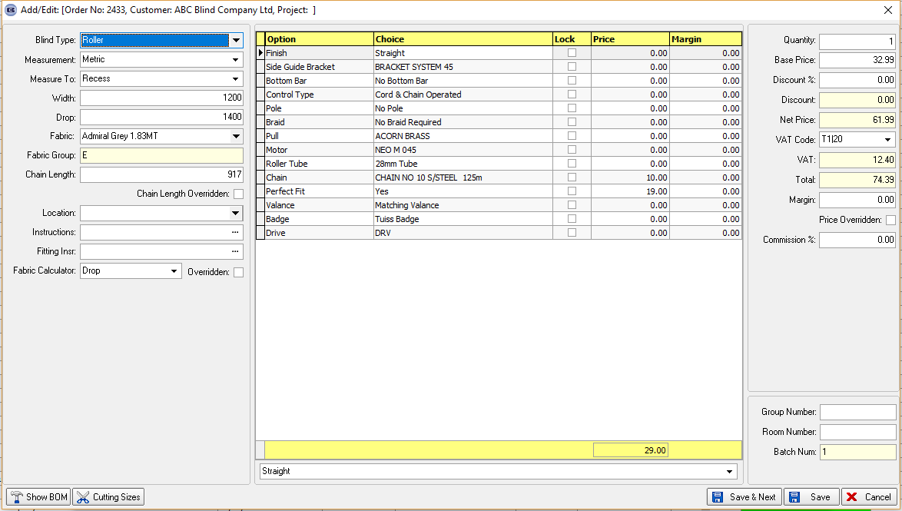

5957. Order Processing > Orders

A ‘Cutting Sizes’ button has been added to Window Blind Amend form.

5963. Order Processing > Orders / Order Enquiry

There is a new context menu choice where we can show a matrix of serial detail lines and processes that have been scanned / not scanned.

For example, if a roller blind has six process scans set up, we want a quick way of seeing what processes have been scanned and what hasn’t. By right clicking on the form and selecting ‘Process Scan Matrix’ it is possible to see how much of the order has been done.

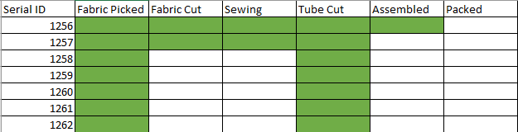

5969. Order Processing > Orders > Quotation Text Lines

When a work order containing a quotation text line item is printed the order status now changes to order printed automatically.

The quotation text detail lines now have the same rules as Carriage detail lines with respect to the order status and blind process scanning.

5975. Quotation – Bespoke 70

If a ‘free type’ fabric has been entered, the free type now prints immediately after the fabric description.

5976. Acknowledgement – Bespoke 70

If a ‘free type’ fabric has been entered, the free type now prints immediately after the fabric description.

5977. Acknowledgement – Bespoke 67

If an order has a repair line in it, the repair text now prints here.

5978. Delivery Docket – Bespoke 67

If an order has a repair line in it, the repair text now prints here.

5981. Order Processing > Cost to Selling Price

There is a new field held against the customer called ‘Cost Price Uplift %’ which defaults to zero. This is then applied as the ‘Uplift %’ in the order detail line.

5982. Order Processing > Orders > Multi Blind

There is now an option to restrict the multi blind option to max of 3 on 1. At the moment there are choices from 2 on 1 to 8 on 1. This has been parameterised, in a new System Table called ‘Multi Blind Choices’.

5985. Invoice – Bespoke 67

The footer ‘Invoice Text’ can now print up to eight lines.

5986. Acknowledgement – Bespoke 67

The ‘Valance Width’ now appear on this report, in front of ‘Return Length’.

5987. Works Order – Bespoke 67

The cutting sizes now appear on the report (if they are flagged to print in Blind Types > Cutting Options > On Works 1 = true).

5988. Quotation – Bespoke 67

Both the ‘Valance width’ and ‘Return Length’ should print on this report (see Acknowledgement – Bespoke 67).

