Blindata Release Note 9.0.0 

1 June 2018

Bug Fixes and Enhancements

The following bugs were recorded in www.support.blindata.co.uk and have been resolved.

5146. possibly from upgrade
5182. PO History duplicated

New Work and Customer Requests
5952. Order Processing > Orders Curtains / Romans

The tabbing is now correct in order detail line entry if the fabric chosen is a free type – after fabric it goes to fabric free type.

In order detail line option entry, after an option is chosen, the pointer remains at the option choice that has just changed.

It is now pricing correctly for Romans if prices are held in Pricing > Linear Width Pricing

5953. Order Processing > Orders > Curtains

A curtain can have borders on it, both horizontal (top and bottom) and vertical (leading and trailing edge). We made a change recently so that we could get an option name (eg Border Fabric) to look up the Fabric – see example here.

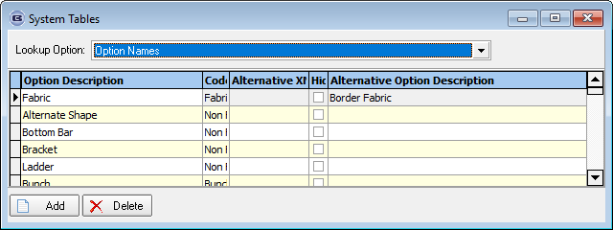

The problem here is that we could have different fabrics being used in the horizontal and vertical borders.

Therefore we have decided to hold multiple option names against stock item. There is a new field in the stock record ‘Product Blind Type’ tab.

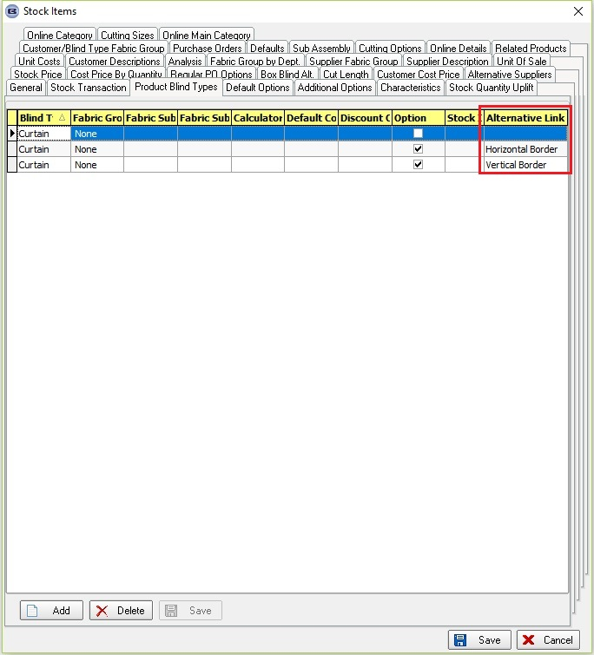

If border sizes are entered, it is now possible to enter ‘Roll Width’ and ‘Pattern Repeat’ in the order detail line entry (RW and PR). But as there could be multiple fabric options, we now hold these amounts against the options. These are available as fields in the option entry section – as column choices (right click in the ‘Option Name’ column).

We changed the Formula calculation for option pricing because the roll width and pattern repeat are now held against the option.

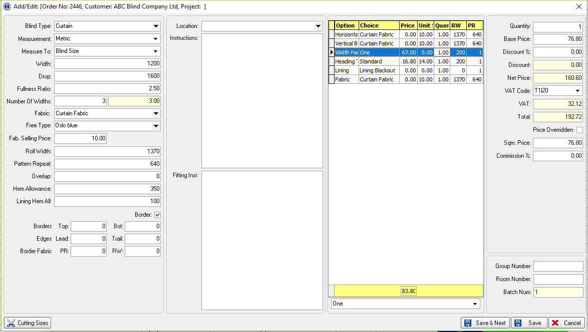

5955. Works Order – Bespoke 73

The ‘No Of Wires’ now appears on this report for Romans.

There are now two blind per A4 page with the barcode on each.

5956. Order Processing > Quotations

The ‘Cutting Sizes’ button is now available in the quotation order detail line amend.

5959. Stock Control > Reports > Fabric Requirement Report

There is a new report called Fabric (Free Type) Requirement Report. This report groups fabric records by fabric description and free type.

5960. Purchase Order Enquiry

A colour can now be held in Parameters > Forms > Purchase Order Enquiry to indicate whether a purchase order is overdue or not.

The ‘Parameters > Forms > Overdue Undelivered’ colour will fill the ‘Expected Delivery Date’ when ‘Purchase Order > Expected Delivered Date’ is filled and it's less or equal to the current date and there is at least one PO detail line that is not been delivered and is not complete.

5961. Order Processing > Order Enquiry

There is now a column choice for ‘Number Of Widths’ and a total for it.

5979. Order Processing > Orders

The customer record flag ‘Quality Check’ now appears as a column choice in the ‘Order Amend Enquiry’ form and also the ‘Order Enquiry’ form.

5980. Works Order – Bespoke 72

- There is now room for 4 more options to print.
- The 1 x 2 table box has been moved to the right of the vertical line.

